BUILDING BLOCK DATA

Species: Catasetum expansum Rchb.f 1878 SUBGENUS Catasetum SECTION Catasetum

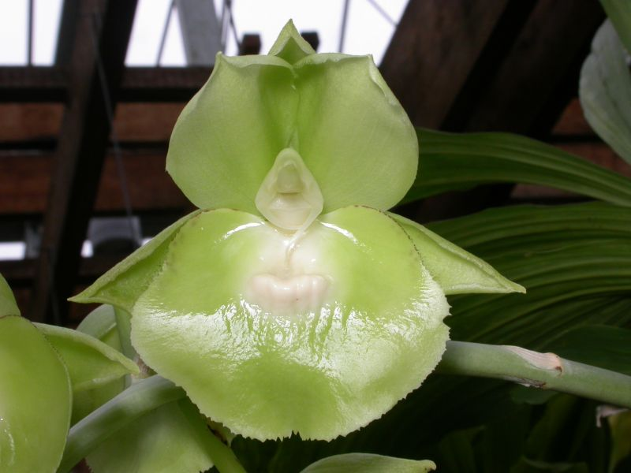
A large sized, showy, hot to cool growing epiphytic Catasetum from northeastern Ecuador in dry forest at elevations of 20 to 1500 meters with spindle shaped pseudobulbs carrying several deciduous, plicate, lanceolate leaves that can bloom from May until December on a basal, 12" [30 cm] long, several [6] flowered arching raceme arising on a newly forming pseudobulb carrying either male or female flowers.
The flowers can be found in many colors including yellow, green, white and sometimes with maroon spots.
Referred to as the expansive catasetum orchid, this species has an expansive blooming season as well as large stems covered with green, white or yellow blooms. This species is native to the dry, but seasonally wet, highland forests of Ecuador. It's a winter deciduous epiphyte (grows on trees) that forms a perennial clump.
"Catasetum" is a Greek compound word meaning "down bristle." This orchid genus is unique in having different gendered flowers on the same plant. Male flowers have an antenna-like trigger device that snaps pollen onto the backs of visiting bees. These pollen-covered insects then find a hooded female flower and unknowingly pollinate it. Because male and female flowers look different, people may have considerable difficulty identifying plants, especially if growing conditions or gender diphasy prevents the development of both flower genders on a single plant at the same time.

Synonyms:
Catasetum expansum var sodiroi [Schlechter] Mansf.; Catachaetum recurvatum Link 1844; Catasetum cliftonii R.H. Torr. 1911; Catasetum platyglossum Schltr. 1916; Catasetum recurvatum Link 1844; Catasetum sodiroi Schltr. 1921

Origin | HCC | AM | FCC | SM | CCM | CBM | Total
 | 6 | 10 |  | 4 |  | 2 | 29
Years | 1977-2008 | 1964-2015 |  | 1964-1984 |  | 1964-1974

Hybrids: Total of 243 to the 5th generation

Generation | Before 1940 | 1940-49 | 1950-59 | 1960-69 | 1970-79 | 1980-89 | 1990-99 | 2000-10 | After 2010
F-1 | 0 | 0 | 0 | 1 | 3 | 11 | 9 | 13 | 4
F-1 Awards | 0 | 0 | 0 | 0 | 41 | 37 | 11 | 19 | 1
F-1 – F-5 | 0 | 0 | 0 | 1 | 5 | 19 | 35 | 96 | 92
F-1 – F-5  Awards | 0 | 0 | 0 | 0 | 45 | 67 | 56 | 184 | 74

Outstanding progeny and reason they are considered outstanding:

Fredclarkeara After Dark ‘Black Diamond’ FCC/AOS

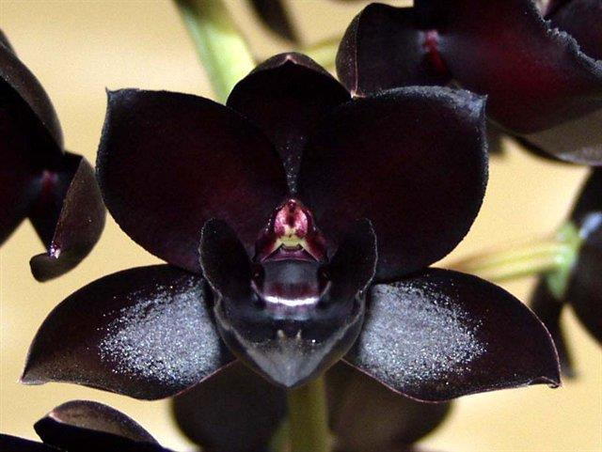
This is the famous, highly awarded hybrid created by Fred Clark of Sunset Valley Orchids in 2002. It has received 74 awards including 9 FCC, 33 AM, 9 HCC and 9 SM. It is a stunning, nearly black color. It has produced 10 progeny, only 5 of which have been awarded. The hybrid is a combination of Catasetum, Mormotes and Clowesia.

Catasetum Orchidglade ‘Davie Ranches’ AM/AOS

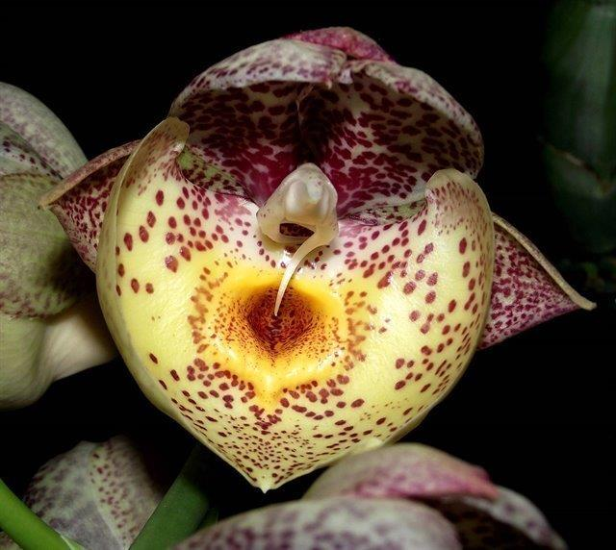
Orchidglade was created in 1974 by Jones and Scully. They crossed Catasetum pileatum with Ctsm. Expansum and got a hybrid that displays the full range of both parent’s influence. The grex has received 41 awards and has been productive with 189 total progeny including contributing to After Dark.

Catasetum Orchidglade ‘Jack of Diamonds’ AM/AOS

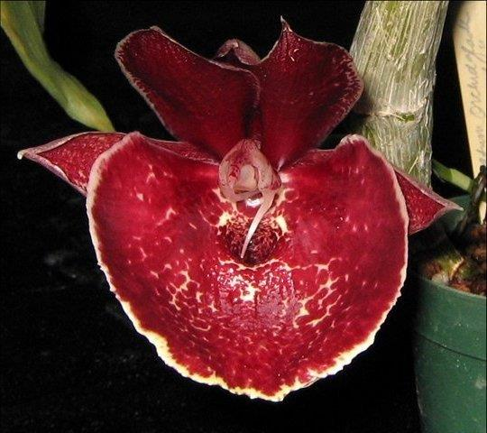

Desirable characteristics which can be passed to progeny:
The good yellow color comes through with many of the hybrids. Albinistic form makes interesting hybrids.

Undesirable characteristics which can be passed to progeny:

Other information:

References:

Aldridge, Peggy, 2008, An Illustrated Dictionary of Orchid Genera
Pridgeon AM, Cribb PJ, Chase MW, Rasmussen FN. 2009. Genera orchidacearum, Vol. 5.
www.orchidspecies.com
http://apps.kew.org/wcsp/qsearch.do
https://secure.aos.org/aqplus/SearchAwards.aspx
OrchidWiz.Database X3.2

