BUILDING BLOCK DATA

Species: Catasetum pileatum Rchb.f 1882 SUBGENUS Catasetum SECTION Catasetum

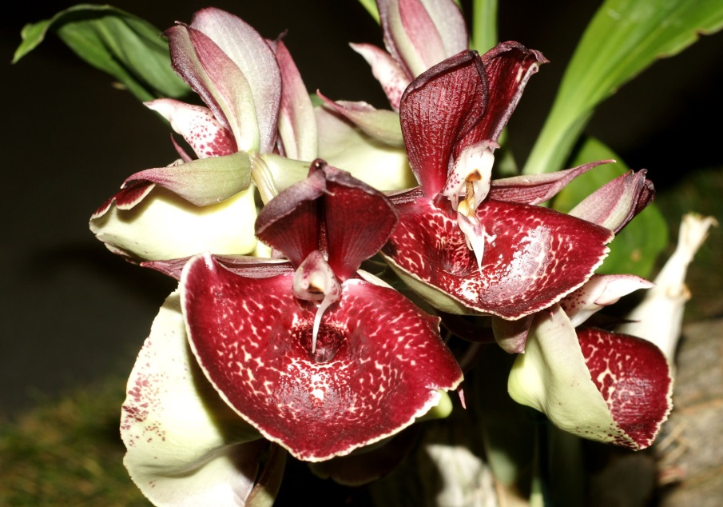
This large sized, hot growing epiphytic species comes from Venezuela, Colombia and Ecuador in lowland forest at elevations around 100 to 200 meters with tropical conditions with a long wet period and a short dry season with clustered, fusiform-ovoid, several noded pseudobulbs that are enveloped by several leaf bearing sheaths carrying distichous, lanceolate, suberect, plicate leaves and blooms in the spring through fall on a basal, erect to pendant, 12" [30 cm] long, several to many [4 to 10] flowered, racemose inflorescence carrying fragrant flowers that open very flat and arise on a mature pseudobulb.
Blooming anytime from late spring into autumn, the felt-capped catasetum has large flowers shaped somewhat like those of Oncidium orchids; they abstractly look like a dancing lady with a wide skirt. This species is native to hot, lowland rainforests in Venezuela, Ecuador and Peru. It's a winter deciduous epiphyte (grows on trees) that forms a perennial clump.
"Catasetum" is a Greek compound word meaning "down bristle." This orchid genus is unique in having different gendered flowers on the same plant. Male flowers have an antenna-like trigger device that snaps pollen onto the backs of visiting bees. These pollen-covered insects then find a hooded female flower and unknowingly pollinate it. Because male and female flowers look different, people may have considerable difficulty identifying plants, especially if growing conditions or gender diphasy prevents the development of both flower genders on a single plant at the same time.
Synonyms:
Catasetum bungerothii N.E.Br 1886; Catasetum bungerothii var. album Linden & Rodigas 1888; Catasetum bungerothii var. aurantiacum Cogn. 1894; Catasetum bungerothii var. lindenii Gower 1894; Catasetum bungerothii var. pottsianum L.Linden & Rodigas 1887; Catasetum bungerothii var. randii Rodigas 1890; Catasetum bungerothii var. regale Gower 1894; Catasetum pileatum var album Gogn. 1902; Catasetum pileatum var aurantiacum Cogn 1895; Catasetum pileatum var lindenii Hort 1894; Catasetum pileatum var pottsianum Linden & Rodig. 1887; Catasetum pileatum var randii Rodigas 1890; Catasetum pileatum var regale Hort. 1894

Origin | HCC | AM | FCC | SM | CCM | CBM | Total
 | 11 | 27 | 1 | 4 |  | 4 | 64
Years | 1971-2012 | 1964-2009 | 1983 | 1964-1984 |  | 1974-1985

Hybrids: Total of 278 to the 5th generation

Generation | Before 1940 | 1940-49 | 1950-59 | 1960-69 | 1970-79 | 1980-89 | 1990-99 | 2000-10 | After 2010
F-1 | 1 | 0 | 0 | 1 | 8 | 5 | 15 | 27 | 28
F-1 Awards | 0 | 0 | 0 | 2 | 55 | 39 | 13 | 21 | 14
F-1 – F-5 | 1 | 0 | 0 | 1 | 11 | 15 | 43 | 112 | 98
F-1 – F-5  Awards | 0 | 0 | 0 | 2 | 55 | 86 | 56 | 192 | 75

Outstanding progeny and reason they are considered outstanding:

Fredclarkeara After Dark ‘Black Diamond’ FCC/AOS

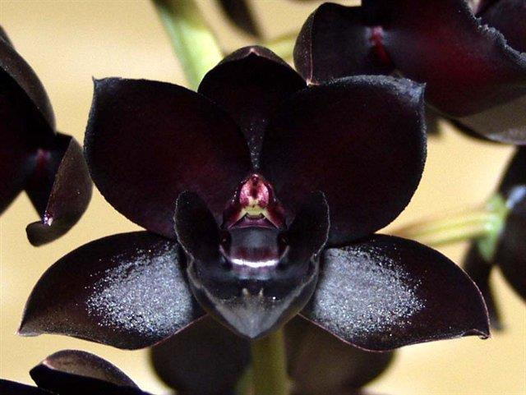
This is the famous, highly awarded hybrid created by Fred Clark of Sunset Valley Orchids in 2002. It has received 74 awards including 9 FCC, 33 AM, 9 HCC and 9 SM. It is a stunning, nearly black color. It has produced 10 progeny, only 5 of which have been awarded. The hybrid is a combination of Catasetum, Mormotes and Clowesia.

Catasetum Orchidglade ‘Davie Ranches’ AM/AOS

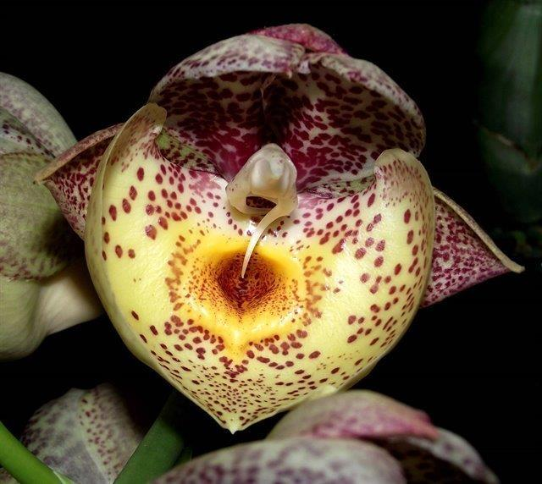
Orchidglade was created in 1974 by Jones and Scully. They crossed Catasetum pileatum with Ctsm. Expansum and got a hybrid that displays the full range of both parent’s influence. The grex has received 41 awards and has been productive with 189 total progeny including contributing to After Dark.

Catasetum Orchidglade ‘Jack of Diamonds’ AM/AOS

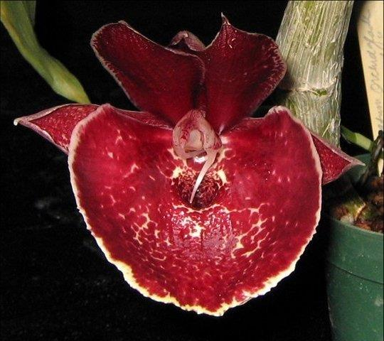

Desirable characteristics which can be passed to progeny:
The good yellow color comes through with many of the hybrids, especially with Lycaste. Variable coloration of cultivars.

Undesirable characteristics which can be passed to progeny:
Overly large lip can be overwhelming. Pollen trigger can cause premature flower wilt.

Other information:

References:

Aldridge, Peggy, 2008, An Illustrated Dictionary of Orchid Genera
Pridgeon AM, Cribb PJ, Chase MW, Rasmussen FN. 2009. Genera orchidacearum, Vol. 5.
www.orchidspecies.com
http://apps.kew.org/wcsp/qsearch.do
https://secure.aos.org/aqplus/SearchAwards.aspx
OrchidWiz.Database X3.2

