Anguloa Hybrid Genera
Angulocaste is a nothogenus created by crossing Anguloa and Lycaste. There are 134 hybrids in the genus, the firse made in 1903 and the latest registered in 2016. In many of the crosses, Anguloa makes up 25% or less of the genetic material. When Anguloa is 50%, the tulip shaped flower is dominant. A few significant progeny are Olympus, Paul Gripp and Apollo.
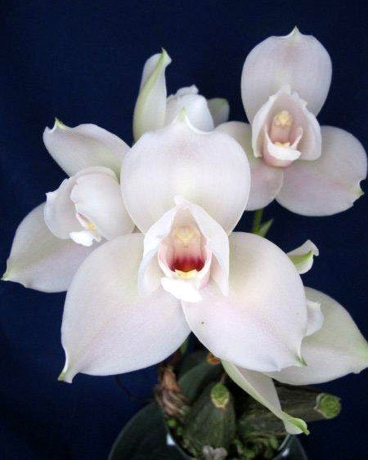
Angulocaste Olympus

Lysudamuloa, a Trigeneric nothogenus, is a result of crossing Sudamerlycaste , Anguloa and Lycaste. There are 32 registered hybrids. The only significant progeny (that being relative) are Red Jewell with 10 awards, Tudor with 2 awards and 18 progeny and Jim Riopelle with 9 awards and 4 progeny.
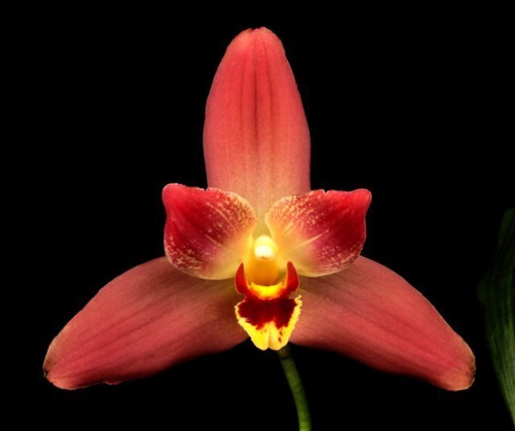
Lysudamuloa Red Jewell

