Zygopetalum maculatum HCC/AOS
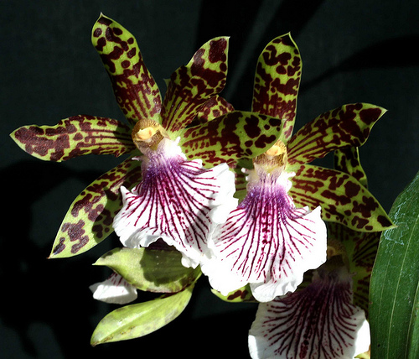
Fourteen fragrant flowers and three buds on two inflorescences; sepals and petals apple green, overlaid with mahogany spots and lines; lip white, violet lines radiating from column base, margins undulate; column cream, brown spots at base; substance firm; texture matte.

Zygopetalum maxillare CCM/AOS
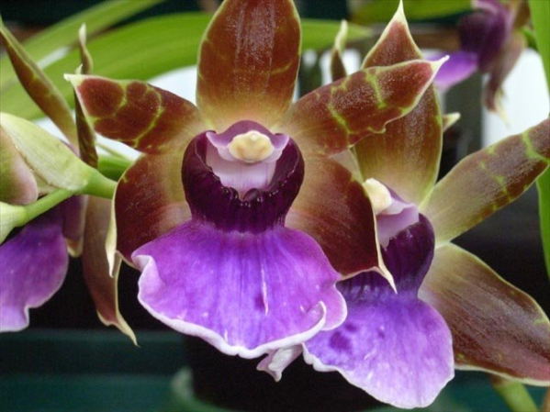
Sixty-four flowers and 17 buds on 16 inflorescences grown on tree fern slab; sepals and petals green, overlaid nearly solid brown; lip white, overlaid light lavender, basal crest deep purple; column light lavender, anther cap pale yellow; substance firm, texture waxey.

Angulocaste Jupiter AM/AOS
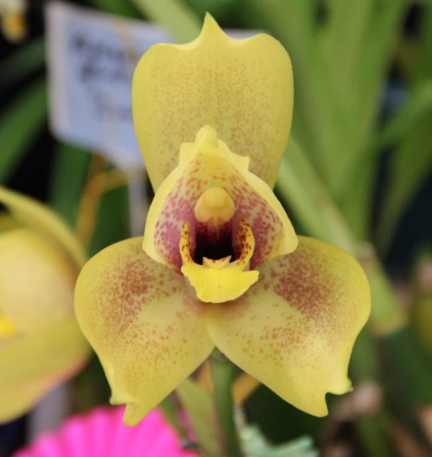
Twenty-one flowers and 6 buds on twenty-two inflorescences; sepals lemon yellow, finely spotted burgundy, heavier on lateral sepals; petals lemon yellow, heavily spotted burgundy; lip golden yellow, spotted red at base; column ruby red basally, anther cap golden yellow; substance firm, texture matte.

Lycaste Corrimal AM/AOS
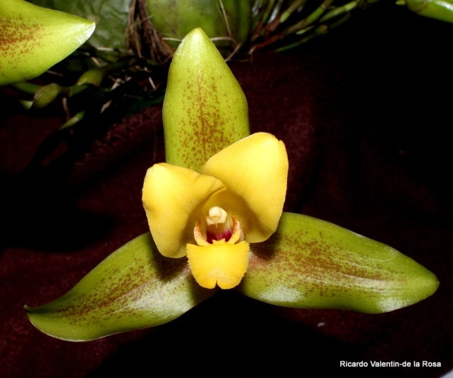
Twenty-one flowers and two buds on twenty-three erect inflorescences; sepals lime green, spotted cordovan centrally ; petals yellow, lightly spotted basally; lip yellow, side lobes heavily spotted red; column yellow; substance firm; texture crystalline.

Lycaste Memoria Olga Anton HCC/AOS
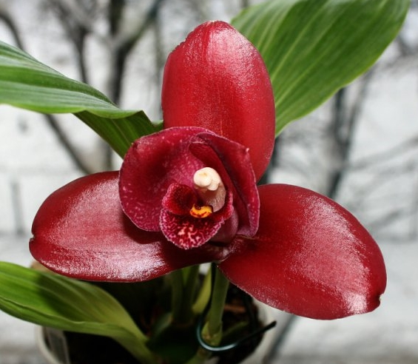
Three flowers and one bud on four inflorescences; sepals oxblood; petals white, heavily overlaid oxblood; lip white, overlaid oxblood, displaying white spots; callus golden yellow, distal edge spotted red; column white; substance heavy; texture satin.

