Cycnoches Jean E. Monnier AM/AOS 86 Points
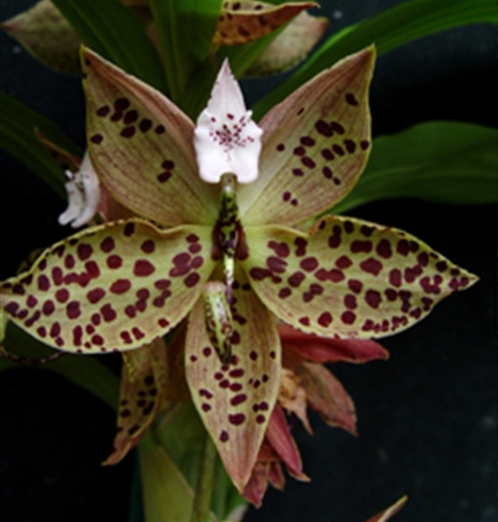
Twenty six non-resupinate male flowers on one pendant inflorescence; sepals olive green, suffused light rose sparsely spotted mahogany; petals olive green, suffused light rose, heavily spotted mahogany; lip lanceolate, cream, finely spotted mahogany centrally; column chartreuse, spotted dark brown; substance firm; texture matte.

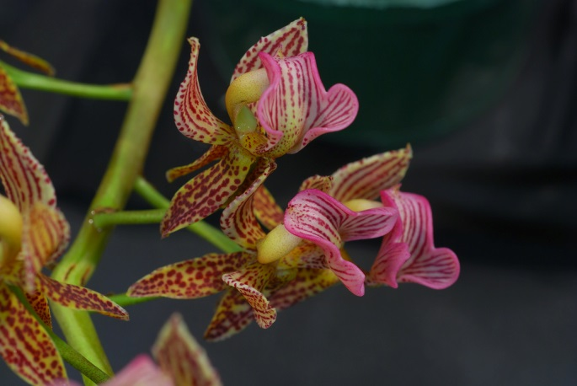
Mormodes warszewiczii CHM/AOS 81 Points
Forty flowers on three inflorescences; sepals and petals light green, spotted maroon-brown in parallel lines; lip saddle shaped, green, heavily suffused rose-pink, veins darker pink; column yellow-green; substance firm; texture matte.

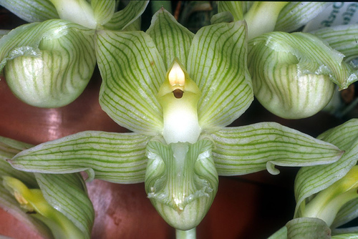
Clowesia russelliana HCC/AOS 77 Points
Twenty six flowers on one inflorescence; sepals and petals pale green, striped darker green; lip pale green, faintly striped laterally, margin ruffled; substance firm; texture diamond dust.

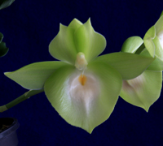
Catasetum Pileabrosum Green AM/AOS 86 Points
Twenty six flowers on two pendent inflorescences; sepals and petals lime green; lip lime green, callus white with proximal yellow-orange spot; substance firm; texture waxy.

Catasetum pileatum HCC/AOS 78 Points
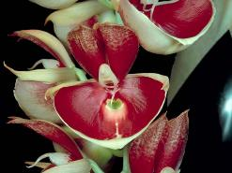
Seven flowers on one pendant inflorescence; sepals ivory, suffused pink; petals cream, heavily overlaid burgundy, color breaking up distally; lip burgundy, center cream, spur bright green; column white; substance heavy; texture waxy.

