BUILDING BLOCK DATA

Species: Anguloa clowesii Lindley 1844 Edwards's Bot. Reg. 30(Misc.): 26. 1844

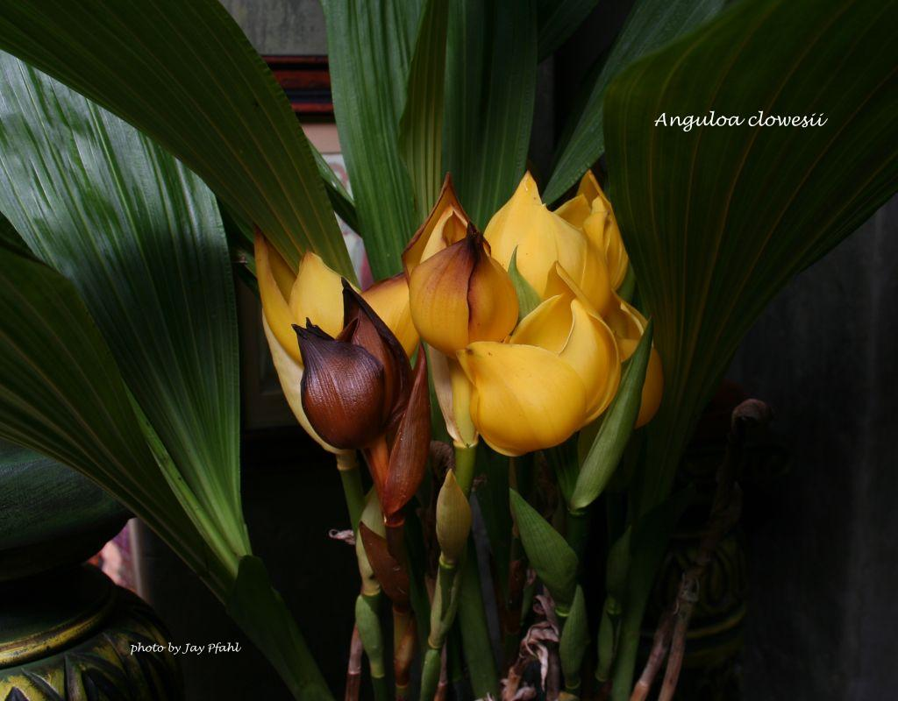
A large terrestrial sometimes epiphytic plant with large, clustered, conical-pyriform, sulcate, slightly compressed pseudobulbs with 3 to 4, deciduous, apical, plicate, obovate or elliptical, obtuse leaves found at elevations of 1800 to 2500 meters, commonly called the Cradle Orchid, as it has a rocking lip, which is enclosed completely by the sepals and petals as in a tulip which gives the plant it's other common name the Tulip Orchid. It is found in Colombia and Venezuela on the eastern slope of the Andes next to the Llanos and is a cool to cold growing orchid that has large, waxy, highly fragrant, solitary flowers smelling of wintergreen and chocolate occuring from the spring through the summer on an erect, 12" [30 cm] long, sheathed, often 2 inflorescence holding the flowers at mid-leaf height that arise basally as the new growths appear in the late winter.
It is a deciduous plant and will drop its leaves in the fall, at that time less water is needed and fertilizer should be curtailed. Watch out for fungus through the winter if kept too wet!

Synonyms:
Anguloa clowesii var. aurea A.DC. ex Oakeley 1999; Anguloa clowesii var. flava A.DC. 1847

Awards:

Origin | HCC | AM | FCC | SM | CCM | CHM | Total
 | 0 | 4 | 0 | 0 | 5 | 0 | 9
Years |  | 1972-1995 |  |  | 1972-2012

Hybrids: Total of 128 to the 5th generation

Generation | Before 1940 | 1940-49 | 1950-59 | 1960-69 | 1970-79 | 1980-89 | 1990-99 | 2000-10 | After 2010
F-1 | 3 | 0 | 2 | 1 | 1 | 2 | 9 | 5 | 3
F-1 Awards | 7 | 0 | 10 | 0 | 1 | 0 | 2 | 2 | 0
F-1 – F-5 | 3 | 0 | 32 | 3 | 5 | 22 | 16 | 20 | 4
F-1 – F-5  Awards | 7 | 0 | 56 | 6 | 1 | 9 | 18 | 30 | 0

Outstanding progeny and reason they are considered outstanding:

Angulocaste Paul Gripp ‘Pacific Gem’ CCE/AOS

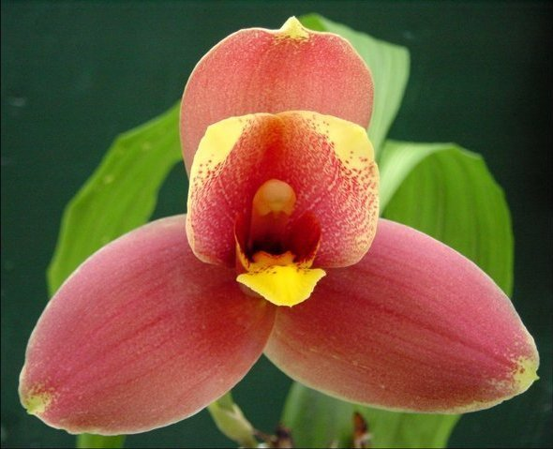
Anguloa hybrids within the genus have not amounted to much, but when crossed with Lycaste, the results are great. Paul Gripp was created in 1984 by Santa Barbara Orchid Estates. It is a cross between Lycaste Auburn ( with a lot of Lyc. virginalis in the background) and Angulocaste Olympus. It has produced 15 F-1 and 19 total offspring. It has been awarded 8 times with 5 AM’s and 2 HCC. It and Angulocaste Olympus are the best of the Anguloa hybrids.

Angulocaste Olympus ‘Everest’ HCC/AOS

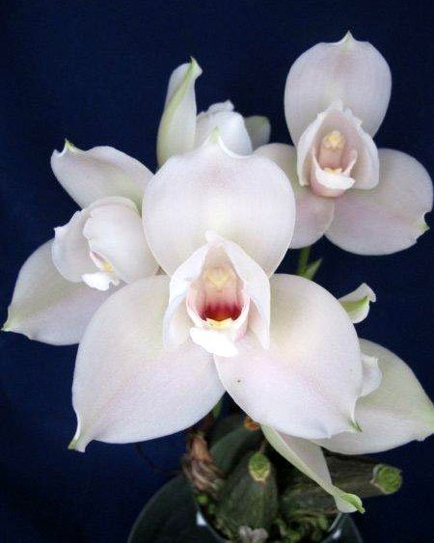
A second generation cross made by Wyld Court in 1959. Olympus has garnered 46 awards including 3 FCC, 12 AM and 6 HCC. It is a cross between Angulocaste Apollo and Lycaste Sunrise. It has 12 F-1 offspring, all with Lycaste . and 35 total progeny.

Desirable characteristics which can be passed to progeny:
The good yellow color comes through with many of the hybrids, especially with Lycaste.

Undesirable characteristics which can be passed to progeny:
The tulip flower form is expressed in the hybrids within the genus but disappears when crossed with Lycaste. It is not particularly desirable.

Other information:
The name commemorates Don Francisco de Angulo, a government official in Peru.

References:

Aldridge, Peggy, 2008, An Illustrated Dictionary of Orchid Genera
Pridgeon AM, Cribb PJ, Chase MW, Rasmussen FN. 2009. Genera orchidacearum, Vol. 5.
www.orchidspecies.com
http://apps.kew.org/wcsp/qsearch.do
https://secure.aos.org/aqplus/SearchAwards.aspx
OrchidWiz.Database X3.2

