BUILDING BLOCK DATA

Species: Lycaste cruenta Lindl. 1843 SECTION Aromaticae

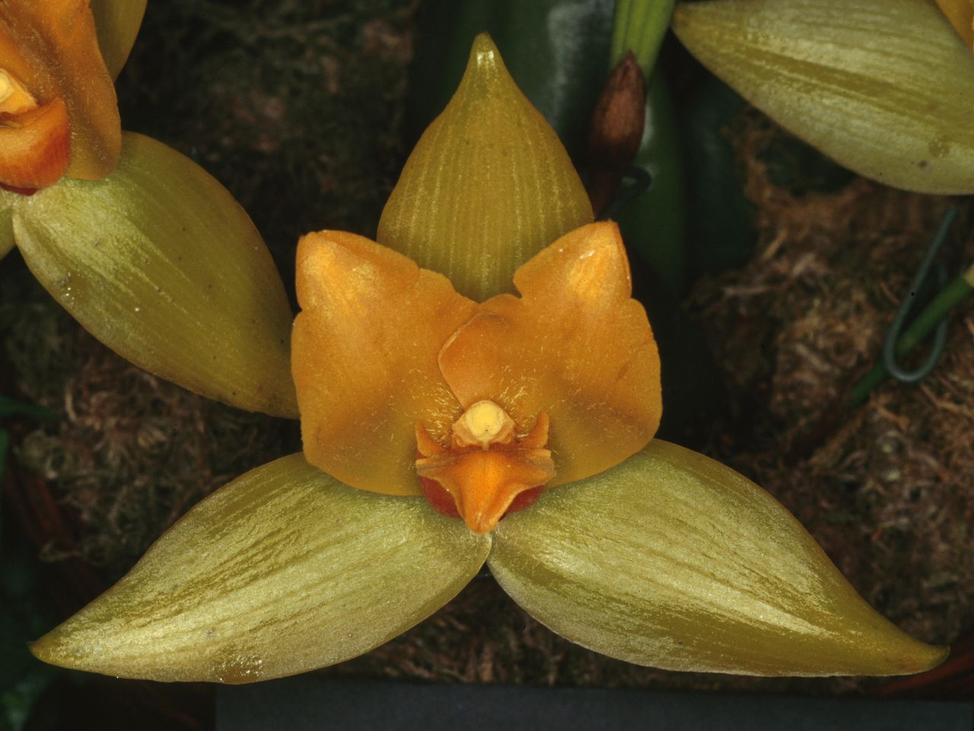
Lycaste cruenta has greenish yellow flowers with bright orange petals and labellum about 8 cm (3 in) wide. They appear in spring in the flower stems up to 15 cm (6 in) high, and there can be more than 20 flowers in one plant. They have a sweet scent resembling cinnamon in the evening. The leaves grow to 38 cm (15 in) long and 15 cm (6 in) wide and are shed before flowering. Lycaste cruenta has pseudobulbs up to 10 cm (4 in) long and 5 cm (2 in) wide.[1] This medium sized, cool to cold growing species occurs in Mexico, Guatemala, Costa Rica and El Salvador as an epiphyte or lithophyte at elevations of 1800 to 2200 meters with large, ovoid-oblong, compressed, spined pseudobulbs enveloped basally by several imbricating, scarious, sheaths and carrying several, deciduous, elliptic-lanceolate to broadly elliptic, plicate, acute or acuminate leaves that blooms in the spring on a lateral, several at once, to 7" [17.5 cm] long, single flowered inflorescence with several inflated sheath bracts that has waxy, long-lasting, scented flowers and heavily spined psuedobulbs. Chiapas Mx., 1890m elev., near Teopisco, epiphytic on large oak limbs, in open oak woods, very plentiful
Synonyms:
Lycaste balsamea A. Rich. 1847; Lycaste cruenta var concolor Oakley 2008; Lycaste cruenta var longibracteata Oakley 2008; Lycaste cruenta var sulphurea Oakley 2008; Lycaste cruenta var sulphurea subvar longibracteata Oakley 2008; Lycaste rossiana Rolfe. 1893; Lycaste rossiana var matto grossensis Barb. Rodr. 1898; Lycaste sulphurea Rchb.f. 1882; Maxillaria balsamea Beer 1854; *Maxillaria cruenta Lindl. 1842

Awards:

Origin | HCC | AM | FCC | SM | CCM | CHM | Total
 | 4 |  | 0 | 0 | 5 | 3 | 12
Years | 1972-2012 | 1978-2013 |  |  | 1953-1974 | 1981-1998

Hybrids: Total of 696 to the 9th generation

Generation | Before 1940 | 1940-49 | 1950-59 | 1960-69 | 1970-79 | 1980-89 | 1990-99 | 2000-10 | After 2010
F-1 | 6 | 0 | 9 | 26 | 3 | 3 | 13 | 0 | 0
F-1 Awards | 9 | 0 | 0 | 6 | 1 | 8 | 2 | 2 | 0
F-1 – F-9 | 23 | 27 | 99 | 93 | 164 | 182 | 184 | 192 | 21
F-1 – F-9  Awards | 10 | 1 | 78 | 57 | 70 | 130 | 96 | 140 | 81

Outstanding progeny and reason they are considered outstanding:

Lycaste Koolena ‘Cotton Candy’ AM/AOS
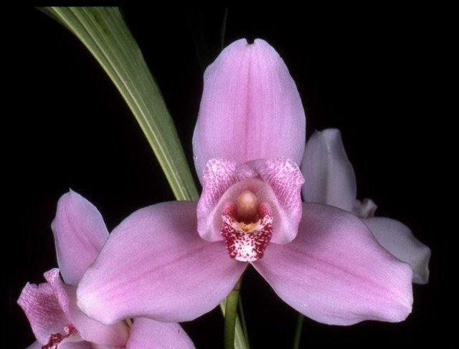
Lycaste produces wonderful hybrids within the genus. Lycaste Koolena was produced by Wondabah in 1967 by crossing Lycaste Auburn and Lycaste virginalis. The hybrid has been awarded 45 times with 21 AM, 18 HCC and a bunch of cultural awards. It has produces 56 F-1 offspring and a total of 325 progeny in 4 generations. After Angulocaste Olynpus, it is the highest awarded Lycaste hybrid.

Lycaste Shoalhaven AM/AOS

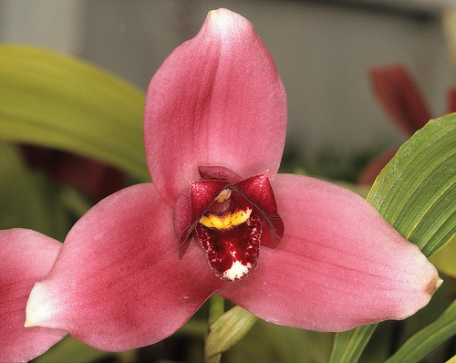
The hybrid Shoalhaven was made back in 1976 by J. Apperley by crossing Lycaste virginalis with Lycaste Koolena. Although it has fewer awards than Koolena, it has produces 83 F-1 offspring with a total progeny of 210 in 4 generations. It has been awarded 28 times with 9 AM and 15 HCC. Some notable offspring are Lyc Chita Impulse with 17 awards, Lyc Sunray with 12 awards and Lyc Abou Sunset with 11 awards.

Desirable characteristics which can be passed to progeny:
The good yellow color comes through with many of the F-1 hybrids. It good form is evident in most hybrids..

Undesirable characteristics which can be passed to progeny:
The floral elements in the species are rather narrow and sometimes the edges are rolled.

Other information:
Pronounced: kroo-EN-ta. The name refers to the blood colored inner lip.

References:

Aldridge, Peggy, 2008, An Illustrated Dictionary of Orchid Genera
Pridgeon AM, Cribb PJ, Chase MW, Rasmussen FN. 2009. Genera orchidacearum, Vol. 5.
www.orchidspecies.com
http://apps.kew.org/wcsp/qsearch.do
https://secure.aos.org/aqplus/SearchAwards.aspx
OrchidWiz.Database X3.2

