BUILDING BLOCK DATA

Species: Lycaste macrophylla (Poepp. & Endl.) Lindl. 1843 SECTION Lycaste

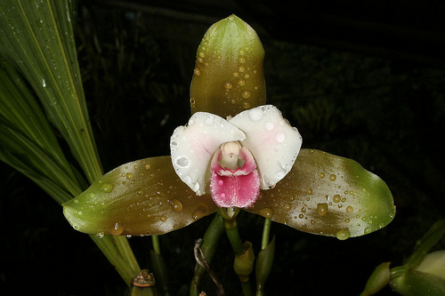
A medium to large sized, cool to hot growing terrestrial species, highly variable in flower color and plant size, that is found from Costa Rica, Panama, Colombia, Ecuador, Peru, Bolivia and Venezuela at elevations of 400 to 2400 meters in wet montane forests with ovoid-oblong to broadly ellipsoid, complanate, sulcate, obtusely angled, pseudobulbs subtended by a few, imbricating leaf sheaths and after leaf fall has no apical teeth, carrying 2 to 3, non-deciduous, large elliptic, attenuate to channeled petiol, acuminate above, plicate leaves that blooms on a succession of erect, many [5] at once, basal, to 7" [17.4 cm] long, inflorescence that has inflated papery bracts, arising on a newly maturing pseudobulb and flowering successively over several months occurring in the summer and fall with fragrant, waxy, color variable flowers held below the leaves.
Synonyms:
Lycaste filomenoi Schltr. 1921; Lycaste macrophylla subsp. desboisiana (Cogn.) Fowlie 1964; Lycaste macrophylla subsp. filomenoi (Schltr.) Fowlie 1964; Lycaste macrophylla subsp. neglecta (Schltr.) Fowlie 1970; Lycaste macrophylla subsp. panamanensis Fowlie 1964 ; Lycaste macrophylla subsp. plana (Lindl.) Fowlie 1964; Lycaste macrophylla subsp. viridescens Oakeley 1991; Lycaste macrophylla var alba Oakley 2008; Lycaste macrophylla var. desboisiana Cogn. 1897; Lycaste macrophylla var. measuresianum Sander 1901; Lycaste macrophylla var. plana (Lindl.) Oakeley 2007; Lycaste neglecta Schltr. 1929; Lycaste plana Lindl. 1842; *Maxillaria macrophylla Poepp. & Endl. 1836; Maxillaria phyllomega Steud. 1841

Awards:

Origin | HCC | AM | FCC | SM | CCM | CHM | Total
 | 6 | 5 | 0 | 0 | 7 | 3 | 21
Years | 1982-2009 | 1993-2008 |  |  | 1975-2007 | 2001-2006

Hybrids: Total of 696 to the 9th generation

Generation | Before 1940 | 1940-49 | 1950-59 | 1960-69 | 1970-79 | 1980-89 | 1990-99 | 2000-10 | After 2010
F-1 | 6 | 1 | 0 | 0 | 3 | 5 | 11 | 15 | 41
F-1 Awards | 5 | 0 | 0 | 0 | 2 | 2 | 2 | 7 | 18
F-1 – F-9 | 40 | 2 | 0 | 0 | 12 | 2 | 2 | 6 | 1
F-1 – F-9  Awards | 5 | 0 | 0 | 0 | 2 | 10 | 1 | 6 | 1

Outstanding progeny and reason they are considered outstanding:

Lycaste Koolena ‘Cotton Candy’ AM/AOS
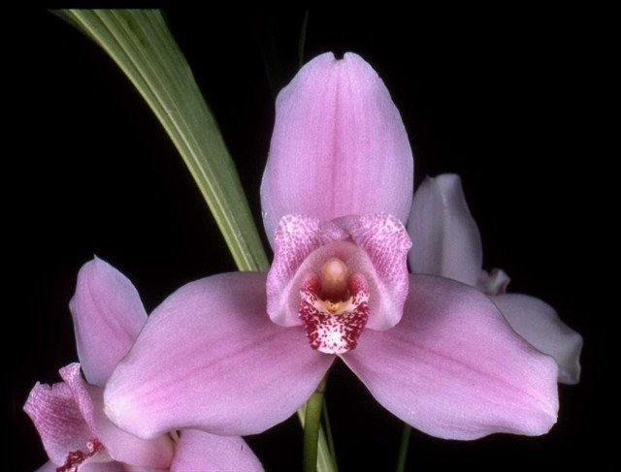
Lycaste produces wonderful hybrids within the genus. Lycaste Koolena was produced by Wondabah in 1967 by crossing Lycaste Auburn and Lycaste virginalis. The hybrid has been awarded 45 times with 21 AM, 18 HCC and a bunch of cultural awards. It has produces 56 F-1 offspring and a total of 325 progeny in 4 generations. After Angulocaste Olynpus, it is the highest awarded Lycaste hybrid. Lycaste macrophylla contributes about 7% genetic material to this cross.

Lycaste Shoalhaven AM/AOS

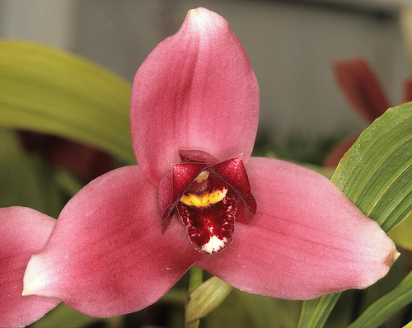
The hybrid Shoalhaven was made back in 1976 by J. Apperley by crossing Lycaste virginalis with Lycaste Koolena. Although it has fewer awards than Koolena, it has produces 83 F-1 offspring with a total progeny of 210 in 4 generations. It has been awarded 28 times with 9 AM and 15 HCC. Some notable offspring are Lyc Chita Impulse with 17 awards, Lyc Sunray with 12 awards and Lyc Abou Sunset with 11 awards. Lycaste macrophylla contributes only 3-4% to this cross.

Lycaste Jackpot ‘Royal Flush’ AM/AOS

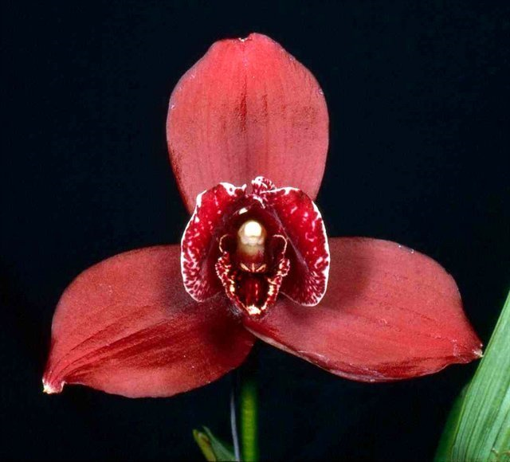
Jackpot is a cross between Lyc Auburn and Lyc Wyld Court. It is mostely Lycaste virginalis with Lyc lasioglossa, Lyc cruenta and Lyc macrophylla making up a third. It has 27 progeny and 36 awards including 2 FCC, 17 AM and 13 HCC.

Desirable characteristics which can be passed to progeny:
The frilled, deeply cupped petals stand out as well as the reds of some cultivars

Undesirable characteristics which can be passed to progeny:
The width of the flower elements is a negative.

Other information:
The name refers to its rather large leaves.

References:

Aldridge, Peggy, 2008, An Illustrated Dictionary of Orchid Genera
Pridgeon AM, Cribb PJ, Chase MW, Rasmussen FN. 2009. Genera orchidacearum, Vol. 5.
www.orchidspecies.com
http://apps.kew.org/wcsp/qsearch.do
https://secure.aos.org/aqplus/SearchAwards.aspx
OrchidWiz.Database X3.2

