BUILDING BLOCK DATA

Species: Lycaste virginalis (Scheidw.) Linden

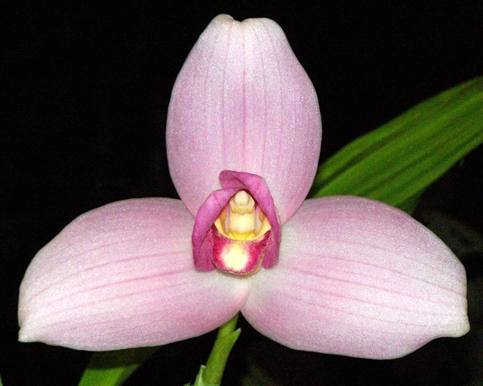
This is a warm to cold growing, large sized, epiphytic or lithophytic orchid from wet montane forests and pine-oak-liquidambar forests at altitudes of 1200 to 1800 meters that has ovoid, compressed pseudobulbs carrying several, apical, deciduous, plicate, elliptic-lanceolate, acuminate leaves, dropping in the autumn, from that time on the plant needs no water or fertilizer and should only be resumed with the emergence of the new growth and flowering in the winter and early spring. The inflorescence is erect, with a few at once, 6 to 12" [15 to 30 cm] long, single flowered inflorescence with the peduncle being concealed by inflated sheathing bracts. The flower is long-lasting, fragrant, and highly variable in size and color. This orchid is the national flower of Guatemala where it is known by the common name 'Monja Blanca' or white nun orchid, it is also found in Mexico, Guatemala, Honduras and El Salvador. Long leaves grow from its thick pseudobulbs. The flowers of this species -generally individual- are triangular and grow from the base of the youngest pseudo-bulb and measure between 10 and 15 centimeters. They can vary from being completely white in the Alba variety, passing from different tones of pink to lavender. This purity in color makes them the best candidate as a starting point for Lycaste hybrid formation. The flower's blooming period is between November and April, with its peak being in the end of January and the beginning of February. A mature plant can produce between 4 and 12 flowers during the time of its blooming, which lasts between 6 and 8 weeks.
It is a hermaphrodite plant capable of producing millions of seeds inside of a fruit in the form of a capsule. Nevertheless, the necessary conditions for the germination include the presence of a specific fungus, which results in the plant being very scarce whose commercialization is prohibited in Guatemala
Lycaste virginalis is found in humid forests of Mexico, Guatemala, El Salvador, and Honduras, being the most abundant in Guatemala. It resides at an average altitude of 1,650 meters above sea level, where it doesn't suffer from the high temperatures during the summer or the low temperatures during the winter. Abundant cloud cover at ground level, elevates the relative humidity during the day and the dry season. It inhabits the branches of woody trees at heights where the lighting conditions are appropriate. It is very sensitive to changes in temperature which range from 27 °C to 18 °C at night and the ideal humidity for its development is between 50 and 70 percent.

Synonyms:
Lycaste alba Cockerell 1919; Lycaste albida Hort 1892; Lycaste amabilis Hort. 1892; Lycaste jamesiana hort. 1889; Lycaste schoenbrunnensis Umlauft 1893; Lycaste skinneri f. virginalis (Scheidw.) Christenson 1996; Lycaste skinneri subvar. alba (Dombrain) A.H.Kent 1893; Lycaste skinneri var. alba Dombrain 1872; Lycaste skinneri var. albaviridis Mills. ex Oakley 2008; Lycaste skinneri var. armeniaca Rolfe 1892; Lycaste skinneri var. cobanensis Archila 2002 Lycaste skinneri var. gloriosa R.Warner & B.S.Williams 1885; Lycaste skinneri var. labelloalba Oakley 2008; Lycaste skinneri var. labelloflava Oakley 2008; Lycaste skinneri var. reginae B.S.Williams 1887; Lycaste skinneri var. superba T.Moore 1861; Lycaste skinneri var. virginalis (Scheidw.) Gajon-Sanchez 1930; Lycaste virginalis [Scheidw.]Lindley 1888; Maxillaria skinneri Lindl. 1840; *Maxillaria skinneri Bateman ex Lindley 1842; Maxillaria virginalis Scheidw. 1842

Awards:

Origin | HCC | AM | FCC | SM | CCM | CHM | Total
 | 56 | 66 | 9 | 18 | 5 | 3 | 182
Years | 1945-2005 | 1940-2016 | 1973-2010 | 2011-2014 | 1971-2008 | 1988-1997

Hybrids: Total of 809 to the 6th generation

Generation | Before 1940 | 1940-49 | 1950-59 | 1960-69 | 1970-79 | 1980-89 | 1990-99 | 2000-10 | After 2010
F-1 | 16 | 3 | 1 | 5 | 3 | 14 | 22 | 26 | 15
F-1 Awards | 26 | 2 | 3 | 61 | 34 | 28 | 32 | 21 | 5
F-1 – F-6 | 19 | 3 | 7 | 11 | 26 | 94 | 170 | 275 | 227
F-1 – F-6  Awards | 27 | 2 | 88 | 70 | 88 | 193 | 108 | 120 | 111

Outstanding progeny and reason they are considered outstanding:

Lycaste Koolena ‘Cotton Candy’ AM/AOS
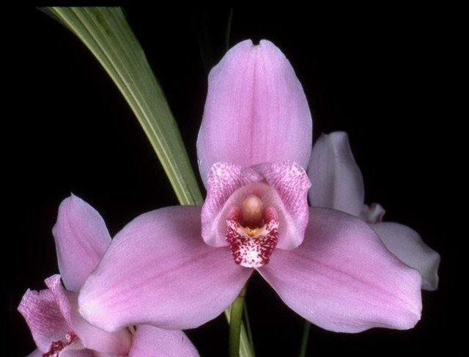
Lycaste produces wonderful hybrids within the genus. Lycaste Koolena was produced by Wondabah in 1967 by crossing Lycaste Auburn and Lycaste virginalis. The hybrid has been awarded 45 times with 21 AM, 18 HCC and a bunch of cultural awards. It has produces 56 F-1 offspring and a total of 325 progeny in 4 generations. After Angulocaste Olynpus, it is the highest awarded Lycaste hybrid. Lycaste virginalis contribution to Koolina is about 80%.

Lycaste Shoalhaven AM/AOS

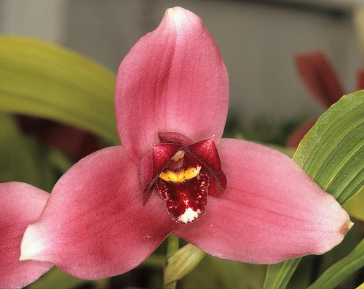
The hybrid Shoalhaven was made back in 1976 by J. Apperley by crossing Lycaste virginalis with Lycaste Koolena. Although it has fewer awards than Koolena, it has produces 83 F-1 offspring with a total progeny of 210 in 4 generations. It has been awarded 28 times with 9 AM and 15 HCC. Some notable offspring are Lyc Chita Impulse with 17 awards, Lyc Sunray with 12 awards and Lyc Abou Sunset with 11 awards. Lycaste virginalis contribution to Shoalhaven is about 90%.

Desirable characteristics which can be passed to progeny:
Great color and form, faint lines on the sepals, nice cupped petals and lip.
Undesirable characteristics which can be passed to progeny:
Many crosses have small flowers and it takes a lot of work to bump up the size. The pink color is very fragile and id easily lost in crosses.

Other information:
A white form is the National Flower of Guatemala.

References:

Aldridge, Peggy, 2008, An Illustrated Dictionary of Orchid Genera
Pridgeon AM, Cribb PJ, Chase MW, Rasmussen FN. 2009. Genera orchidacearum, Vol. 5.
www.orchidspecies.com
http://apps.kew.org/wcsp/qsearch.do
https://secure.aos.org/aqplus/SearchAwards.aspx
OrchidWiz.Database X3.2
Oakeley, Henry Francis. 1991. Lycaste skinneri: Hybridization in nature and in cultivation,
volume 60. American Orchid Society Bulletin 60:738-747

