BUILDING BLOCK DATA

Species: Zygopetalum crinitum Lodd. 1831

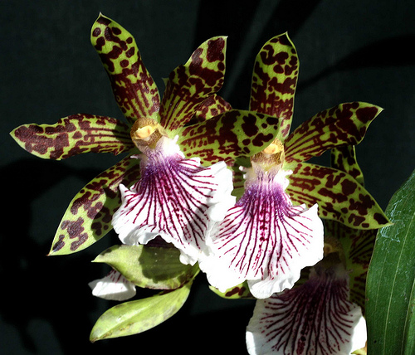
Found in Santa Catarina to Espirito Santo states, Brazil at elevations of 600 to 1200 meters as a medium sized, cool to warm growing terrestrial or epiphyte, has clustered, often buried in leaf litter, ovoid or ovoid-oblong, compressed, lightly sulcate, shiny dark green pseudobulbs carrying 3 to 5 apical, coriaceous, narrowly lanceolate or linear-lanceolate, acute or shortly acuminate, plicate, long-attenuate below leaves that blooms on an erect, to 1 1/2' [45 cm] long, several [3 to 10] flowered, racemose inflorescence with showy, fragrant, waxy, long-lived flowers occuring in the winter through spring.
Synonyms:
Zygopetalum claesianum Hort. 1894; Zygopetalum crinitum var coeruleum Willms. 1885; Zygopetalum crinitum var roseum Hort 1892; Zygopetalum crinitum var rubellum Hort 1855; Zygopetalum crepeauxii Carrière 1887; Zygopetalum intermedium Linden & Rodigas. 1890; Zygopetalum mackaii Hort 1899; Zygopetalum mackaii Hkr. var. convexum Mutel 1842; Zygopetalum mackaii Hkr. var. crinitum Lindley 1833; Zygopetalum microtis Hoffmannsegg 1863; Zygopetalum pubescens Hoffmannsegg 1843; Zygopetalum stenochilum Lodd. 1833

Awards:

Origin | HCC | AM | FCC | 1st | CBM | CHM | Total
 | 1 |  |  | 1 | 1 | 1 | 4
Years | 2011 |  |  | 2015 | 1973 | 1978

Hybrids: Total of 434 to the 5th generation

Generation | Before 1940 | 1940-49 | 1950-59 | 1960-69 | 1970-79 | 1980-89 | 1990-99 | 2000-10 | After 2010
F-1 | 7 | 0 | 0 | 0 | 1 | 2 | 8 | 9 | 0
F-1 Awards | 0 | 0 | 0 | 0 | 3 | 8 | 3 | 2 | 0
F-1 – F-5 | 23 | 0 | 32 | 88 | 26 | 134 | 105 | 207 | 78
F-1 – F-5  Awards | 2 | 0 | 7 | 36 | 3 | 40 | 37 | 21 | 9

Outstanding progeny and reason they are considered outstanding:

Zygopetalum Artur Elle HCCAOS
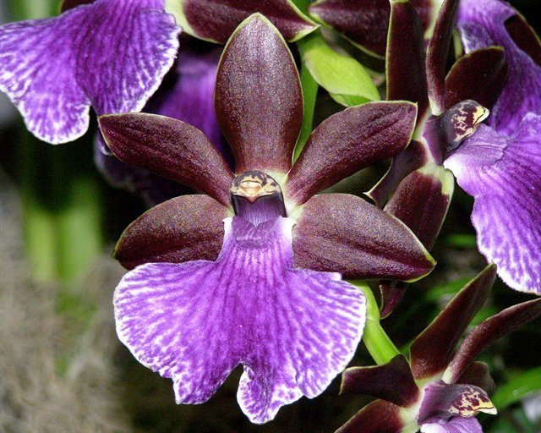
Zygopetalum Artur Elle is a cross betyween Z Blackii and Z B G White. It was created in 1969 by Wichmann Orchids and got its first of 27 awards in 1973 with a HCC in San Francisco. It has 1 FCC, 9 AM, 8 HCC and 3 Silver Medals. It has 56 F-1 offspring and a total of 148 progeny in 5 generations. It is part of a large number of complex hybrid genera. The purple lip color of Z crinitum expresses itself in most of its offspring.

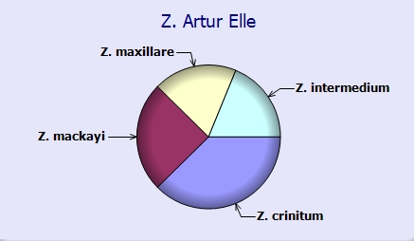

Zygoneria Adelaide Meadow ‘Braeburn’ AM/AOS
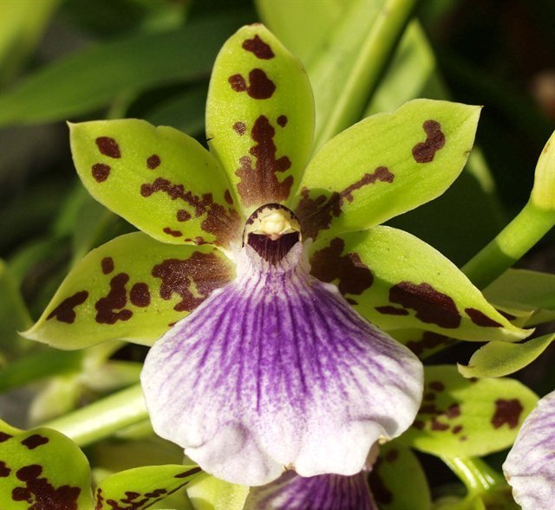
The hybrid Zygoneria Adelaide Meadows is a cross between Z Titanic and Zga Dynamo which is in turn a cross with Neogardneria murrayana. The hybrid displays the strong purple color in the wide lip and spotting on the sepals and petals from its Zygopetalum crinitum ancestery. It has been awarded 25 times with 6 AM, 18 HCC and a JC. It has 26 F-1 and 43 total progeny. It is part of many complex intergeneric crosses.

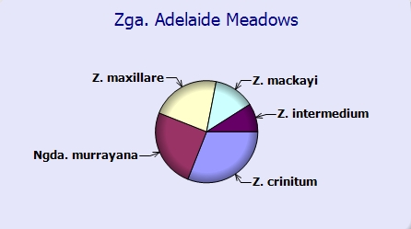

Desirable characteristics which can be passed to progeny:
Great color and form, resilient purple lip color, spotted sepals and petals.
Undesirable characteristics which can be passed to progeny:
No information was found.

Other information:

Zygopetalum (zy-go-PET-al-lum)
crinitum (krin-EE-tum)

References:
Aldridge, Peggy, 2008, An Illustrated Dictionary of Orchid Genera
Pridgeon AM, Cribb PJ, Chase MW, Rasmussen FN. 2009. Genera orchidacearum, Vol. 5.
www.orchidspecies.com
http://apps.kew.org/wcsp/qsearch.do
https://secure.aos.org/aqplus/SearchAwards.aspx
OrchidWiz.Database X3.2
Kusber, Leo J.. 1998. Zygopetalums, spectacular colors and patterns combined with fragrance add up, Orchids 67:240-245

