BUILDING BLOCK DATA

Species: Zygopetalum maculatum (Kunth) Garay 1970

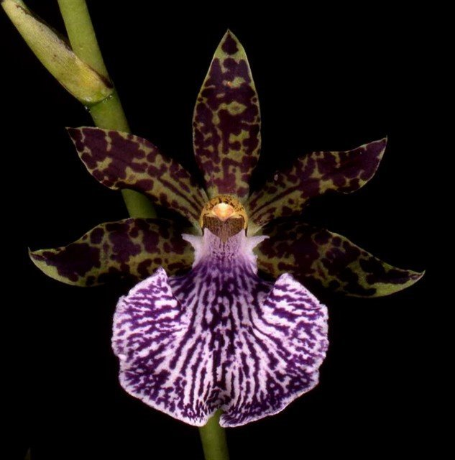
Found in Peru, Bolivia and Brazil in flat, very wet, moss-covered, semi-boggy areas at elevations of 1100 to 2250 meters as a small sized, cool to cold growing epiphyte with ovoid, smooth pseudobulbs arising after blooming and carry 2 apical, lanceolate, acute-acuminate, somewhat thick, plicate leaves that blooms in the spring on an erect-arching, scapose, racemose, 16" [40 cm] long, 8 to 12 flowered inflorescence arising with a new growth and has several large, remote, tubular bracts and large, subinflated, broadly ovate, acute floral bracts and carry large, showy, fragrant, campanulate flowers

Synonyms:
Broughtonia maculata (Kunth) Spreng. 1826; *Dendrobium maculatum Kunth 1815; Maxillaria maculata (Kunth) Lindl. 1832

Awards:

Origin | HCC | AM | FCC | 1st | CCE | CCM | Total
 | 3 | 6 | 0 | 0 | 1 | 6 | 20
Years | 1989-2002 | 1971-2001 |  |  | 1973 | 1978-2005

Hybrids: Total of 469 to the 6th generation

Generation | Before 1940 | 1940-49 | 1950-59 | 1960-69 | 1970-79 | 1980-89 | 1990-99 | 2000-10 | After 2010
F-1 | 9 | 2 | 2 | 1 | 4 | 4 | 13 | 11 | 4
F-1 Awards | 0 | 0 | 7 | 0 | 4 | 5 | 5 | 5 | 1
F-1 – F-6 | 15 | 2 | 2 | 3 | 6
F-1 – F-6  Awards | 0 | 0 | 7 | 36 | 7

Outstanding progeny and reason they are considered outstanding:

Zygopetalum Artur Elle HCCAOS
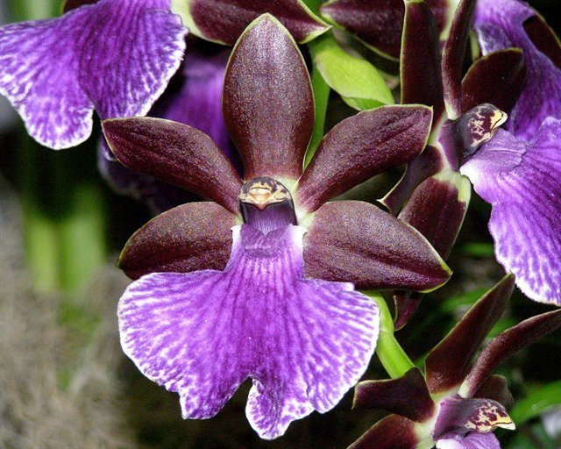
Zygopetalum Artur Elle is a cross betyween Z Blackii and Z B G White. It was created in 1969 by Wichmann Orchids and got its first of 27 awards in 1973 with a HCC in San Francisco. It has 1 FCC, 9 AM, 8 HCC and 3 Silver Medals. It has 56 F-1 offspring and a total of 148 progeny in 5 generations. It is part of a large number of complex hybrid genera. The purple lip color of Z crinitum and Z maculatum expresses itself in most of its offspring.

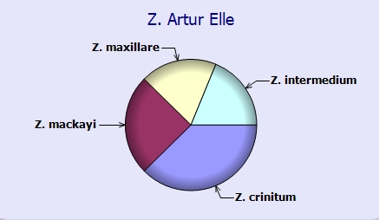

Zygoneria Adelaide Meadow ‘Braeburn’ AM/AOS
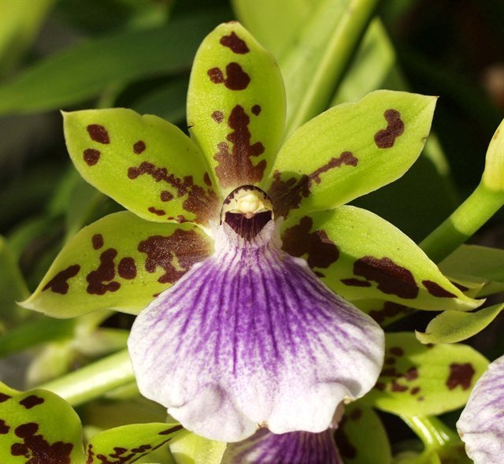
The hybrid Zygoneria Adelaide Meadows is a cross between Z Titanic and Zga Dynamo which is in turn a cross with Neogardneria murrayana. The hybrid displays the strong purple color in the wide lip and spotting on the sepals and petals from its Zygopetalum crinitum and Z maculatum ancestery. It has been awarded 25 times with 6 AM, 18 HCC and a JC. It has 26 F-1 and 43 total progeny. It is part of many complex intergeneric crosses.

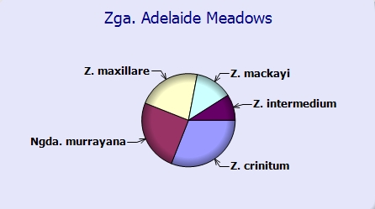

Desirable characteristics which can be passed to progeny:
Great color and form, resilient purple lip color, spotted sepals and petals.
Undesirable characteristics which can be passed to progeny:
No information was found.

Other information:

Zygopetalum (zy-go-PET-al-lum)

References:
Aldridge, Peggy, 2008, An Illustrated Dictionary of Orchid Genera
Pridgeon AM, Cribb PJ, Chase MW, Rasmussen FN. 2009. Genera orchidacearum, Vol. 5.
www.orchidspecies.com
http://apps.kew.org/wcsp/qsearch.do
https://secure.aos.org/aqplus/SearchAwards.aspx
OrchidWiz.Database X3.2
Kusber, Leo J.. 1998. Zygopetalums, spectacular colors and patterns combined with fragrance add up, Orchids 67:240-245

