BUILDING BLOCK DATA

Species: Zygopetalum maxillare Lodd. 1832

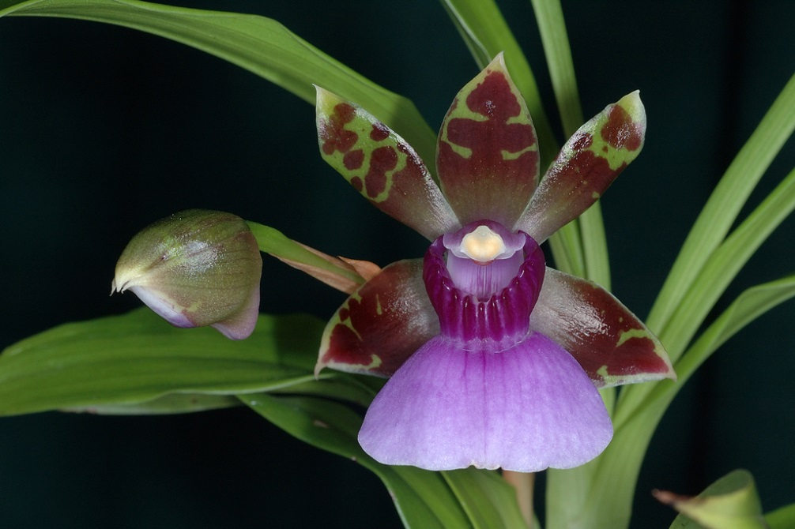
Found in montane rainforests in southeastern Brazil and Paraguay, this small to medium sized, cool to warm growing epiphyte occurs at elevations of 600 to 1000 meters with ovoid, slightly compressed pseudobulbs carrying 2 to 3, apical, conspicuously veined, narrowly lanceolate, subacuminate leaves that blooms on a lateral, to 15" [37 cm]long, racemose, several [5 to 8] flowered inflorescence with fragrant, waxy, long-lived flowers occuring in the summer in Brazil.

Synonyms:

Eulophia maxillaris (Lodd.) G.Don 1850; Zygopetalum gautieri Lem. 1867; Zygopetalum hasslerianum Krnzl. 1906; Zygopetalum mandibulare Rchb.f 1877; Zygopetalum maxillare var gautieri [Lem]Regel 1869; Zygopetalum maxillare var sanderianum [Regel] Cogn. 1902; Zygopetalum sanderae Sander 1927 ; Zygopetalum sanderianum Regel 1888

Awards:

Origin | HCC | AM | FCC | CBM | CHM | CCM | Total
 |  |  |  | 1 | 1 | 2
Years |  |  |  | 1967 | 1983 | 1980, 1986

Hybrids: Total of 462 to the 6th generation

Generation | Before 1940 | 1940-49 | 1950-59 | 1960-69 | 1970-79 | 1980-89 | 1990-99 | 2000-10 | After 2010
F-1 | 13 | 1 | 0 | 1 | 3 | 4 | 4 | 8 | 0
F-1 Awards | 2 | 0 | 0 | 9 | 0 | 6 | 7 | 3 | 0
F-1 – F-6 | 20 | 1 | 1 | 2 | 5 | 21 | 133 | 189 | 77
F-1 – F-6  Awards | 4 | 0 | 7 | 36 | 3 | 40 | 150 | 101 | 15

Outstanding progeny and reason they are considered outstanding:

Zygopetalum Artur Elle AM/AOS
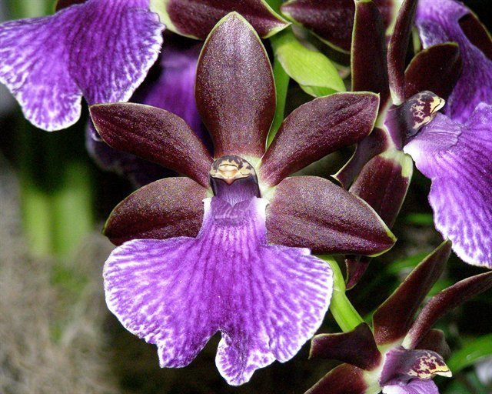
Zygopetalum Artur Elle is a cross betyween Z Blackii and Z B G White. It was created in 1969 by Wichmann Orchids and got its first of 27 awards in 1973 with a HCC in San Francisco. It has 1 FCC, 9 AM, 8 HCC and 3 Silver Medals. It has 56 F-1 offspring and a total of 148 progeny in 5 generations. It is part of a large number of complex hybrid genera. The purple lip color of Z crinitum and Z maculatum expresses itself in most of its offspring.

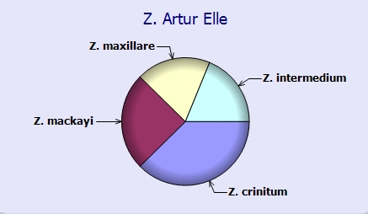

Zygoneria Adelaide Meadow ‘Braeburn’ AM/AOS
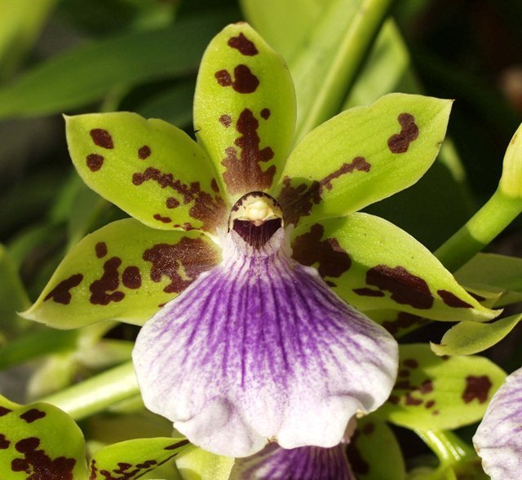
The hybrid Zygoneria Adelaide Meadows is a cross between Z Titanic and Zga Dynamo which is in turn a cross with Neogardneria murrayana. The hybrid displays the strong purple color in the wide lip and spotting on the sepals and petals from its Zygopetalum crinitum and Z maculatum ancestery. It has been awarded 25 times with 6 AM, 18 HCC and a JC. It has 26 F-1 and 43 total progeny. It is part of many complex intergeneric crosses.

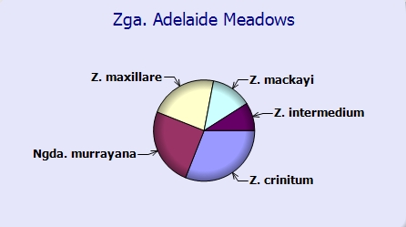

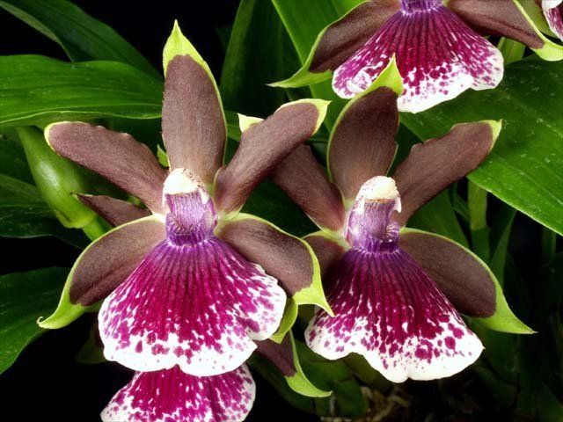
Zygolum Louisendorf grex ‘Solana Beach HCCAOS

Desirable characteristics which can be passed to progeny:
Great color and form, resilient purple lip color, solid color sepals and petals.
Undesirable characteristics which can be passed to progeny:
No information was found.

Other information:

Zygopetalum (zy-go-PET-al-lum)

References:
Aldridge, Peggy, 2008, An Illustrated Dictionary of Orchid Genera
Pridgeon AM, Cribb PJ, Chase MW, Rasmussen FN. 2009. Genera orchidacearum, Vol. 5.
www.orchidspecies.com
http://apps.kew.org/wcsp/qsearch.do
https://secure.aos.org/aqplus/SearchAwards.aspx
OrchidWiz.Database X3.2
Kusber, Leo J.. 1998. Zygopetalums, spectacular colors and patterns combined with fragrance add up, Orchids 67:240-245

