Aganisia Species Data

SPECIES PROGENY AWARDS AWARD TYPE RANGE TEMP/LHT BLOOM TIME
F-1/Total Peak
cyanea | 26/71 | 15 | 6 AM, 1 AV1, 1AV2, 1 CBE, 1 CBM, 1 CCM, 1 FCC, 2 HCC | Bra, Col, Ven | Lo/Warm-Hot | July
fimbriata | n/a | 0 |  | Bra, Guy, Sur, Ven, Col, Ecu, Peru | Lo/Hot | No data
pulchella | 2/2 | 0 |  | Trin, Fr Gui, Guy, Sur, Ven, Bra | Lo/Hot | November
rosariana | 0 | 0 | No Data | No Data | No Data | No Data

Type species:

Building Block Species

Aganisia is a minor genus with a total of 74 registered grexes It has been used in a large number of intergeneric crosses including Hamelwellsara ( Agn x Btmna x Otst x Z x Zspm), Agasepalum (Agn x Zspm), Bifranesia ( Agn x Bif), Zygonisatoria ( Agn x Pes x Z), among many others. Its two claims to fame are Hamelwellsara Jume with 9 awards and Pabanisia Eva’s Blue Amazon with 8 awards.

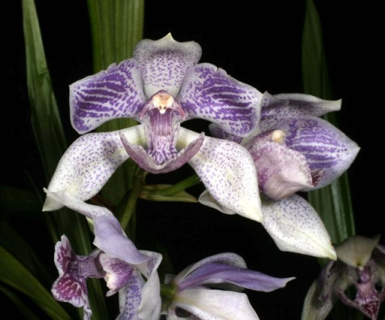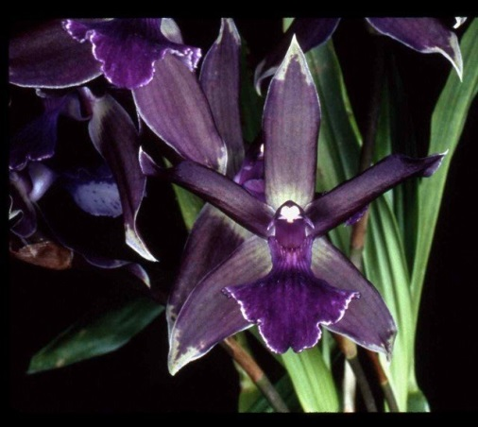

Pabanisia Eva’s Blue Amazon Hamelwellsara June ‘Indago Sue’ AM/AOS

