Aganisia cyanea AM/AOS 88 Points
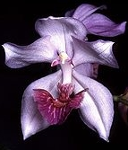
Twelve flowers and three buds on three inflorescences; sepals and petals lavender-blue, darker purple on reverse; lip pale lavender basally, deep red-violet distally, veined white; callus yellow, column wings intense lavender; substance firm; texture crystalline.

Bifrenaria harrisoniae HCC/AOS 76 Points
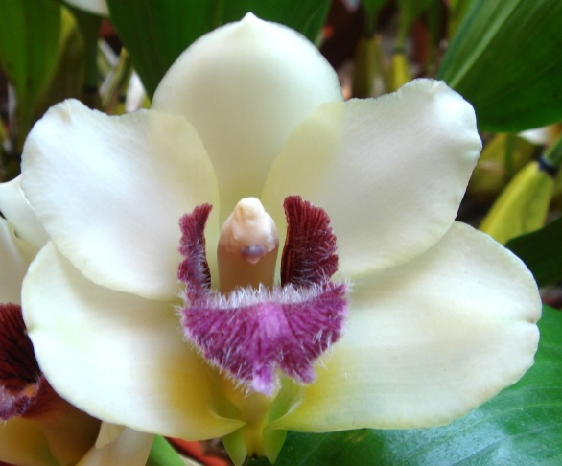
Five flowers and two buds on two inflorescences; sepals and petals ivory-white; lip mauve, midlobe hairy, side lobes deeper purple, callus light orange; column light orange, anther cap white; substance medium; texture matte.

Maxillaria sanderiana AM/AOS 85 Points
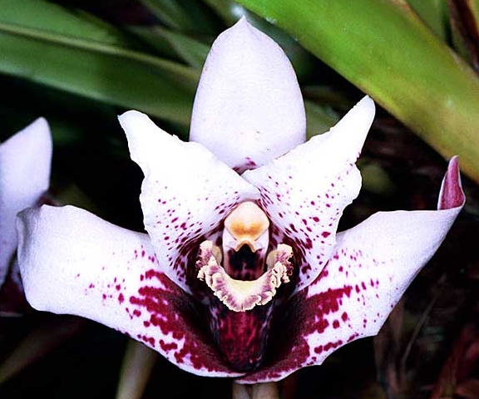
Six flowers and 4 buds on eight inflorescences; sepals and petals white, splashed and spotted maroon basally; lip cream-white, edge and side lobes flushed maroon, column white, anther cap golden yellow; substance heavy; texture matte.

Pescatoria lehmannii CCM/AOS 83 Points
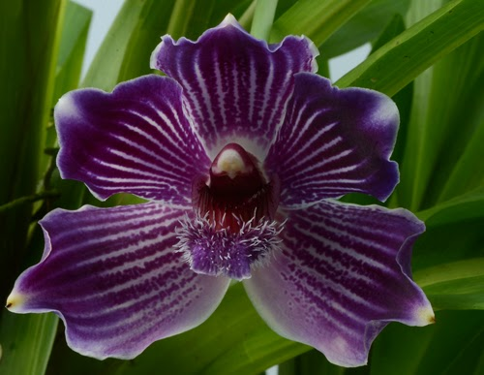
Twenty flowers on twenty inflorescences symmetrically arranged around a 25 cm growth in a 20 cm basket of sphagnum moss; sepals and petals white, heavily infused grape-purple, striped white; lip lighter purple, heavily papillose; column white, suffused purple basally, anther cap cream; substance medium; texture matte.

Promenaea Meadow Gold AM/AOS 81 Points
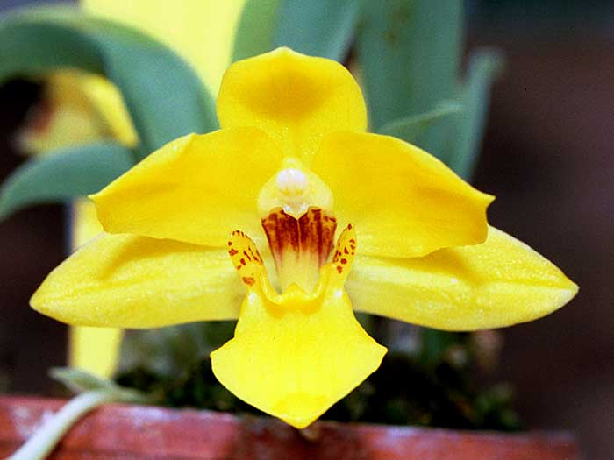
Thirty five flowers and four buds on thirty six inflorescences; sepals and petals rich yellow; lip yellow, side lobe margins dotted maroon; column maroon, anther cap yellow, cream distally, substance medium; texture crystalline.

