Bifrenaria Lindl., Gen. Sp. Orchid. Pl, 152 (1832).
Type species: Bifrenaria atropurpurea (Lodd.) Lindl.
Description: Epiphytic, lithophytic or rarely terrestrial, sympodial herbs to 60 cm tall, caespitose to long-rhizomatous. Roots cylindrical, velamentous, glabrous. Rhyzomes rigid. pseudobulb erect, often quadrangular, pyramidal, compressed, usually with a black or dark-purple ring at apex, unifoliate, becorning irregularly wrinkled with age. Leaves distichous, membranaceous to coriaceous, plicate, lanceolate to oblong, acuminate, attenuate at base forming a pseudopetiole, with convolute vernation. lnﬂorescence racemose, lateral, erect or pendent, 1-10-flowered, subtended by scarious, brownish, membranaceous to coriaceous, acuminate or truncate bracts; ﬂoral bracts similar to or smaller than scape bracts. Flowers resupinate, zygomorphic, fragrant or not, of various colours, often long-lived. Sepals concave, ovate, rarely lanceolate or oblong, rarely attenuate or mucronate, lateral sepals parallel to column or divergent, sometimes basally prolonged into a spur that is fused to the column foot. Petals obovate, rarely rhombic or lanceolate, asymmetric and always smaller than sepals. Labellum mobile, entire to trilobed, lan- ceolate to obovate, attached to column foot by a straight (rarelyrecurved) claw, lateral lobes involute, enfolding the column, mid-lobe deflexed (rarely straight), glabrous to pubescent, with entire, undulate to crenate margins; callus ligulate from labellum base to middle, distal portion protuberant, entire to trilobed, glabrous to papillose or pubescent. Column clavate, fleshy, arcuate, with attenuate (rarely apiculate) apex, glabrous to pubescent, basally prolonged to form a column foot, straight to arched, glabrous to pubescent; anther galeate, four-celled, terminal, incumbent, anther cap papillose, pollinia four, cartilaginous, ﬂattened, ovate to round, in two superposed unequal pairs, tegular stipe strap-shaped, two or biﬁd (rarely simple); stigma concave, ovoid, entire; viscidium prominent, basally acute, cuneate or truncate. Ovary sulcate, straight to curved. Capsule erect or pendent, green, with persistent perianth parts.

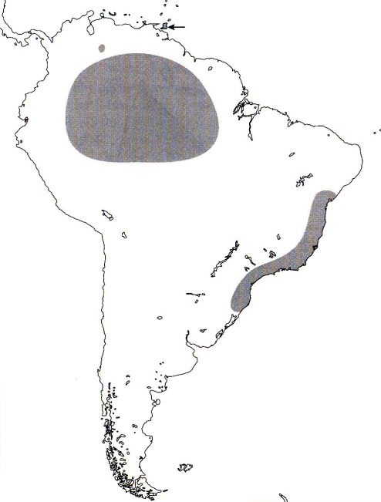
Distribution:

Reference:
Pridgeon AM, Cribb PJ, Chase MW, Rasmussen FN. 2009. Genera orchidacearum, Vol. 5.

