Pescatoria Species Data

SPECIES PROGENY AWARDS AWARD TYPE RANGE TEMP/LHT BLOOM TIME
F-1/Total Peak
cerina | 12/21 | 11 | 3 AM, 3 CCM, 4 HCC | Costa Rica to Colombia | Lo/Warm | June
coelestis | 8/12 | 33 | 7 AM, 9 AWD, 1 BM, 1 CBM, 1 CCE, 5 FCC, 4 CCM | Colombia | Lo/Cool-Wrm | August
coronaria | 9/12 | 5 | 4 AM, 1 CHM | Colombia | Lo/Cool-Wrm | March-April
lehmannii | 9/15 | 24 | 8 AM, 9 AWD, 1 BM, 2 CCM, 1 CHM, 3 HCC | Colombia & Ecuador | Lo/Warm | March & Oct
violacea | 8/16 | 7 | 2 AM, 1 CBR, 3 CCM, 1 HCC | N S America | Lo/Hot | May

Type species:

Building Block Species

Pescatoria coelestis Pescatoria cerina Pescatoria lehmannii

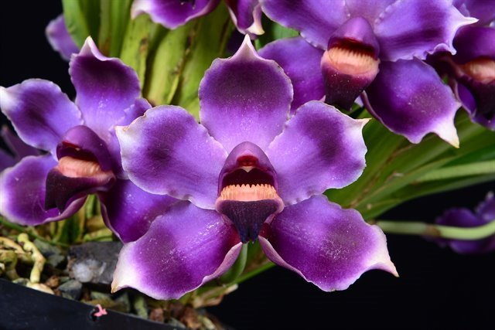
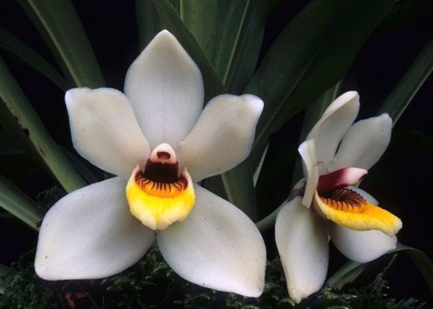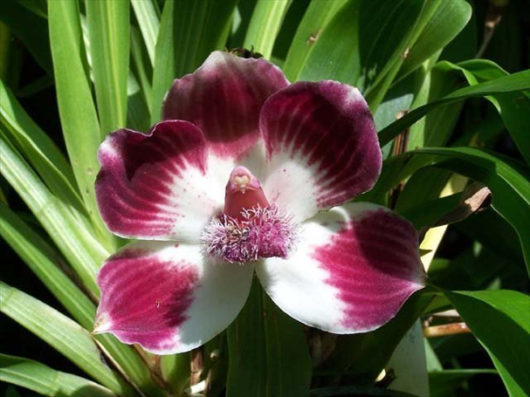

Pescatoria is another minor genus that has beautiful, colorful flowers, but is not particularly fertal within the genus or in intergeneric hybrids. Most hybrids are with Warczewiczella. Most of the awards have been given to the species.

