Promenaea Species Data

SPECIES PROGENY AWARDS AWARD TYPE RANGE TEMP/LHT BLOOM TIME
F-1/Total Peak
ovatiloba | 3/20 | 2 | 1 CCM, 1 CHM | Brazil | Lo/Cool-wrm | April
rollissonii | 3/17 | 3 | 1 CBR, 1 CHM, 1 CBR | Brazil | Lo/Cool-wrm | Jul-0Aug
stapelioides | 21/80 | 15 | 5 AM, 1 CBM, 5 CCM, 2 HCC, 2 JC | Brazil | Lo/Cool-wrm | July
xanthina | 21/106 | 17 | 1 AM, 3 CBM, 1 CCE, 5 CCM, 2 CHM, 2 HCC | Brazil | Lo/Cool-wrm | June

Type species: Promenaea lentiginosa

Building Block Species

Promensaea ovatiloba P. rollissonii P. stapelioides P. xanthina
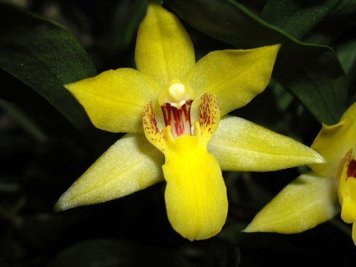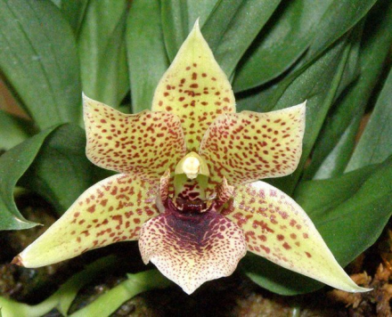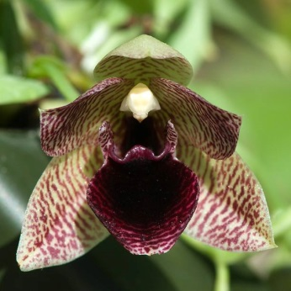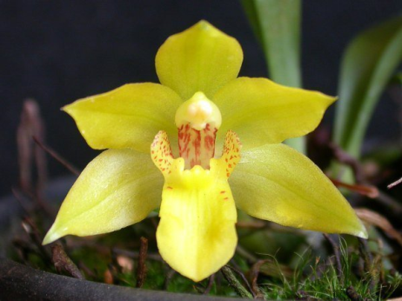

Promenaea is a small genus of attractive flowering plants that has not been very successful in hybridization. It has been experimented with quite a lot in intergeneric crosses, but none have gone anywhere.

