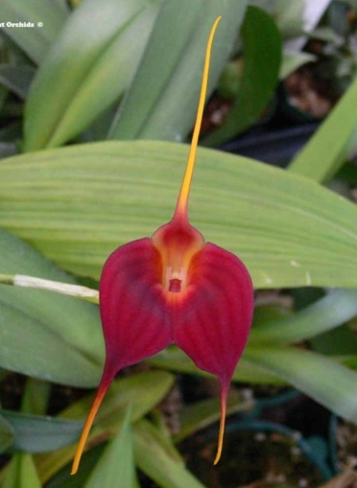
Masdevallia Redwing HCC/AOS 77 Points
Four flowers and 2 buds on six inflorescences; dorsal sepal center red ,grading to red-orange at margins, lateral sepals deep garnet red, veined darker red, caudae grading to gold yellow distally; substance firm; texture velvet.

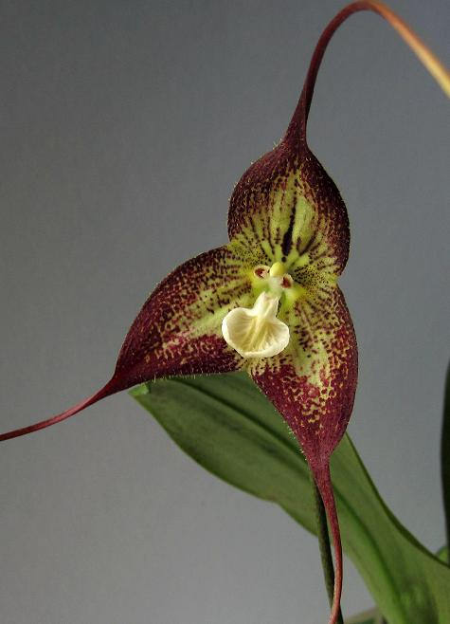
Dracula Phantom HCC/AOS 76 Points
Two flowers and one bud on three pendant inflorescences; sepals cream, overlaid red-brown becoming spotted basally, caudae cupped; lip cream, overlaid pink, translucent; substance firm; texture pubescent.

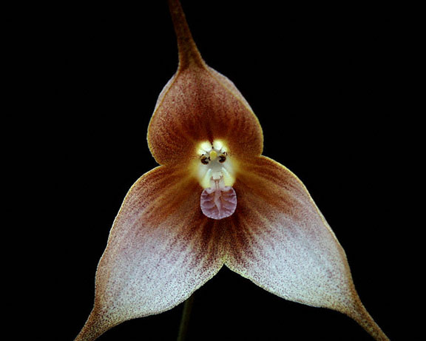
Dracula gigas AM/AOS 81 Points
One flat flower on one inflorescence held well above foliage; sepals pale yellow basally, heavily overlaid with red-brown hairs; lip translucent pink, pleated; substance light; texture matte.

