BUILDING BLOCK DATA
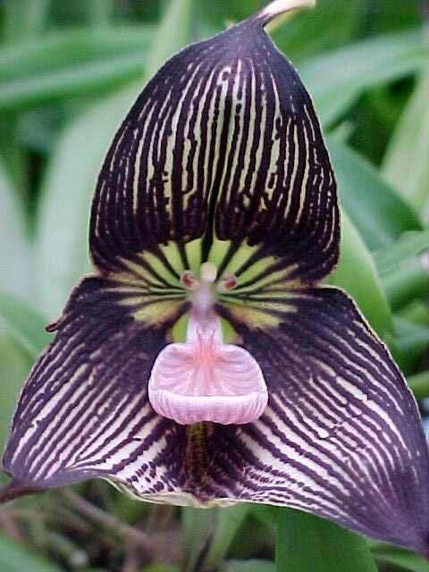
Species Dracula vampira Luer (Luer)
Distribution: Ecuador, western slopes of Mount Pichincha, Pichincha Province/
Habitat: Cloud Forest at 5900 – 7200 ft.. Plants are common in good habitat.

Synonyms: Masdevallia vampire Luer

Awards:

Origin | HCC | AM | FCC | JC | CHM | CCM | Total
 | 2 | 12 | 3 |  |  | 2 | 19
Years | 1983-2011 | 1983-2015 | 1978-2004 |  |  | 1984 - 1992

Other awards and when given:

Hybrids: F-1
Before  1940 | 1940-49 | 1950-59 | 1960-69 | 1970-79 | 1980-89 | 1990-99 | After 1999
0 | 0 | 0 | 0 | 0 | 2 | 5 | 15
In primary crosses, Dracula vampira has been the seed parent 9 times and pollen parent 4 times. The most awarded primary, with Dracula robledorum, is Dracula Nightshade with 5 awards. Following close behind is Dracula Transilvania ( with Dracula gigas) with 3 awards.

Hybrids: Progeny
Before  1940 | 1940-49 | 1950-59 | 1960-69 | 1970-79 | 1980-89 | 1990-99 | After 1999
0 | 0 | 0 | 0 | 0 | 2 | 5 | 18

Dracula vampira hybridizes with Masdevallia and Porroglossum. All of its hybrids, are first and second generation.

Outstanding progeny and reason they are considered outstanding:

Dracula Ravin FCC/AOS
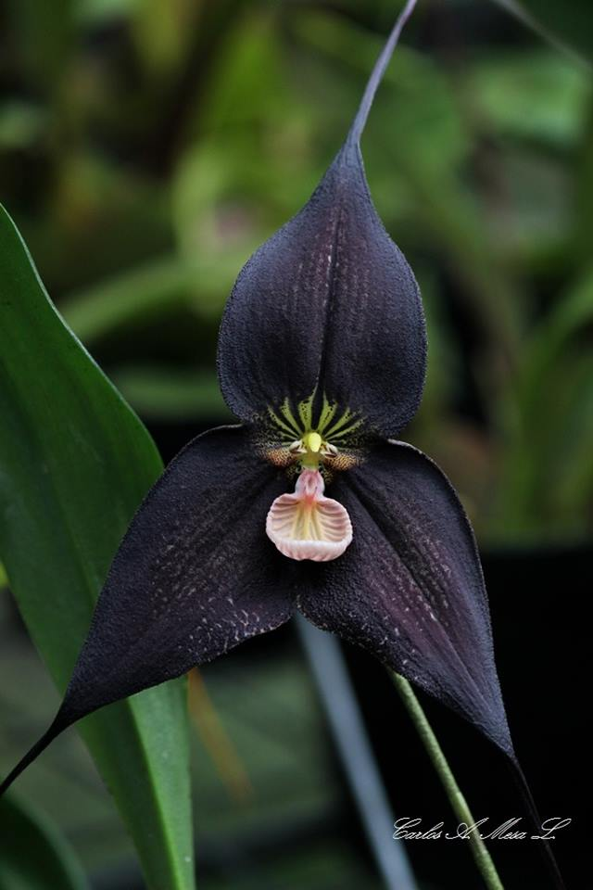
This is a Primary with Dracula roezlii. It has 7 AOS awards including an FCC in 2016. The FCC had 2 flowers and 12 buds on 14 inflorescences, an amazing feat considering the difficulty of growing these and getting them to a show intact.

Dracula Phantom AM/AOS
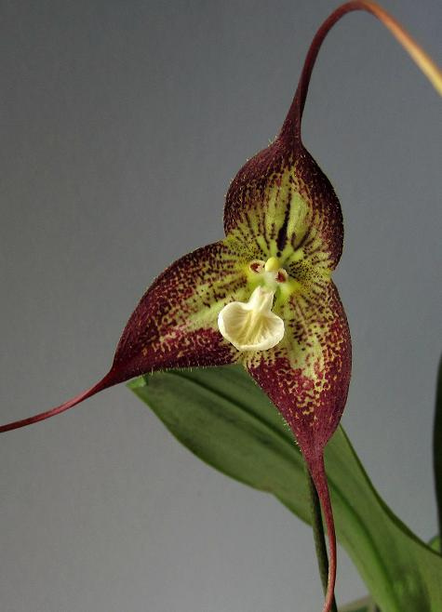
This is another Primary, this time with Dracula tubeana. This cross received 5 AOS awards including 2 AM, 2 HCC and a CCM. None of the Draculas are particularly prolific. This grex has only one progeny with Dracula polycrater making Dracula Don Garling AM/AOS

Desirable characteristics which can be passed to progeny:
Deep, rick purple coloration, nice striping, fantastic symmetrical form.

Undesirable characteristics which can be passed to progeny:
Extremely intolerant of heat and changes in environment, Difficult getting these to judging.

Other information:

References:

Aldridge, Peggy, 2008, An Illustrated Dictionary of Orchid Genera

Chase MW. 2009. Subtribe Oncidiinae. In: Pridgeon AM, Cribb PJ, Chase MW, Rasmussen F, eds. Genera Orchidacearum, Vol. 5. Oxford: Oxford University Press, 211–394.

Gettel, Steve. 1998. Back to Basics: Dracula emerges from the shadow of Masdevallia as a separate genus, volume 67. Orchids, 1020 – 1025.

Hermans, Johan; Hermans, C. 1996. Dracula’s daughter lost and found in England,
volume 65. Orchids 1: 1278 - 1283.

Luer, Carlyle A. 1979. The genus Dracula, volume 48. American Orchid Society Bulletin, 702 - 709.

www.orchidspecies.com
http://apps.kew.org/wcsp/qsearch.do
https://secure.aos.org/aqplus/SearchAwards.aspx
OrchidWiz.Database X3.3

