BUILDING BLOCK DATA
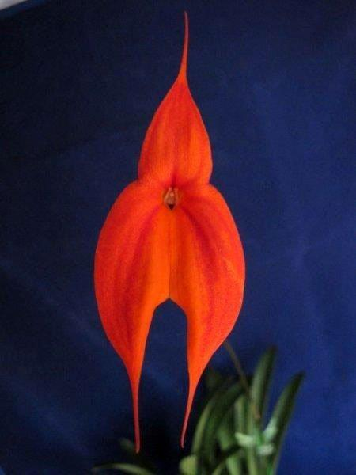

Species Masdevallia veitchiana Rchb.f.

Distribution/Habitat: Peru. Plants grow near Cuzco in humus-filled crevices between rocks at 11,000-13,000 ft. (3350-3950 m). They also occur at 7200-8850 ft. (2200-2700 m) on the sunny banks of the walls of the Inca ruins at Machu Picchu, Huayna Picchu, and Vinay Huayna. Although once plentiful at these sites, collectors have virtually exterminated the species in these areas. In the habitat, plants commonly grow fully exposed to the tropical sun. Source: Charles Baker.

Awards:

Origin | HCC | AM | FCC | JC | CCM | CCM | Total
 | 4 | 15 | 2 | 2 |  | 2 | 26
Years | 1973-1994 | 1970-2015 | 1984-2010 | 1858-1976 | 1979-1980 | 1979-1980

Other awards and when given:
1 AQ - 2011

Hybrids: F-1
Before  1940 | 1940-49 | 1950-59 | 1960-69 | 1970-79 | 1980-89 | 1990-99 | After 1999
17 | 0 | 0 | 0 | 2 | 12 | 62 | 48
In primary crosses, Masdevallia veitchiana has been the seed parent 81 times and pollen parent 79 times. The most awarded primary, with Masdevallia triangularis, is Masdevallia Copper Angel with 47 awards. Following close behind is Masdevallia Falcata ( with M. coccinea) with 46 awards.

Hybrids: Progeny
Before  1940 | 1940-49 | 1950-59 | 1960-69 | 1970-79 | 1980-89 | 1990-99 | After 1999
23 | 0 | 0 | 0 | 2 | 27 | 268 | 472

Masdevallia veitchiana hybridizes with Dracula, Diodonopsis, Porroglossum and other Masdevallias. Its hybrids run to 5 generations.

Outstanding progeny and reason they are considered outstanding:

Masdevallia Copper Angel AM/AOS

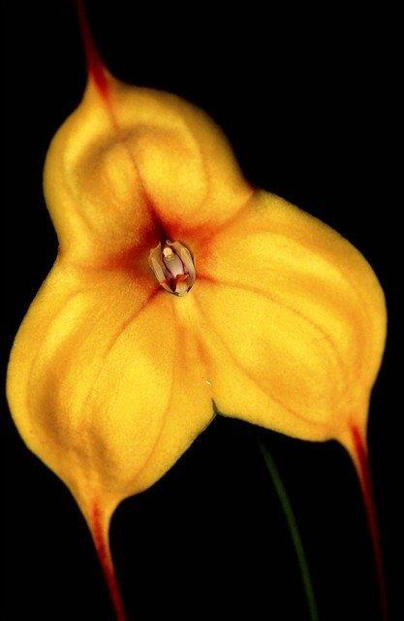
This is a Primary with Masdevallia triangularis. It has 30 AOS awards including 14 AM and a boatload of cultural awards. It has 71 F-1 offspring and a total progeny of 169. Its progeny have been awarded 355 times. The intensity of color and wonderful form makes the high award number no surprise.

Dracula Phantom AM/AOS
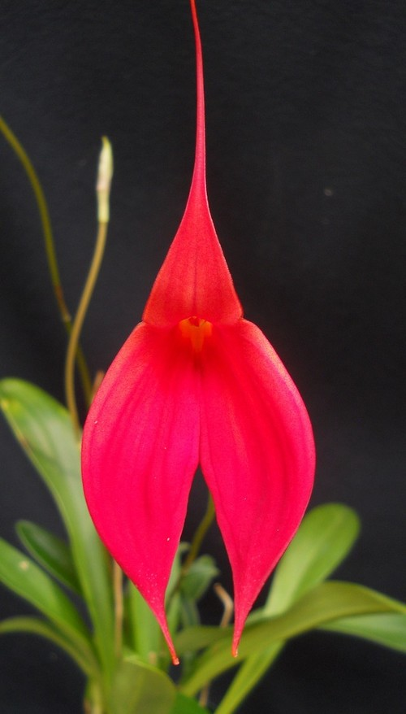
This is another Primary, this time with Masdevallia coccinea. This cross received 21 AOS awards including an FCC in 1991. It has 40 F-1 offspring and a total progeny of 104. Its progeny have been awarded 156 times. Again, the color intensity of this grex is incredable.

Desirable characteristics which can be passed to progeny:
Intense color and slender, symmetrical form are passed on to most progeny. The purple suffusion in its flower actually consists of many tiny purple hairs. These hairs often appear on the hybrids enhancing the color. M. veitchiana can enhance shape when crossed with cupped species like M. infracta.

Undesirable characteristics which can be passed to progeny:
Tends to produce hybrids with tall but weak stems. The flowers can present themselves in “an awkward manner”.Intolerant of heat and changes in environment, Difficult to grow in warmer, drier parts of the world.

Other information:

References:

Aldridge, Peggy, 2008, An Illustrated Dictionary of Orchid Genera

Chase MW. 2006. Tribe Epidendreae. In: Pridgeon AM, Cribb PJ, Chase MW, Rasmussen F, eds. Genera Orchidacearum, Vol. 4. Oxford: Oxford University Press, 367-371.

Collantes, Benjamin; Leon, M.;Moscoso, D. 2003. <asdevallia veitchiana, morphological variation of this showy species and it’s conservation in the historic sanctuary of Machu Pichu, volume 72, Orchids, 832-837.

Head, Cordelia; Webb, M; Winn, L. 1983. Masdelavvoa veitchiana in modern hybridizing, volume 52. American Orchid Society Bulletin, 237-242.

www.orchidspecies.com
http://apps.kew.org/wcsp/qsearch.do
https://secure.aos.org/aqplus/SearchAwards.aspx
OrchidWiz.Database X3.3

