Stelis quadrifida CCM/AOS 84 Points
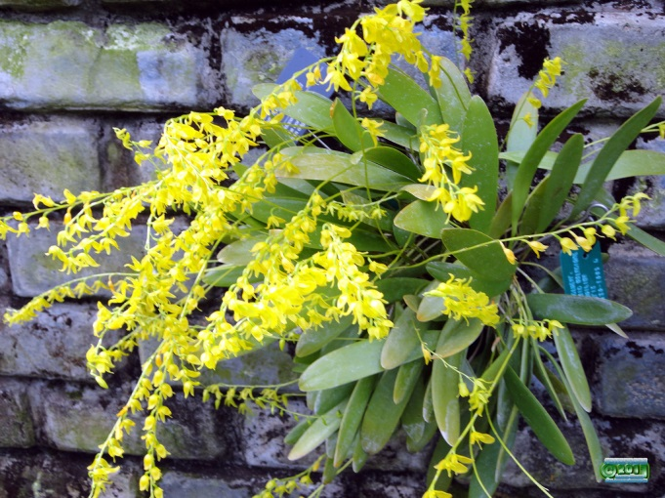
Six hundred and forty flowers and 27 bud on 32 inflorescences on a well grown specimen on a 20cm x 20cm tree fern plaque; flowers bright yellow’ natural spread 0.3cm; lateral sepals fused entire length; substance light; texture diamond dust.

Pleurothallis marthae AM/AOS 81 Points
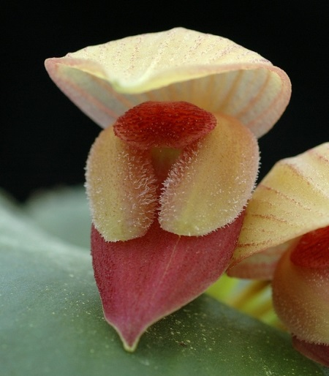
Fifty six flowers and seven buds on fifty two inflorescences; dorsal sepal and petals cream, faintly striped pale orange; lateral sepals cream, fused, sparsely pubescent; lip coral; substance firm; texture matte.

Lepanthes telipogoniflora HCC/AOS 77 Points
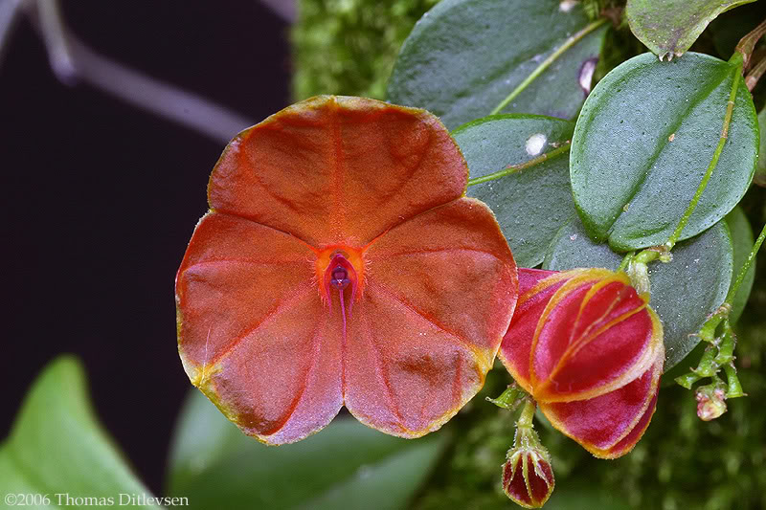
One round, flat flower and one bud on two pendant inflorescences; sepals fused, red-orange, margins gold-yellow; petals minute, dark red; lip dark red; column red, anther cap purple; substance firm; texture crystalline.

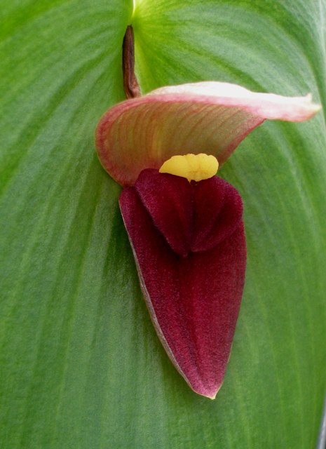
Pleurothallis gargantuan HCC/AOS 78 Points
One large flower on one inflorescence emerging from center of leaf; dorsal sepal hooded, cream overlaid with coral-pink striations; lateral sepals fused, tongue shaped, deep plum with darker striations at apex: lip plum, pale pink at apex; substance firm; texture velvety.

Stelis quadrifida AM/AOS 82 Points
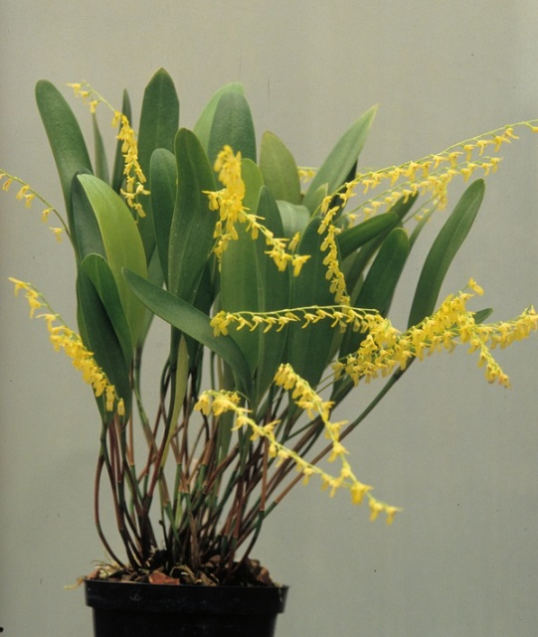
Three hundred and fifteen flowers on fourteen inflorescences presented within foliage; flowers lemon yellow; sepals fused for entire length; lip with bright green medial line; substance light, texture crystalline.

