Lepanthes Species Data

SPECIES PROGENY AWARDS AWARD TYPE RANGE TEMP/LHT BLOOM TIME
F-1/Total AOS Peak
cochearifolia | 3/3 | 0 |  | Jamaica | Lo/Warm | May
guatemalensis | 1/1 | 1 | 1 CHM | Mex, Guat, El Sal | Lo/Cool-Wrm | April
horrida | 1/1 | 2 | 1 CCM, 1 CBR | Costa Rica, Panama | Lo/Cool-Wrm | Feb Oct
pulchella | 2/2 | 0 |  | n/a | n/a | n/a
calodictyon | 3/3 | 3 | 1 CCE, 1 CHM | Ecuador, Colombia | Lo/Cool | Feb
telipogoniflora | 1/1 | 8 | 1 AM, 2 CCM, 3 CHM, 2 HCC | Colombia | Lo/Hot | Oct
Type species: Lepanthes ovalis Judging Scale- Pleurothallids

Lepanthes is a huge genus of over 1000 species. In spite of this, there are only 9 hybrids registered and only 1 intergeneric hybrid (Lepanthes x Lepanthopsis) Lepanopsis Michelle.

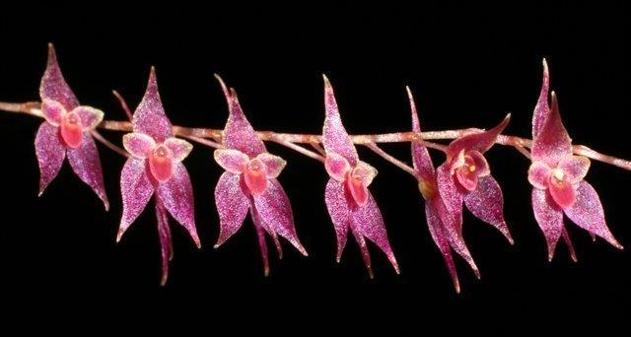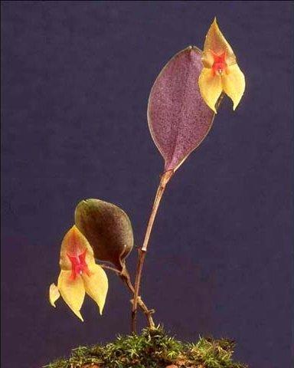

Lepanopsis Michelle 1993 Lepanthes Ayla HCC/AOS

