Lepanthes calodictyon Hooker (1861)
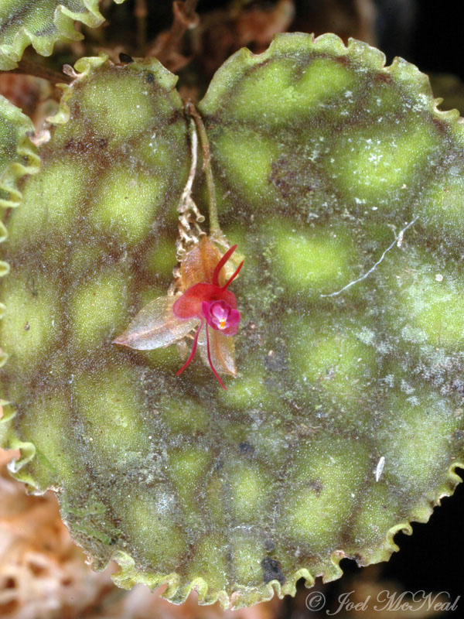
Synonyms: Stelis calodyction Spruce 1862
Description: Lepanthes calodycton has clustered erect ramicauls enveloped by 2 to 3, obconical, acute, ciliate lepanthiform sheaths and carrying a densely patterned, satiny, pendant, broadly ovate top, subcircular, obtuse or shortly apiculate leaf that is lime to emerald green and red in color with a congested, fasiculate, subsecund, shorter than the leaves, one to several flowered inflorescence that can occur at any time of the year with very small flowers that open in singly in sucession and needs high humidity, constant watering and fertilize
Distribution: Ecuador and Colombia. In Ecuador, this orchid has been found on the western slopes of the Andes in the provinces of Esmeraldas, Pichincha, Cotopaxi, and Bolívar at elevations of (750-1400 m). Collections have been reported from wet forests and from citrus trees. In Colombia, plants are found below 3300 ft. (1000 m) in the Western Cordillera of the Andes in the departments of Antioquia and Valle del Cauca. -- Source: Charles Baker

Hybrids:
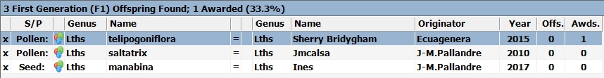
Lepanthes calodycton has been crossed with three other Lepanthes species. None of them have gone on to a second generation and only one, Sherry Bridygham, has been awarded. It received an HCC in 2015.

