Pleurothallis Species Data

SPECIES PROGENY AWARDS AWARD TYPE RANGE TEMP/LHT BLOOM TIME
F-1/Total AOS Peak
gargantua | 4/4 | 5 | 2 AM, 3 HCC | Ecuador | Lo/Cool | February
marthae | 2/2 | 5 | 4 AM, 1 CHM | Colombia | Lo/Cool | N/d
nossax | 2/3 | 2 | 1 HCC, 1 CBR | Colombia | Lo/Cold | February
teaguei | 3/3 | 10 | 2 AM, 1 CBR, 1 CCE, 1 CHM, 1 HCC, 4 CCM | Ecuador | Lo/Warm | March
Type species: Pleurothallis ruscifolia Judging Scale – Pleurothallids.

Lepanthes is a large genus of over 636 species. In spite of this, there are only 12 hybrids registered and only 0 intergeneric hybrids.

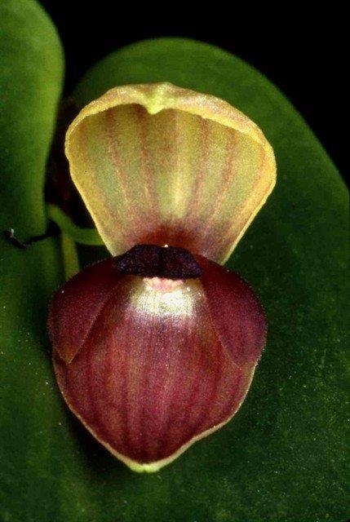

Pleurothallis Safsax HCC 2004 Pleurothallis Imp’s Pal HCC 1999

