Pleurothallis gargantuan Luer (1996)

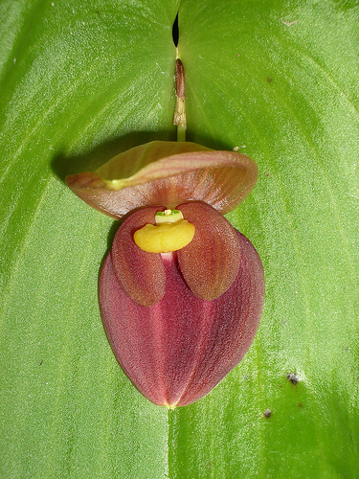
Synonyms: Acronia gargantua (Luer) Luer 2005
Description: Found in Ecuador as a large sized, warm to cool growing terrestrial orchid on steep forests at elevations around 1500 to 2500 meters with stout, erect ramicauls enveloped by 3 to 4 tubular sheaths and another below the middle and carrying a single, apical, spreading, coriaceous, broadly ovate, acute, basally sessile and deeply cordate leaf that blooms in the winter and spring on a short fascile of short, successive single flowered inflorescence arising through a spathe at the leaf base holding the flower close against the base of the leaf. This species flower is the largest of the genus and the other giant leafed relatives are P imperialis, P reginae, P colossus and P teaguei Source Jay Pfahl.
Distribution: Ecuador. This terrestrial orchid was discovered in Carchi Province where it was growing in a steep forest between Maldonado and Chical at 4900 ft. (1500 m). -- Source: Charles Baker
Awards: The species has been awarded 9 times between 2000 and 2015. The AOS has given 3 HCC and 2 AM. Germany has awarded 2 Bronze Medals and Australia a CBM.
Hybrids:
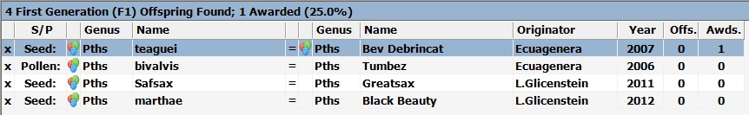
Pleurothallis gargantua has produced three primary crosses with other Pleurothallis species and one cross with Pleurothallis Safsax, a primary of P. ruberrima and P. nossax.

