Stelis Species Data

SPECIES PROGENY AWARDS AWARD TYPE RANGE TEMP/LHT BLOOM TIME
F-1/Total AOS Peak
argentata | 0/0 | 10 | 1 AM, 7 CCM, 2 CHM | S Mexico to Trop America | Cool-hot/Lo | Apr-Nov
cypriprdioides | 0/0 | 6 | 5 CCM, 1 CBR | Ecuador & peru | Hot/Lo | Sept
gelida | 0/0 | 8 | 1 CBM, 1 CBR, 1 CCE, 4 CCM, 1 CHM | FL, Carr, Central America, N S America | Warm/Lo | Feb, Nov
immersa | 0/0 | 6 | 1 AM, 2 CCM, 2 CHM, 1 HCC | Mex to N S America | Hot/Lo | Mar, Dec
kefersteiniana | 0/0 | 6 | 1 AM, 2 CCE, 1 HCC, 1 CHM, 1 CBR | Ven, Col, Ecu, Peru, Bol | Cool/Lo | Mar, Oct
quadrifida | 0/0 | 15 | 3 AM, 1 CBM, 1 CCE, 9 CCM, 1 CHM | Mex, C America, Col, Ven
Type species: Stelis purpurea Judging Scale: General because of non-labiate flowers different from most pleurothallids with caudae.

Stelis is a large genus of 982 species but has no registered hybrids. The most awarded species are listed above. Most awards are cultural.

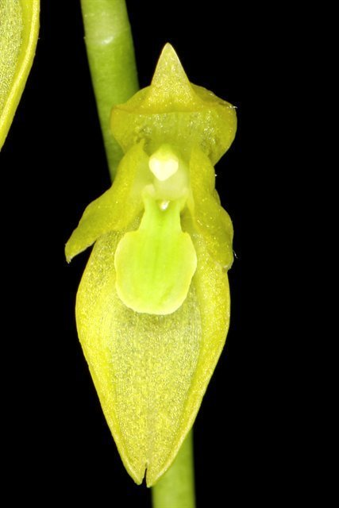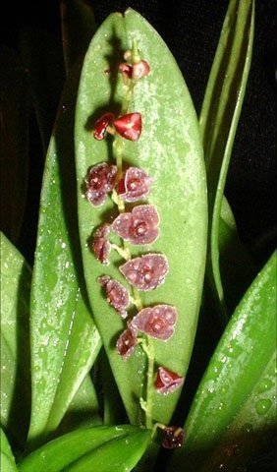

Stelis quadrifida AM/AOS Stelis argentata AM/AOS

