Stelis villosa (Knoweles & Westcott) Pridgeon & M. W. Chase 1838
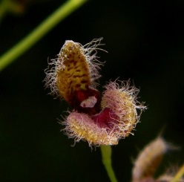
Synonyms: Pleurothallis villosa, Pleurothallis schiedei, Pleurothallis hirsute, Specklinia villosa
Description: As many as 6 leaves up to 2 cm long, Inflorescence loosely few-flowered, with one or two flowers open together. Sepals 5 to 7 mm long, yellow-green mottled with purple, with long purple hairs inside.
Ecology: The delicate flowers of Stelis show diverse adaptations to pollination by flies. Most flowers produce nectar, often visible as clear droplets, to reward their fly visitors. Many emit a mild attractive odor. Numerous species have light sensitive flowers that require direct sunlight to open. At night the flowers close completely, presumably to save valued fragrance compounds for the next day. The flowers are programmed to release fragrance when their pollinators are active. Cues other than scent may be employed, for example, S. villosa captures the attention of flies with icicle-like waxy strings that hang from its sepals, swaying in the faintest breeze.
Distribution: Mexico, Guatemala, Honduras, and El Salvador. In Mexico, plants are found in the states of Guerrero, Jalisco, Mexico, Michoacan, and Morelos. They grow in oak, oak-pine, or mixed deciduous forest, which grow on lava-flows, and in the mountains sloping toward the Pacific at 5900-8550 ft. (1800-2600 m). In the Guatemala provinces of Chiquimula and Huehuetenango, plants are found on trees and cliffs in dense mountain forests at elevations up to 9850 ft. (3000 m). In El Salvador, plants are found at 5100-6250 ft. (1550-1900 m). -- Source: Charles Baker.
Progeny: The genus Stelis has not been hybridized within the genus nor with any other genera.

