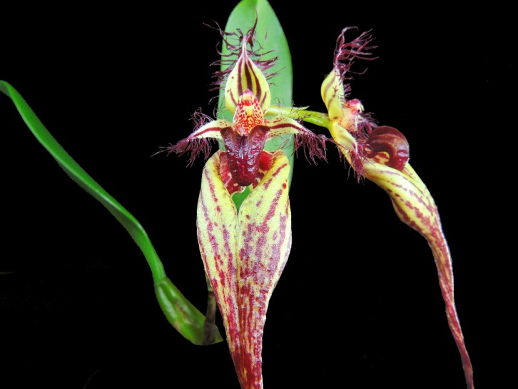
Bulbophyllum fascinator AM/AOS 85 points
Two large flowers on two descending inflorescences; dorsal sepal cupped, base color chartreuse, striped dark burgundy, ciliate on margins; lateral sepals fused, lightly spotted burgundy, coalescing to stripes distally, petals chartreuse spotted burgundy, striped centrally, burgundy appendages on margins,; lip hinged, deep ruby red; column green, finely spotted ruby; substance firm; texture waxy.

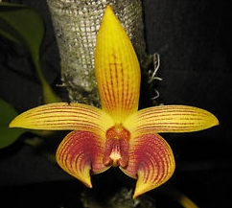
Bulbophyllum Wilmar Candy Stripes HCC/AOS 77 points
Two flowers and one partially opened flower on three inflorescences; dorsal sepal golden yellow, veined maroon with faint cross hatching; lateral sepals curved, proximal three-quarters overlaid maroon, striped and cross hatched; lip hinged, yellow, spotted maroon; substance firm; texture matte.

Bulbophyllum fascinator CCM/AOS 84 points
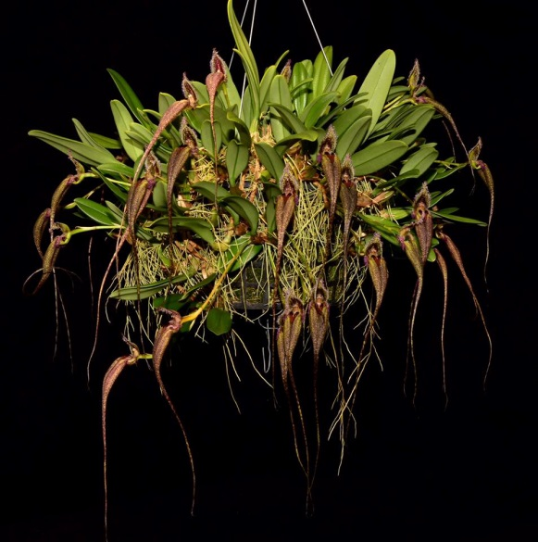
Twenty-three flowers and six buds on twenty-nine evenly distributed inflorescences on an approximately 140 growth plant, 130 cm wide by 25 cm tall grown in sphagnum in a wooden basket; flowers chartreuse, marked burgundy; dorsal sepal striped vertically burgundy; lateral sepals fused, spotted burgundy; petals with single maroon stripe; lip purple, spotted yellow; column green, finely spotted burgundy; substance firm; texture matte.

Bulbophyllum annandelei AM/AOS 86 points
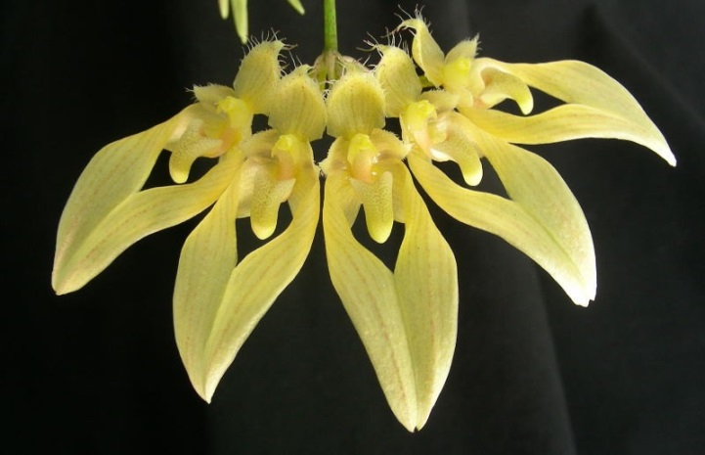
Six flowers well arranged on one inflorescence; dorsal sepal and petals translucent lemon yellow, faintly striped; lateral sepals fused, lemon yellow, faintly striped medially; lip hinged, yellow; column and anther cap orange-yellow; substance firm; texture crystalline.

Bulbophyllum falcatum HCC/AOS 76 points
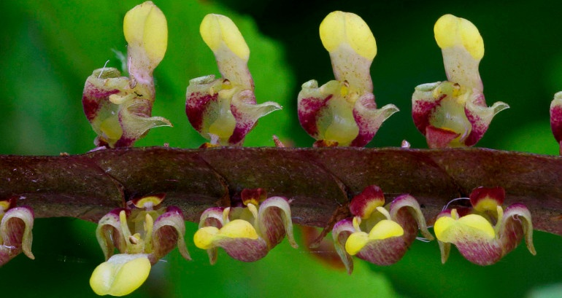
Three hundred forty-two flowers and 410 buds on 31 inflorescences; rachis dark mahogany; dorsal sepals lemon yellow distal one third, remainder beige; lateral sepals light green, spotted oxblood basally; mobile lip velvety burgundy; substance very firm; texture matte.

