Bulbophyllum annandalei Ridl., J. Straits Branch Roy. Asiat. Soc. 82: 197 (1920).
SECTION Cirrhopetalum [Lindl.] Rchb.f 1861
Named for the original collector.

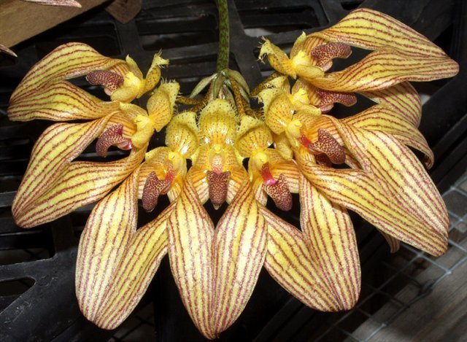
Synonyms
Cirrhopetalum annandelei

Description
Found in penninsular Thailand and Malaysia at elevations around 1000 meters as a miniature to small sized, cool to warm growing epiphyte with conical pseudobulbs carrying a single, apical, thick, blunt leaf that blooms in the spring on a basal, 3 3/5" to 5" [9 to 12 cm] long, 2 to 4 flowered inflorescence holding the flowers in a loose umbel. Flowers smell like cheese. Lips move. Keep plant in cool to intermediate temperatures in shaded conditions.
Habitat
Peninsular Thailand and Malaya. For many years this species was known only from the type specimen which was collected in from Bukit Besar at about 6.1N Latitude, which is near the border between Thailand and Malaya. The plant has been recently found farther south, however, in the Genting Highlands near Kuala Lumpur, Malaya at about 3300 ft. (1000 m). -- Source: Charles Baker
F-1 Hybrids and Progeny
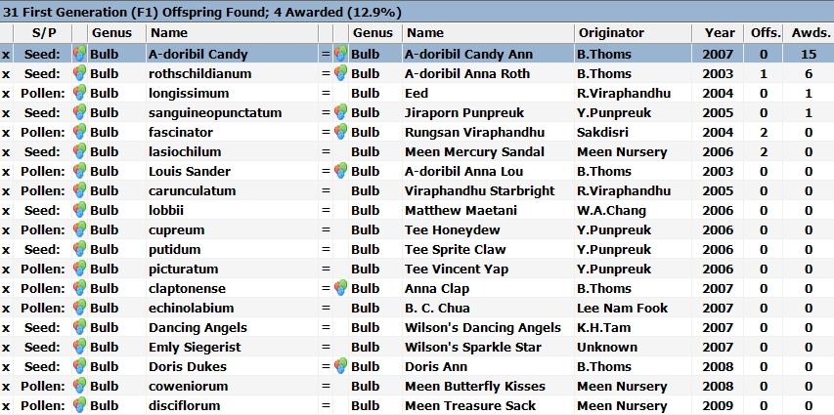
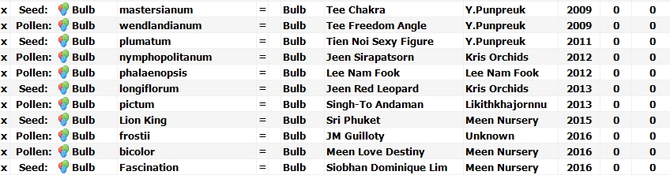

Bulbophyllum annandalei hybridizes well in primary crosses with other Bulbophyllum species. Twenty-three of the 31 F-I hybrids are primary crosses within the genus Bulbophyllum. As the chart shows, all but 5 of the F-1 fail to reproduce. The most awarded F-1 grex is Bulbophyllum A-doribil Candy Ann with 13 AOS awards including an FCC, 9 AM and a couple of cultural awards. Bulbophylum Anna Roth crosses Candy Ann with Bulbophyllum rothschildianum. It has 4 AM, 1 HCC and a CCM in 2009.

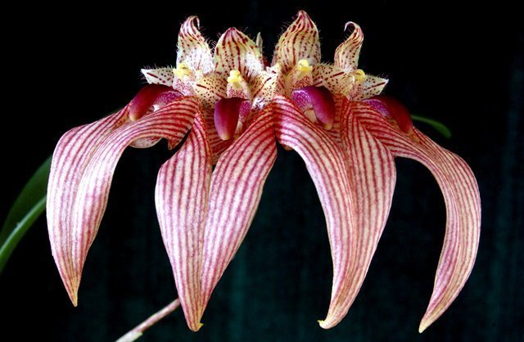
Bulbophyllum A-doribil Candy Ann
(Bulbophyllum annandalei x Bulbophyllum A-doribil Candy) Get it?
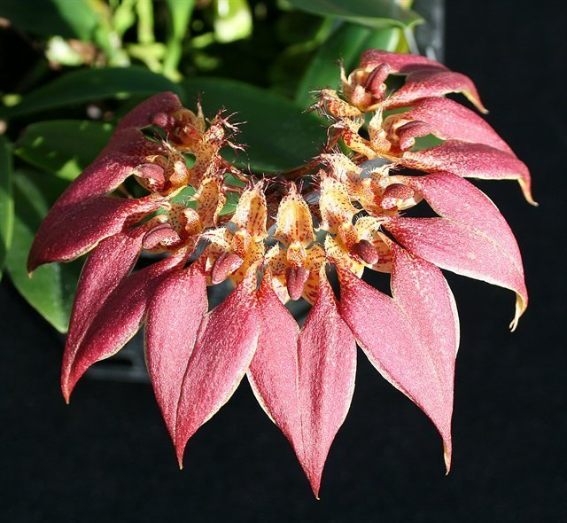
Bulbophyllum A-doribil Anne Roth ‘Cherry’ Am/AOS

References
Aldridge, Peggy. 2008. An Illustrated Dictionary of Orchid Genera. Selby Botanical Garden Press.
la Croix, Isobyl. 2008. The New Encyclopedia of Orchids. Timber Press
Meisel, Kaufmann, Pupulin 2014. Orchids of Tropical America .Cornel University Press
Ossian, Clair Russell. 1983. Noteworthy Bulbophyllums and Cirrhopetalums – Part II, v52. American Orchid Society Bulletin, 349-358.
Siegerist, Emily S. 2001. Bulbophyllums and Their Allies; A Growers Guide. Timber Press
Teuscher, Henry. 1965. Collector’s Item: Three Large Flowered Bulbophyllums, v34. American Orchid Society Bulletin, 321-324.

