Bulbophyllum barbigerum Lindley 1837
SECTION Ptiloglossum Lindley 1862.
In this section there is one leaf per pseudobulb, the labellum is exceptionally mobile and feathery and the plants grow on tree trunks or in moss.
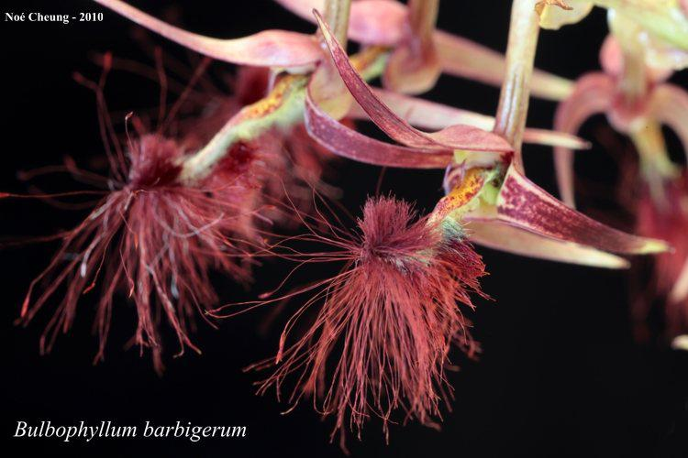
This species occurs in Ivory Coast, Sierra Leone, Liberia, Nigeria, Gabon, Cameroon, Central African Republic, Congo and Zaire on mossy tree trunks and in crowns of trees in evergreen and deciduous forests up to elevations of 900 to 2300 meters as a small sized, warm to cold growing epiphyte with orbicular or ovoid, somewhat flattened pseudobulbs carrying a single, apical, narrowly elliptic, emarginate leaf that blooms in the spring and early summer on a basal, 3 to 7 3/4" [7.5 to 19 cm] long, racemose, spreading or erect inflorescence with ovate bracts and carrying several to many foul smelling, hairy flowers.
Pseudobulbs orbicular, 2-3 cm across, flattened, 1 leafed. Leaves ca 10 cm long, arching or erect, several flowered. Flowers deep red, the sepals tinged with green, lip 10 mm long, the margin ciliate, with long, fine clavate red-brown hairs near the apex, greenish-yellow lightly or heavily marked with dark red, the lateral sepals 7-8 cm long, linear, tapering, joined together to near the apex. Epiphytic in woodlands, often in good light, 700-1100 m.
A fascinating addition to any collection is Bulbophyllum barbigerum which belongs to the section Ptiloglossum. It comes from the area of Africa along the coast of the Gulf of Guinea from Sierra Leone to Gabon where it grows in mossy forests at elevations as high as 2300 m above sea level. The pseudobulbs are ﬂattened and about 2 to 3 cm apart, and the many-ﬂowered inﬂorescence is 18 or 19 cm long. The sepals and petals are pale yellow green, and the sepals are spotted with purple. The column is white with long purple stelidia. The remarkable aspect of the ﬂower is the many ﬁne, long red-brown hairs on the elongated labellum which move with every breath of air, making the ﬂower notoriously difﬁcult to photograph. If adequate moisture can be provided, mounting this plant with a pad of moss under the roots would be very attractive and would be preferable as the plant naturally grows on tree trunks, but pots with spaghnum added to the mix would be appropriate under drier conditions. Warm to intermediate temperatures and light shade are required for maximum growth and good ﬂowering.
Synonyms
Phyllorchis barbigera (Lind.)Kuntz 1891
Habitat
Tropical West Africa. This orchid has been collected in the Kolahum District of LIberia, the Sanguiné Forest of the Ivory Coast, the Ashanti District of Ghana, the Niger Delta in Nigeria, and near Victoria in Cameroon. This orchid is found at low elevations, usually below 2950 ft. (900 m), in forests from Sierra Leon to Cameroon. Plants are also reported in Congo and Zaire, but we have been unable to find any additional information about habitat type or locations in these two countries. -- Source: Charles Baker
Ecology and History: Molecular clock evidence reveals Bulbophyllum arose on the
supercontinent Gondwana before it fractured into Asia, Africa, Australia, and North
and South America. The resulting worldwide distribution is therefore explained not by
dispersal but by what is called vicariancé: the land moved, rather than the plants. Most
Bulbophyllum species are adapted to one of two types of fly pollination. Myophily is
the attraction of fruit ﬂies and hover flies to nectar and pollen or fragrance. Fragrances
may serve as precursors of sexual hormones, or to generate scents that deter predators.
Sapromyophily involves luring carrion flies to flowers that mimic egg-laying sites like
rotting carcasses and decaying vegetation. Such flowers exude rank odors that have
been described variously as “all the foul smells imaginable including some new ones”
(van der Pijl and Dodson 1966), or more succinctly, like “a herd of dead elephants”
(Pridgeon 2006: 42). In both groups the hinged lip traps the pollinator against the
column. Some Brazilian species even require a wind gust to trigger the lip, offering
ﬂies nectar as a delaying tactic to extend their visit until the wind cooperates.
Offspring
Bulbophyllum barbigerum has not been successfully hybridized and has no offspring.
Awards
Like many of the Bulbophyllums, all three of B barbigerum American Orchid Society awards are cultural, in this case three CCM.

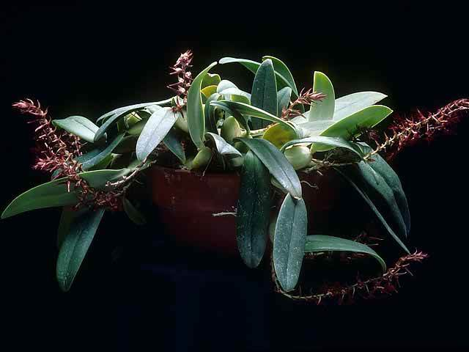
Bulbophyllum barbigerum ‘Miss Aggie” CCM/AOS 2006

References
Aldridge, Peggy. 2008. An Illustrated Dictionary of Orchid Genera. Selby Botanical Garden Press.
Hua, Hu Song. 1999. Bulbophyllum barbigerum var. aureum, an exciting new color phase of this miniature Chinese species, v68. Orchids, 242-243.
la Croix, Isobyl. 2008. The New Encyclopedia of Orchids. Timber Press
Meisel, Kaufmann, Pupulin 2014. Orchids of Tropical America .Cornel University Press
Ossian, Clair Russell. 1983. Noteworthy Bulbophyllums and Cirrhopetalums – Part II, v52. American Orchid Society Bulletin, 349-358.
Siegerist, Emily S. 2001. Bulbophyllums and Their Allies; A Growers Guide. Timber Press
Teuscher, Henry. 1965. Collector’s Item: Bulbophyllum barbigerum, v34. American Orchid Society Bulletin, 600-601.

