Bulbophyllum dearie Reichenbach fil. (1888)
SECTION Sestochilos (Brada) Benth. & Hooker ﬁl. (1883)
Sestochilos is one of the most interesting and perhaps most often discussed
sections of the genus Bulbophyllum. These orchids have good-sized pseudo-
bulbs on creeping rhizomes, one leaf per pseudobulb, and almost always one
ﬂower, rarely two or three, per inﬂorescence. The rhizomes and pseudo-
bulbs are encased in long, stiff bristles. The ﬂowers are large with large sepals
and petals.

Named for an English plant collector and enthusiast in the 1800's.
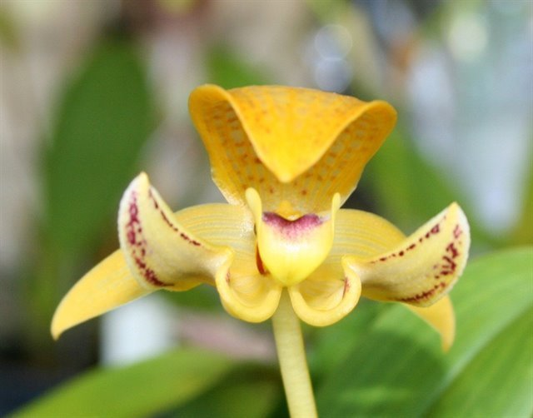
Synonyms
Phyllorchis dearie (Reichenbach fil.) Kuntze (1891)
Bulbophyllum godseffianum Weathers (1890)
Bulbophyllum reticosum Ridl. (1896)
Bulbophyllum goebelianum Kraenzl. 1921
Bulbophyllum punctatum Ridl. 1908
Sarcopodium dearei hort. 1883
Sarcopodium godseffianum Sander 1890

This species of the section Sestochilos was known in gardening as Sarcopodiuum dearei
before it was formally published. The pseudobulbs are less than 2 cm tall, encased m bristles,
and are held closely together on the rhizome. The leaf is13 cm long and the inflorescences at
least 7 cm long, usually much longer, and bears one slightly fragrant ﬂower. The dorsal sepal is
4 cm long and curves forward over the labellum. The lateral sepals are about the same length but
widely spreading, with the lower portion curved. The petals are 3 cm long, spreading, and
reﬂexed. The petals and dorsal sepal are pale yellow to white with darker yellow and purple
veins The lateral sepals are basically the same as the dorsal, but the lower portions are white
with dark purple markings 1n the center The labellum is pubescent and cordate, and the
hypochile is reﬂexed The species grows epiphytically at about 1000m above sea level in Malaya,
Borneo, and the Philippines and can be cultivated in pots or baskets in semi-shaded areas with
intermediate to warm temperatures and regular applications of water and fertilizer.

Found in Borneo, peninsular Malaysia and the Philippines in hill and lower montane forests at elevations of 700 to 1200 meters as a small sized, unifoliate epiphyte and occasional lithophyte in montane forests on bare trunks of large trees or in forests on limestone, with 2" [5 cm] egg-shaped pseudobulbs encased in bristles and held close together on the rhizome and a solitary, elliptic-oblong leaf, blooming in the summer and fall on a erect, 6 5/8" [17 cm] long, single flowered inflorescence carrying a long-lasting, heavy textured, slightly fragrant flower held near the leaf's end. This species does best in pots or baskets, with partial shade, given hot to cool temperatures and regular water and fertilizer.

Habitat
Borneo, Malaya, the Philippines. In Malaya, this orchid is known only from the southern state of
Johor where it has been found on Gunung Belumut and Gunung Pulai. Habitat elevation was not
given, but these are rather low-lying mountains. On Borneo, plants have been found in Sarawak
near Kuching and other locations in the lowlands and in mossy hill forests at 650-2600 ft. (200-
800 m). Wood, Beaman, & Beaman (1993) reported the occurrence of this species in Sabah
where it was growing in hill forests on Mt. Kinabalu at 3950 ft. (1200 m). In the Philippines,
plants have been found on the islands of Mindanao and Palawan at 2300-3950 ft. (700-1200 m).
Source: Charles Baker

Ecology
Ecology and History: Molecular clock evidence reveals Bulbophyllum arose on the
supercontinent Gondwana before it fractured into Asia, Africa, Australia, and North
and South America. The resulting worldwide distribution is therefore explained not by
dispersal but by what is called vicariancé: the land moved, rather than the plants. Most
Bulbophyllum species are adapted to one of two types of fly pollination. Myophily is
the attraction of fruit ﬂies and hover flies to nectar and pollen or fragrance. Fragrances
may serve as precursors of sexual hormones, or to generate scents that deter predators.
Sapromyophily involves luring carrion flies to flowers that mimic egg-laying sites like
rotting carcasses and decaying vegetation. Such flowers exude rank odors that have
been described variously as “all the foul smells imaginable including some new ones”
(van der Pijl and Dodson 1966), or more succinctly, like “a herd of dead elephants”
(Pridgeon 2006: 42). In both groups the hinged lip traps the pollinator against the
column. Some Brazilian species even require a wind gust to trigger the lip, offering
ﬂies nectar as a delaying tactic to extend their visit until the wind cooperates.

F-1 Hybrids
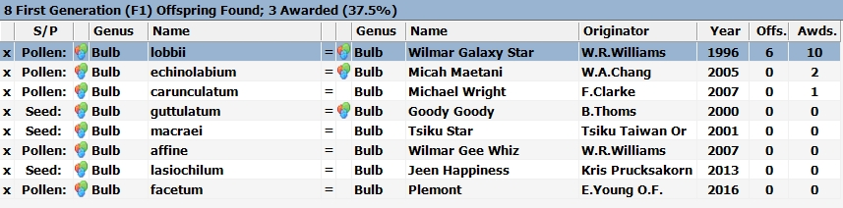
Bulbophyllum dearie hybridizes well in primary crosses with other Bulbophyllum species, but
only one produces any subsequent progeny. The one successful F-1 is Bulbophyllum Wilmar
Galaxy Star with 10 awards and 6 offspring.

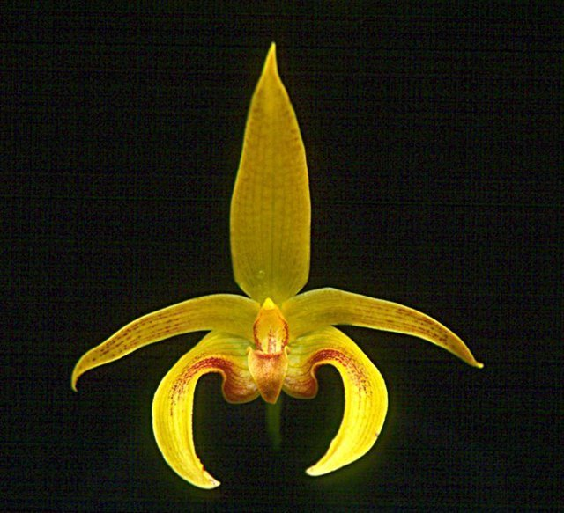
Bulbophyllum Wilmar Galaxy Star ‘Enchantment’
(Bulbophyllum dearie x B. lobbii)

Progeny
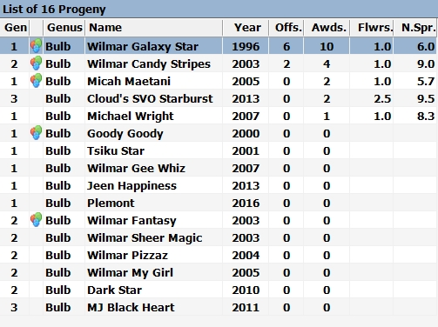
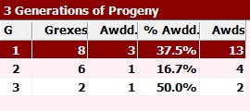

There are few notable hybrids of Bulbophyllum dearie. When crossed with B. facetum in 2003, Wilmer Galaxy Star produced Bulbophyllum Wilmer Candy Stripes with 4 AOS awards. In 2013, Candy Stripes was then crossed with B. echinolabium producing Bulbophyllum Cloud’s SVO Starburst. It was awarded an AM and an HCC. Generation 3 is as far as any of B. dearie offspring have made it.
References
Aldridge, Peggy. 2008. An Illustrated Dictionary of Orchid Genera. Selby Botanical Garden Press.
la Croix, Isobyl. 2008. The New Encyclopedia of Orchids. Timber Press
Meisel, Kaufmann, Pupulin 2014. Orchids of Tropical America .Cornel University Press
Ossian, Clair Russell. 1983. Noteworthy Bulbophyllums and Cirrhopetalums – Part II, v52. American Orchid Society Bulletin, 349-358.
Siegerist, Emily S. 2001. Bulbophyllums and Their Allies; A Growers Guide. Timber Press
Teuscher, Henry. 1965. Collector’s Item: Three Large Flowered Bulbophyllums, v34. American Orchid Society Bulletin, 321-324.

