Bulbophyllum falcatum (Lindley) Reichenbach f.
SECTION Megaclinium Summerh. 1935.
In this section the pseudobulbs each have two leaves, only rarely one or three leaves, and a
peduncle bearing a ﬂattened rachis. There is a single row of small ﬂowers on either side of this
rachis and they open successively. In 1824, John Lindley established the genus Megaclinium to
describe this very unusual group of African orchids. Heinrich Gustav Reichenbach, whose
father is also well known in botanical circles, considered Megaclinium a section of the genus
Bullvop/ayllum in 1861, but some taxonomists of the time, including Ernst Pﬁtzer and Friedrich
W. L. Kraenzlin, agreed with Lindley that it should have its generic status maintained. Today
most taxonomists agree with Reichenbach. The distribution of this section is limited to lowland
forests that are rarely as high as 1400 m above sea level in Africa and the adjacent islands. There
have been more than 40 species described with these characteristics. Unfortunately, many of
them are seldom seen in cultivation although they are all well worth growing if they can be
obtained.
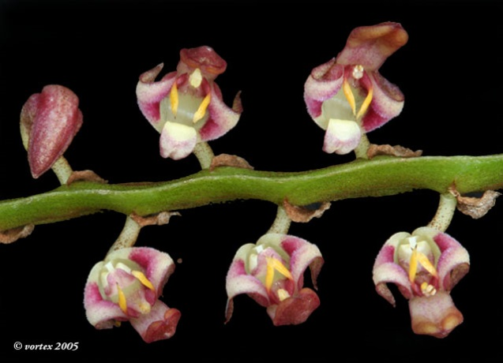
Named for its sickle-shaped leaf.
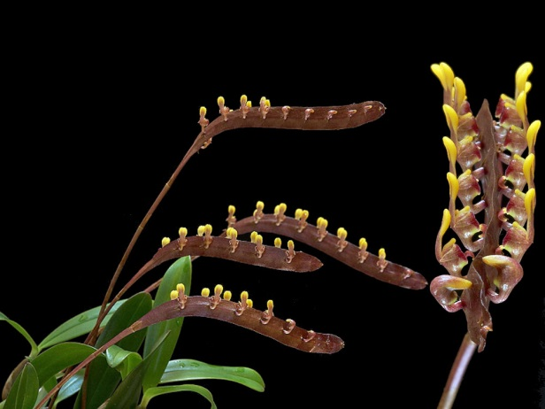

Synonyms
Bulbophyllum arnoldianum (De Wild.) De Wild. 1921
Bulbophyllum bakossorum Schltr. 1905
Bulbophyllum brixhei De Wild. 1916
Bulbophyllum bufo (Lindl.) Rchb.f. 1861
Bulbophyllum dahlemense Schltr. 1919
Bulbophyllum deistelianum (Kraenzl.) Schltr. 1905
Bulbophyllum falcatum var. bufo (Lindl.) Govaerts 1996
Bulbophyllum falcatum var. velutinum (Lindl.) J.J.Verm. 1992
Bulbophyllum fractiflexum Kraenzl. 1912
Bulbophyllum hemirhachis Pfitzer 1908
Bulbophyllum kewense Schltr. 1914
Bulbophyllum lanuriense De Wild. 1921
Bulbophyllum leptorrhachis Schlechter 1905
Bulbophyllum longibulbum Schltr. 1905
Bulbophyllum lubiense De Wild. 1921
Bulbophyllum melanorrhachis (Rchb.f.) Rchb.f. 1875
Bulbophyllum millenii (Rolfe) Schltr. 1905
Bulbophyllum minutum (Rolfe) Engl. 1908
Bulbophyllum minutum var. purpureum (De Wild.) De Wild. 1921
Bulbophyllum oxyodon Rchb.f 1888
Bulbophyllum rhizophorae Lindl. 1861
Bulbophyllum seretii De Wild. 1916
Bulbophyllum simonii Summerh. 1935
Bulbophyllum solheidii De Wild. 1916
Bulbophyllum ugandae (Rolfe) De Wild. 1921
Bulbophyllum velutinum (Lindl.) Rchb.f. 1861
Megaclinium arnoldianum De Wild. 1905
Megaclinium angustum Rolfe 1922
Megaclinium brixhei De Wild. 1916
Megaclinium bufo Lindl.1841
Megaclinium deistelianum Kraenzl. 1902
Megaclinium endotrachys Kraenzel 1905
Megaclinium falcatum Lindley 1826
Megaclinium gentilii De Wild. 1902
Megaclinium hemirhachis Pfitzer 1908
Megaclinium lanuriense De Wild. 1921
Megaclinium lasianthum Kraenzl. 1912
Megaclinium melanorrhachis Rchb.f. 1875
Megaclinium millenii Rolfe 1897
Megaclinium minutum Rolfe 1893
Megaclinium minutum var. purpureum De Wild. 1911
Megaclinium oxyodon Rchb. f. 1888
Megaclinium seretii De Wild. 1916
Megaclinium solheidii De Wild. 1916
Megaclinium ugandae Rolfe 1913
Megaclinium velutinum Lindl. 1847
Phyllorchis bufo (Lindl.) Kuntze 1891
Phyllorchis falcata (Lindl.) Kuntze 1891
Phyllorchis rhizophorae (Lindl.) Kuntze 1891
Phyllorchis velutina (Lindl.) Kuntze 1891

Pseudobulbs to 7 x 2 cm, 2-leaved, set up to 5 cm apart on the rhizome. Leaves lanceolate, to ca. 16 cm long. Inﬂorescence 3-40 cm long, several to many-ﬂowered. Rachis swollen or ﬂattened, sometimes markedly so, sometimes hardly at all. Flowers distichous, greenish marked with brown, purple, yellow, or purple and yellow; dorsal sepal ca. 9 mm long.
Var. bufo (Lindley) I. I. Vermeulen (syn. Bulbophyllum bufo Lindley) has a rachis 30 cm long or more, with greenish-brown ﬂowers opening over a long period. Epiphytic in lowland and sub-montane forest, to 1800 m (6000 ft.) West and Central Africa
Mini flowers on the side of a pea pod, needs to be magnified to truly enjoy, blooms in winter till spring on a 6 1/4" [to 16 cm] long, spicate inflorescence with a very flattened, strongly undulate, rachis with short-stalked flowers horizontally aligned on either side and comes from central to west Africa in lowland and sub-montane forests where it is a hot growing, bifoliate epiphyte or occasional lithophyte at altitudes below 1800 meters with broadly to narrowly ovoid, 2 to 4 angled pseudobulbs carrying 2 apical, lanceolate or linear leaves.
Habitat
Tropical West Africa. Plants are reported in Guinea, Sierra Leone, Liberia, Ivory Coast, Ghana, and Cameroon, as well as the Congo, Uganda, and Principe Island. Few details pertaining to habitat are available, but several collections have been reported in mountain regions at 1000-3000 ft. (300-910 m). In Cameroon, plants were collected near the coast on Mt. Cameroon, but habitat elevation was not given. -- Source: Charles Baker
Ecology
Ecology and History: Molecular clock evidence reveals Bulbophyllum arose on the
supercontinent Gondwana before it fractured into Asia, Africa, Australia, and North
and South America. The resulting worldwide distribution is therefore explained not by
dispersal but by what is called vicariancé: the land moved, rather than the plants. Most
Bulbophyllum species are adapted to one of two types of fly pollination. Myophily is
the attraction of fruit ﬂies and hover flies to nectar and pollen or fragrance. Fragrances
may serve as precursors of sexual hormones, or to generate scents that deter predators.
Sapromyophily involves luring carrion flies to flowers that mimic egg-laying sites like
rotting carcasses and decaying vegetation. Such flowers exude rank odors that have
been described variously as “all the foul smells imaginable including some new ones”
(van der Pijl and Dodson 1966), or more succinctly, like “a herd of dead elephants”
(Pridgeon 2006: 42). In both groups the hinged lip traps the pollinator against the
column. Some Brazilian species even require a wind gust to trigger the lip, offering
ﬂies nectar as a delaying tactic to extend their visit until the wind cooperates.

F-1 Hybrids
Bulbophyllum falcatum has been hybridized only 1 time in a primary cross with Bulbophylum purpureorhachi in 2002. The offspring, Bulbophyllum Sue Blackmore, has 3 cultural awards.
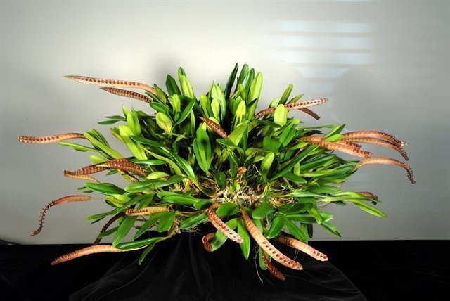
Bulbophyllum Sue Blackmore ‘A-doribil’ CCE/AOS

Awards
Like many of the Bulbophyllums, most of B. falcatum awards are cultural. Of its 35 American Orchid Society awards, only 4 are for flower quality including 3 AM and 1 HCC.
References
Aldridge, Peggy. 2008. An Illustrated Dictionary of Orchid Genera. Selby Botanical Garden Press.
la Croix, Isobyl. 2008. The New Encyclopedia of Orchids. Timber Press
Meisel, Kaufmann, Pupulin 2014. Orchids of Tropical America .Cornel University Press
Ossian, Clair Russell. 1983. Noteworthy Bulbophyllums and Cirrhopetalums – Part II, v52. American Orchid Society Bulletin, 349-358.
Siegerist, Emily S. 2001. Bulbophyllums and Their Allies; A Growers Guide. Timber Press
Teuscher, Henry. 1965. Collector’s Item: Three Large Flowered Bulbophyllums, v34. American Orchid Society Bulletin, 321-324.

