Bulbophyllum fascinator (Rolfe)Rolfe Bot. Mag. 134: t. 8199 (1908).
SECTION Cirrhopetaloides Garay, Hamer & Siegerist 1994
The plants have one leaf per pseudobulb, and the outer margins of the lateral sepals are curved in and seemingly joined along their central portion. The tips of the sepals are always free, are not ﬂeshy, and are setaceous.
Named for its unusually attractive, fascinating appearance.

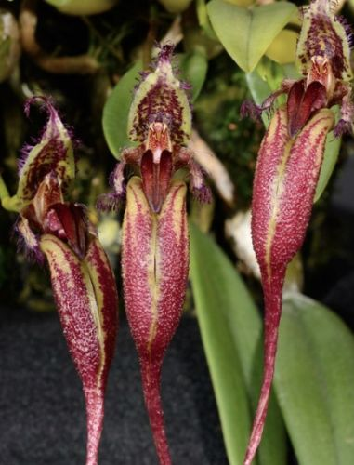

Synonyms
Cirrhopetalum fascinator Rolfe 1908
Cirrhopetalum ornatissimum Auct. non Rchb.f 1898
Mastigion fascinator (Rolfe) Garay, Hamer & Siegerist 1994
Description
This species has incredible blooms that move, wave, and wiggle. It is found in peninsular Malaysia, Sumatra, Borneo and the Philippines in primary montane forests at elevations of sea level to 1000 meters. It is a small sized, hot to warm growing epiphyte with 3/4 " to 1.2" [2 to 3 cm] between each ovoid to elliptic, olive green, obtusely 4 angled pseudobulb carrying a single, apical oblong-elliptic, petiolate base leaf that blooms in the summer and fall on a basal, suberect to patent, peduncle 1.6 to 2" [4 to 5 cm] long, 6.8 to 7.6 " [17 to 19 cm] long overall, single flowered inflorescence with a membraneous, lanceolate floral bract.
This species is a hot to warm grower that is potted in wood slat baskets with some tree fern. Give it shade, moist conditions, and plenty of air movement. The trick is to let the newest growth be close to the wood basket and the oldest in the center. This way the new growth attaches to the wood and is more likely to bloom.
Some references put this species as a synonym of B. putidum but this species has a more acute apex to the lip and has a low median ridge that more or less continues half way down the lip while in B. putidum the median ridge goes from the base to almost to the apex.
The pseudobulbs of this species are about 2 cm tall and close together, with a leaf that is 5 cm long. The scape is 10 cm tall and has only one ﬂower which is light greenish white with red markings. The dorsal sepal is 3 cm long and ﬁmbriate, and the lateral sepals are 18 cm long, caudate, and connate for the majority of their length but with the tips free. The petals are 2 cm long, linear-oblong, decurved, with long paleolate or clavate ornaments. The labellum is triangular and purple, and has two pubescent keels. This plant grows throughout the lowlands of Malaya and Laos. It can be cultivated in pots or baskets and requires warm, moist conditions and shade

Ecology
Ecology and History: Molecular clock evidence reveals Bulbophyllum arose on the supercontinent Gondwana before it fractured into Asia, Africa, Australia, and North and South America. The resulting worldwide distribution is therefore explained not by dispersal but by what is called vicariancé: the land moved, rather than the plants. Most Bulbophyllum species are adapted to one of two types of fly pollination. Myophily is the attraction of fruit ﬂies and hover flies to nectar and pollen or fragrance. Fragrances may serve as precursors of sexual hormones, or to generate scents that deter predators. Sapromyophily involves luring carrion flies to flowers that mimic egg-laying sites like rotting carcasses and decaying vegetation. Such flowers exude rank odors that have been described variously as “all the foul smells imaginable including some new ones” (van der Pijl and Dodson 1966), or more succinctly, like “a herd of dead elephants” (Pridgeon 2006: 42). In both groups the hinged lip traps the pollinator against the column. Some Brazilian species even require a wind gust to trigger the lip, offering ﬂies nectar as a delaying tactic to extend their visit until the wind cooperates.
F-1 Hybrids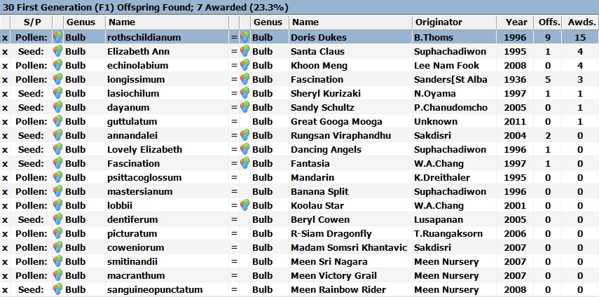
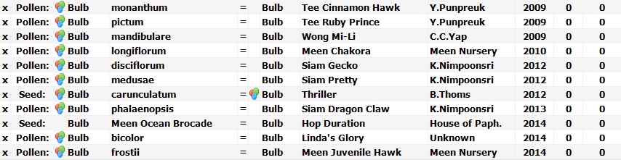
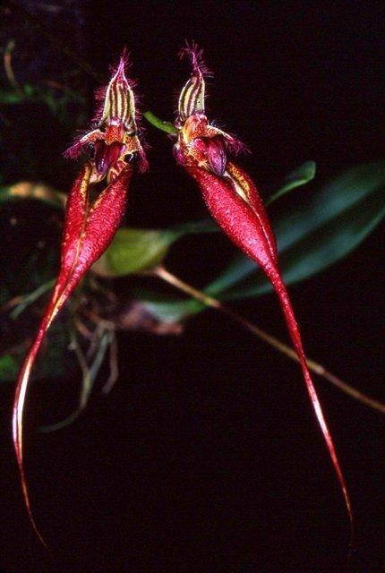
Bulbophyllum fascinator hybridizes well in primary crosses with other Bulbophyllum species, but few produces any subsequent progeny. Bulbophyllum Doris Dukes is the most successful with 11 total progeny and 14 AOS awards. Doris Dukes is the only B. fascinator hybrid to produce third generation hybrids.

Bulbophyllum Doris Dukes ‘Bill’s Best’ AM/AOS
(Bulbophyllum fascinator x B. rothschildianum)

Another primary cross, this time with B. longissimum, is Bulbophyllum Fascination. Fascination has produced 5 F-1 progeny and 1 second generation grex. It has received 3 Australian awards.
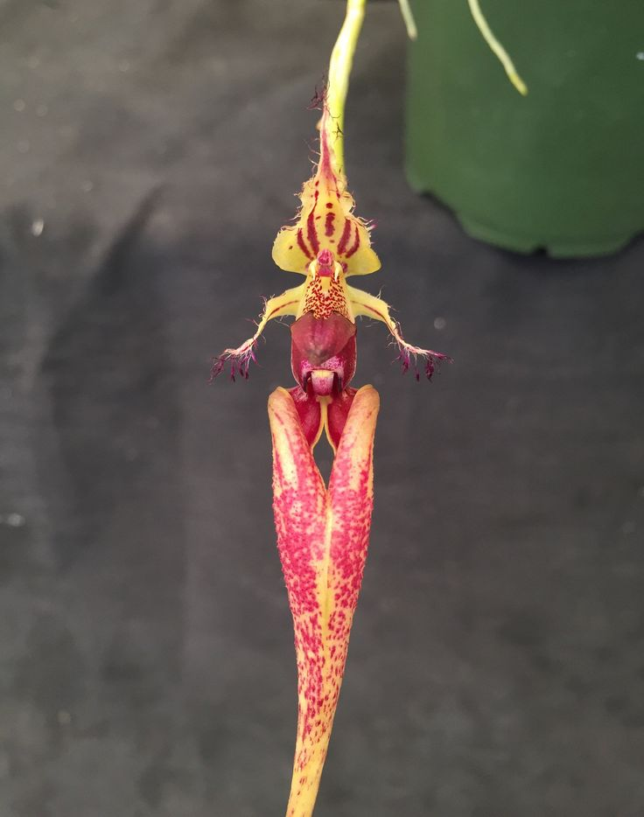

Bulbophyllum Fascinaion ‘Chianti’
(Bulbophyllum fascinator x B. longissmium)

References
Aldridge, Peggy. 2008. An Illustrated Dictionary of Orchid Genera. Selby Botanical Garden Press.
la Croix, Isobyl. 2008. The New Encyclopedia of Orchids. Timber Press
Meisel, Kaufmann, Pupulin 2014. Orchids of Tropical America .Cornel University Press
Ossian, Clair Russell. 1983. Noteworthy Bulbophyllums and Cirrhopetalums – Part II, v52. American Orchid Society Bulletin, 349-358.
Siegerist, Emily S. 2001. Bulbophyllums and Their Allies; A Growers Guide. Timber Press
Teuscher, Henry. 1965. Collector’s Item: Three Large Flowered Bulbophyllums, v34. American Orchid Society Bulletin, 321-324.
Teuscher, Henry. 1974. Collector’s Item: Cirrhopetalum collettii, C. rothschildianum and C. fascinator, v43. American Orchid Society Bulletin, 883-889.

