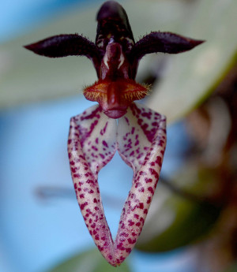
Bulbophyllum lasiochilum HCC/AOS 77 points
Forty-one flowers and twenty-seven buds on fifty-three inflorescences; porrect dorsal sepal and petals maroon; lateral sepals white aging to pink suffusion, spotted maroon, enrolled over top surface forming narrow tube; lip yellow, ciliate, yellow crest arching beaklike; column golden, anther cap yellow, substance firm; texture matte.

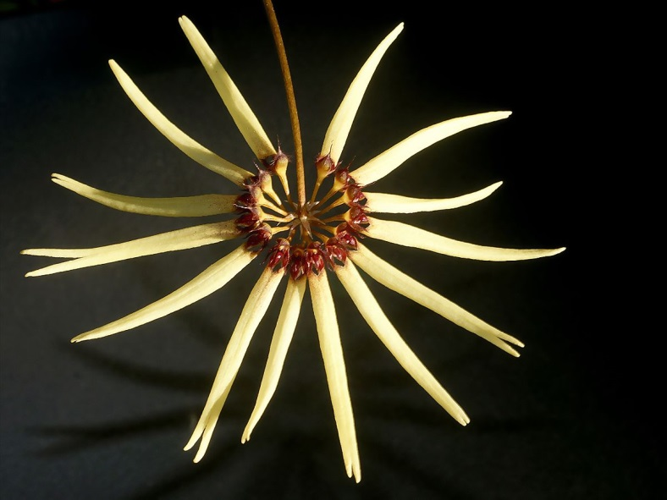
Bulbophyllum makoyanum AM/AOS 88 points
Forty-eight flowers on three full umbellate inflorescences plus two immature inflorescences; dorsal sepals pale yellow, red-brown basally; lateral sepals pale yellow, fused and rolled; petals rose; lip red, hinged; substance light; texture matte.

Bulbophyllum barbigerum CCM/AOS 82 points
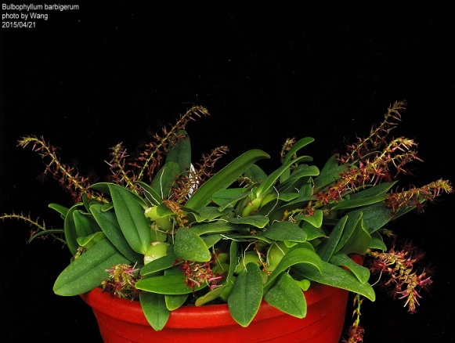
Seventy-four flowers and 60 buds on 12 inflorescences and 9 maturing inflorescences presented on a thirty-eight growth plant mounted in a 25 cm plastic pot; flowers red-brown; petals insignificant; lip green, apex with tuft of wine red hairs, the longest 1.7 cm; substance good; texture matte.

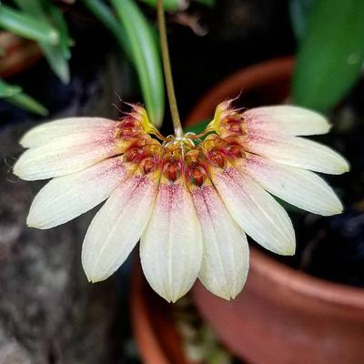
Bulbophyllum Daisy Chain HCC/AOS 76 points
Six flowers well arranged on one inflorescence; dorsal sepal and petals translucent lemon yellow, faintly striped; lateral sepals fused, lemon yellow, faintly striped medially; lip hinged, yellow; column and anther cap orange-yellow; substance firm; texture crystalline.

Bulbophyllum lasiochilum CCM/AOS 82 points
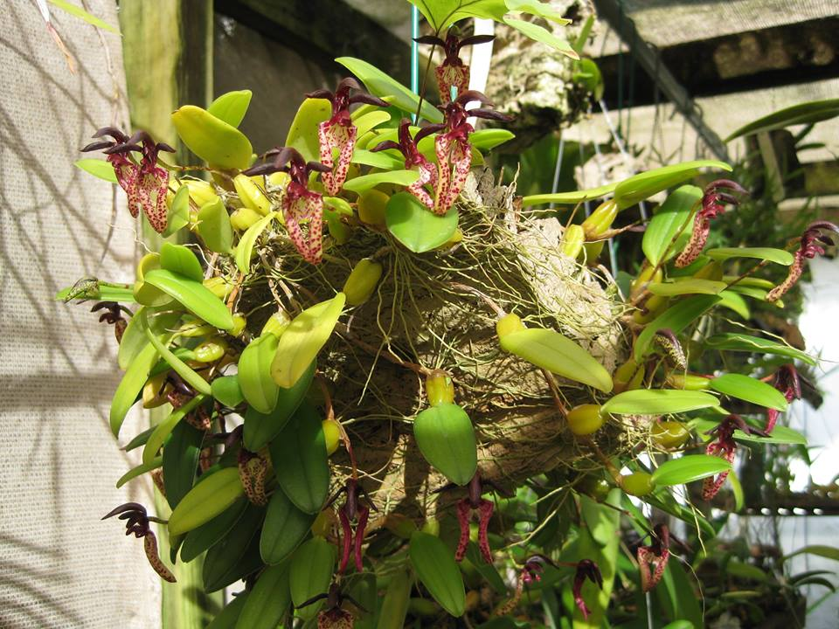
Forty-three flowers and ten buds on sixty-three inflorescences presented on a plant thirty cm high by 40 cm wide growing on a cork slab; flowers oxblood, sepals and petals cream, spotted oxblood, lateral sepals flat distally, enrolled over top surface; lip orange-yellow with liquid exudate; substance firm; texture matte.

