Bulbophyllum lasiochilum Parish & Rchb.f 1874
SECTION Brachyantha Rchb.f 1861
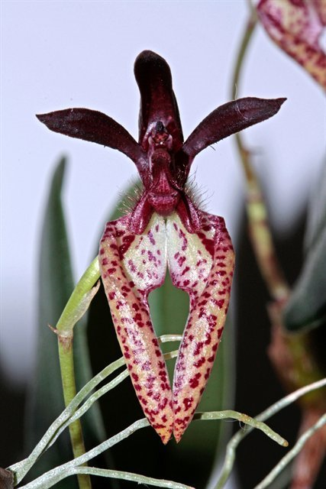
Found in India, Myanmar, Thailand and Malaysia in moist montane forests and seasonally dry forests as a mini-miniature to miniature sized, warm to cool growing species with cylindro-ovate pseudobulbs with a single, apical, oblong-obovate leaf that blooms in the fall with solitary flowers, or a few in umbels on shorter, slender inflorescence that arises from a mature pseudobulb and has the fragrant flower scented of strawberries held just below or above the leaves.
Pseudobulbs 2-3 cm long, ovoid, 1 leafed, set ca 3 cm apart on creeping rhizomes. Leaves to 25 cm long. Inflorescence 10-15 cm long, 1 flowered. Dorsal sepals and petals purple, lateral sepals cream spotted red-brown, 2-3 cm long, incurved; lip purple with long marginal hairs. Epiphytic in forests to1500 m.
This lovely little plant is part of the section Brachyantha and has ridged pseudobulbs that are 2 cm tall and spaced 3 cm apart on the rhizomes. The one leaf is 5 cm long. The scape is approximately 4 cm long and has one very attractive ﬂower. The dorsal sepal is about 2 cm long and 0.5 cm wide, erect, and usually dark purple. The lateral sepals are 2.5 cm long and incurved, which gives them a rather bowlegged appearance, and they are very pale cream or white with dark red spots. The petals are a bit smaller than the dorsal sepal and also are a dark, shiny purple. The labellum is 1 cm long, slightly curved, and has two widely spreading wings that have very long dark purple cilia on the edges. An attractive color variation exists that is a pale yellow throughout with light red spots. This orchid grows in Myanmar, Thailand, and Malaya and adapts well to culture on a tree fern in warm conditions with daily waterings and frequent fertilization. It is an easily grown small species and highly recommended for the collection.
Synonyms
Bulbophyllum breviscapum (Rolfe) Ridl. 1907
Cirrhopetalum breviscapum Rolfe 1905
Cirrhopetalum lasiochilum [Parish & Rchb. f.] Hkr.f 1874
Phyllorchis lasiochila (Parish & Rchb. f.) Kuntze 1891
Habitat
Thailand, Burma, and Malaya. In Thailand, plants are found throughout the country, and the habitat varies from the mountains in the north to peninsular Thailand in the south. In the north, collections have been reported at 3950-4900 ft. (1200-1500 m). Habitat elevation was not reported for other collections around the country, however. This orchid has been found in the Tenasserim region of Burma. In Malaya, it is known only from the type specimen for Bulbophyllum breviscapum which was sent from Perak to Dublin in 1908. No additional details of habitat location, type, or elevation were given. -- Source: Charles Baker
Ecology and History: Molecular clock evidence reveals Bulbophyllum arose on the supercontinent Gondwana before it fractured into Asia, Africa, Australia, and North
and South America. The resulting worldwide distribution is therefore explained not by
dispersal but by what is called vicariancé: the land moved, rather than the plants. Most
Bulbophyllum species are adapted to one of two types of fly pollination. Myophily is
the attraction of fruit ﬂies and hover flies to nectar and pollen or fragrance. Fragrances
may serve as precursors of sexual hormones, or to generate scents that deter predators.
Sapromyophily involves luring carrion flies to flowers that mimic egg-laying sites like
rotting carcasses and decaying vegetation. Such flowers exude rank odors that have
been described variously as “all the foul smells imaginable including some new ones”
(van der Pijl and Dodson 1966), or more succinctly, like “a herd of dead elephants”
(Pridgeon 2006: 42). In both groups the hinged lip traps the pollinator against the
column. Some Brazilian species even require a wind gust to trigger the lip, offering
ﬂies nectar as a delaying tactic to extend their visit until the wind cooperates.
F-1 Offspring
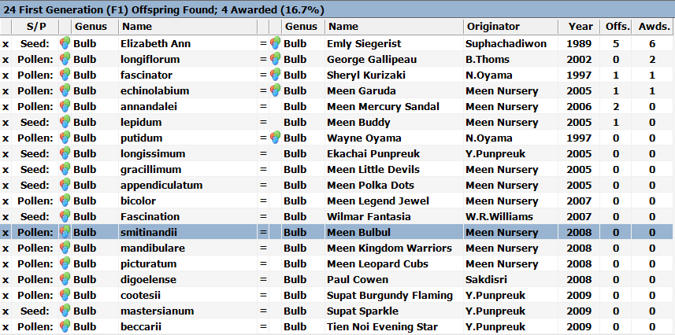
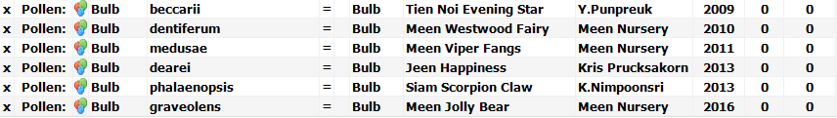
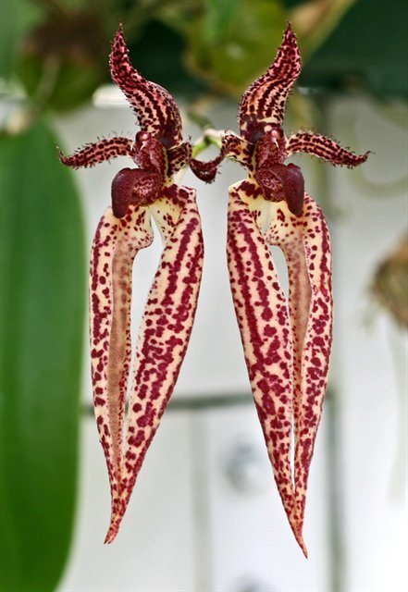
A lot of breeding was done with B. lasiochilum on the early 2000’s. Experimentation with a couple dozen species produced many Primary hybrids only four of which produced any offspring, The most successful cross was with Bulbophyllum Elizabeth Ann (B. longissimum x B. rothschildianum) creating Bulbophyllum Emily Siegerist HCC/AOS (see to the left)
Another minor but interesting primary hybrid is George Gallipeau (B. lasiochilum x B. longifolium) It has no offspring but was awarded twice with an AM and an HCC.

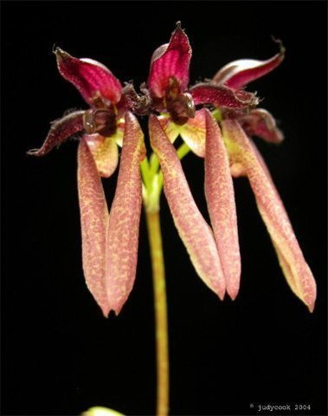

Bulbophyllum George Gallipeau
Bulbophyllum lasiochilum has produced 34 progeny in 2 generations.
Awards
Bulbophyllum lasiochilum has been awarded 9 times by the AOS. All are cultural except for its CBM and one HCC in 1977.
Four of the 34 hybrid grexes have been awarded.

References
Aldridge, Peggy. 2008. An Illustrated Dictionary of Orchid Genera. Selby Botanical Garden Press.
la Croix, Isobyl. 2008. The New Encyclopedia of Orchids. Timber Press
Meisel, Kaufmann, Pupulin 2014. Orchids of Tropical America .Cornel University Press
Ossian, Clair Russell. 1983. Noteworthy Bulbophyllums and Cirrhopetalums – Part II, v52. American Orchid Society Bulletin, 349-358.
Siegerist, Emily S. 2001. Bulbophyllums and Their Allies; A Growers Guide. Timber Press

