Bulbophyllum makoyanum [Rchb.f] Ridley 1879
SECTION Ephippium Schlechter 1913
These plants have pseudobulbs that are spaced slightly apart and have only one leaf each. There is one flower per inflorescence, and the petals are much shorter that the sepals, while the labellum is rather long.
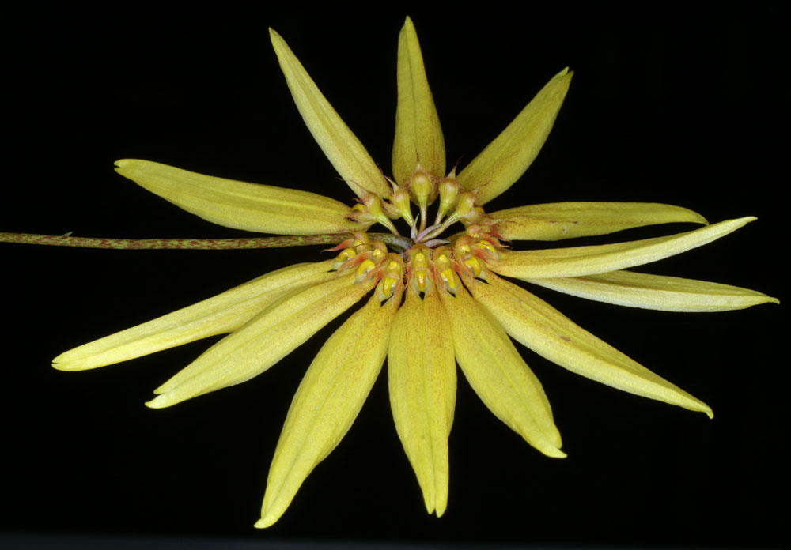
The daisy orchid, blooms variable all year but most often in the winter, a miniature to small sized, warm to hot growing, unifoliate epiphyte that is an easy grower from Malaysia, Singapore, Borneo and the Philippines in lowland forests at elevations up to 300 meters that has 3/4" [2 cm] between each ovate, ridged with age pseudobulb, carrying a single, erect, narrowly ovoid, leaf that narrows below into a petiole and blooms on a basal, slender, 8" [20 cm] long, purple, several [5 to 12] flowered inflorescence that has an apical umbel of fragrant flowers held just beyond the leaf.
Pseudobulbs 2 cm tall are fairly close together, with leaves 10 cm tall. The inflorescence is twice that length and has about 10 flowers. The dorsal sepal and petals are quite small, red brown with thread like apices and edged with pale hairs at least 0.1 cm long. The real focus point of the flowers is the shape of the lateral sepals which are almost 4 cm long and have the upper edges connate for almost their entire length. The lower edges roll under and are sometimes partially joined. This makes the sepals appear extremely narrow. The lateral sepals radiate from the umble, giving them the appearance of a sun flower. This species has been found in the Philippines, Borneo, Malaysia and Vietnam. It can be easily grown in warm to intermediate temperatures, either potted or mounted.
Synonyms
Cirrhopetalum makoyanum Rchb. f 1879
Habitat
Philippine Islands, Borneo, Malaya, and a single collection was reported for Singapore. In the Philippines, plants grow on trees at low elevations on Mindanao Island in Agusan Province, on Busuanga Island, on Luzon Island in the Provinces of Ifugao, Rizal, and Zambales, on Palawan Island, and the Polillo Islands off the east coast of Luzon. In Borneo, plants grow in lowland forests in Kalimantan at (100–200 m). -- Source: Charles Baker
Ecology and History: Molecular clock evidence reveals Bulbophyllum arose on the supercontinent Gondwana before it fractured into Asia, Africa, Australia, and North
and South America. The resulting worldwide distribution is therefore explained not by
dispersal but by what is called vicariancé: the land moved, rather than the plants. Most
Bulbophyllum species are adapted to one of two types of fly pollination. Myophily is
the attraction of fruit ﬂies and hover flies to nectar and pollen or fragrance. Fragrances
may serve as precursors of sexual hormones, or to generate scents that deter predators.
Sapromyophily involves luring carrion flies to flowers that mimic egg-laying sites like
rotting carcasses and decaying vegetation. Such flowers exude rank odors that have
been described variously as “all the foul smells imaginable including some new ones”
(van der Pijl and Dodson 1966), or more succinctly, like “a herd of dead elephants”
(Pridgeon 2006: 42). In both groups the hinged lip traps the pollinator against the
column. Some Brazilian species even require a wind gust to trigger the lip, offering
ﬂies nectar as a delaying tactic to extend their visit until the wind cooperates.

F-1 Offspring
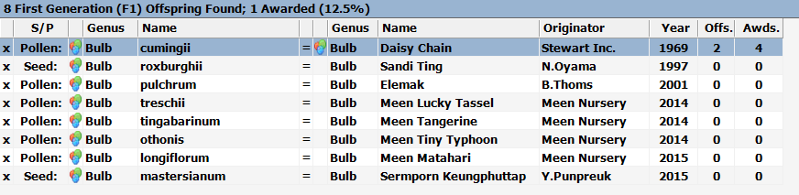

Eight primary crosses were made with B. makoyanum between 1969 and 2015. The best known and widely grown is Bulbophyllum Daisy Chain. In spite of being very popular, it has only been awarded 3 CCM and one JC. There are no flower quality awards. It is interesting to note that is spite of both parents having full circle umbel inflorescences, Daisy Chain’s is truncated at about 190 degrees.
There are 2 second generation progeny, both out of Daisy Chain. Bulbophyllum Sharese by way of B. gracillimum, has been awarded a JC and has no offspring.
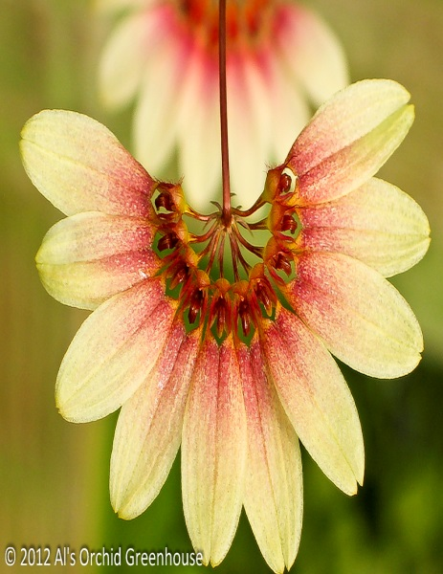
Bulbophyllum Daisy Chain

Awards
Bulbophyllum makoyanum has gotten quite a few AOS awards including 5 for flower quality. The awards are 3 AM, 2 HCC, 5 CCM and 1 CHM.
References
Aldridge, Peggy. 2008. An Illustrated Dictionary of Orchid Genera. Selby Botanical Garden Press.
la Croix, Isobyl. 2008. The New Encyclopedia of Orchids. Timber Press
Meisel, Kaufmann, Pupulin 2014. Orchids of Tropical America .Cornel University Press
Ossian, Clair Russell. 1983. Noteworthy Bulbophyllums and Cirrhopetalums – Part II, v52. American Orchid Society Bulletin, 349-358.
Siegerist, Emily S. 2001. Bulbophyllums and Their Allies; A Growers Guide. Timber Press

