Paphiopedilum canhii (Rchb. f.) Stein 1895
Canh’s Paphiopedilum
Etymology: Named for a current Vietnamese Orchid Enthusiast .⁷
SUBGENUS Paphiopedilum SECTION Pygmaea Aver. (Averyanov et al., 2011³
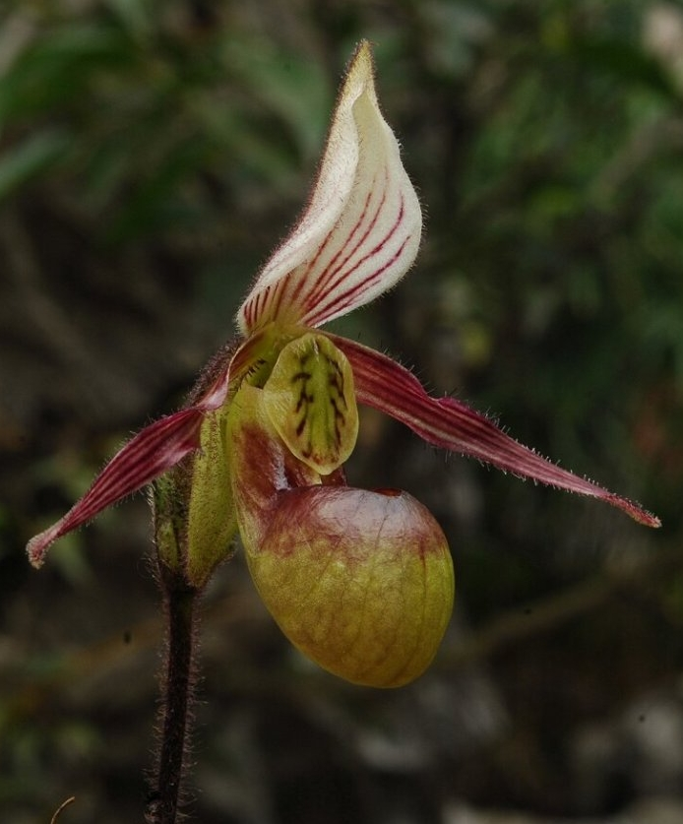
Synonyms
Paphiopedilum canhii var. funingense Z.J.Liu & L.J.Chen 2013 ³
Description
A mini-miniature sized, cool growing lithophyte with 3 to 5, elliptic to oblong-elliptic, acute to subacute, slightly emarginate, shortly apiculate, distinctly tesssellate laight and darker green above, pale green and heavily marked with dark dirty-violet below leaves that blooms in the earlier spring on an erect, dark green sometimes with a violet tint, pubescent, dirty olive-violet haired, 2.4 to 4" [6 to 10 cm] long, single flowered inflorscence ³

Terrestrial sympodial rosulate herb with 3– 4(5) leaves. Leaves elliptic to oblong-elliptic, acute or sub-acute, slightly emarginate and shortly apiculate at the apex, 5–7 cm long, 1.5–2(2.5) cm
wide, distinctly tessellated light and darker green above, pale green and heavily marked with dark dirty-violet below. Inflorescence erect, one-flowered; peduncle (6)8–10 cm long, slender, dark green, sometimes with violet tint, pubescent with dirty olive-violet hairs. Bract narrowly ovate-elliptic, acute, 1.2–1.4 cm long, 0.5 cm wide, green, oliveviolet pubescent. Flowers 6–8 cm across. Dorsal sepal ovate to broadly ovate, acute; 2–3 cm long, 1.5–1.8 cm wide; white, slightly greenish at the base, in lower half veined with 5–7 purple nerves; densely
hairy outside. Synsepal narrowly ovate, acute; 1.5–2 cm long, 0.6–1 cm wide; light uniformly dull green; hairy outside. Petals 3–4 cm long, 0.5–0.7 cm wide at the base; spreading, more or less horizontal; cuneate, narrowing from broad base to elongate, acuminate apex; background light green to pinkish-green, brightly deep green toward base, dull purple-violet to the apex; with 7–9 dark purple-violet longitudinal stripes along nerves; long white ciliate along irregularly slightly undulate margin; petal base with dense tuft of long dark violet papillae
at lower margin faced to lip entrance. Lip slipper-sac-like; 2–2.5 cm long, 0.8–1.4 cm wide, light dull green, with light brownishpurple tint on smooth and glossy incurved side lobes; inside at the base densely haired
with long white glassy papillae, dark violet at apex. Column short and broad, 3–4 mm long, brightly green. Stamens with elongate acute filament apices; filaments green; anther spherical, yellow to orange. Stigma light greenish-white. Staminode large, 1.2–1.6 cm long, 0.6–0.8 cm wide; entire, glossy, broadly ovate to ovate-elliptic, flat, hardly indistinctly emarginate and grooved at apex; white to light greenish, with irregular washy yellowish-green or greenish veins. Pedicel and ovary 2–3 cm long, dark green, densely pubescent with dirty oliveviolet hairs. Fruit dry narrowly ellipsoid, ribbed, shortly beaked capsule about 2 cm long and 4–5 mm in diameter.⁶

Range and Habitat
Found in Laos and Vietnam near mountain summits on shady vertical cliffs or on narrow mossy shelves with plant roots densely adpressed to solid naked limestone having no soil level at elevations of 1600 to 1800 meters.³
Few plants of new species were collected in 2009 in northwestern Vietnam. This species occurs as an endogenous element of primary coniferous, mixed and broad-leaved endemic forests covering
tops of remnant table- or mesa-like hills and mountains composed of highly eroded marblelike rocky limestone. A lone population was found in a shady place at the base of a vertical cliff near the mountaintop at an elevation about 4,920 feet (1,500 m) above sea level. Plants were collected and flowered in the nursery a few months later.⁶

F-1 Hybrids and Progeny
This species was not described until 2009 and has only 6 hybrids to date, none of which have been awarded nor have any progeny.

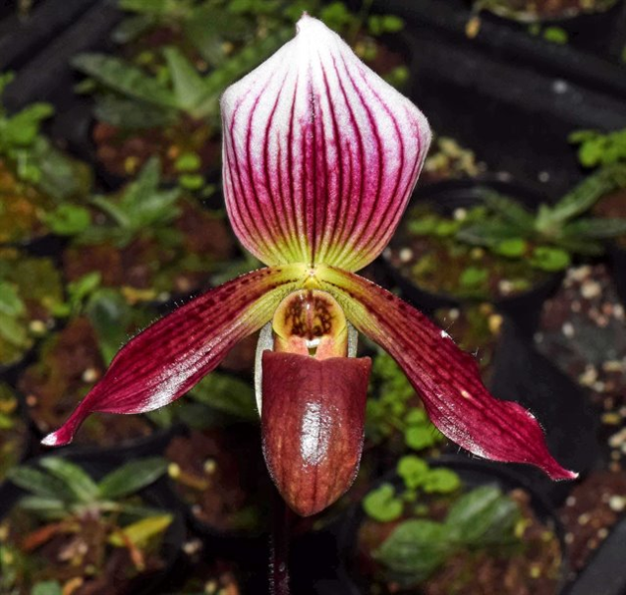
Paphiopedilum Wossner Zwergflammerl
(canhii x Jac Flash)

Awards
None

Culture
Paphiopedilums will grow easily into specimen plants. With good culture they branch freely and regularly. Because paphiopedilums are capable of producing flowers on rootless growths, particular care must be taken with watering when growing a specimen plant in order to produce a lovely display of blooms with a healthy extended root system beneath the surface of the potting medium.
Temperature and Humidity: The green-leaved types ideally require night temperatures around 50 to 55 oF, while the mottled-leaved types need 60 to 65 oF at night. Day temperatures should range between 70 and 80 oF, although short periods of moderate higher or lower temperatures will not injure the plants. The humidity should be moderate, between 40 and 50 percent.
Light and shade: Paphiopedilums enjoy medium light intensity, requiring 800 to 1,000 foot candles throughout the year for optimum growth. Direct sun, except in the early morning, should be avoided. In the home, move the plants back from the window at the peak of the noonday sun, or ideally grow them behind a filmy curtain.
Air Movement: As with all orchids, moist, vigorous air movement, at a temperature favorable to the plants is highly recommended to keep the leaves cool and to dry drops of water from the plants, thereby reducing chances of disease. Hot or cold drafts will blast paphiopedilum flower buds so be very careful of the position of your plants, particularly on a windowsill.
Watering: Although the growth habit of paphiopedilums is sympodial, they do not possess pseudobulbs. Hence, like phalaenopsis, they must receive regular and constant watering. This will entail keeping the potting media moist but not wet. Perfection of this technique requires some experimentation.

Water your paphiopedilums every five to seven days; however, your own conditions affect the rate at which your plants will dry out and thus require water. Watering should always be done early in the day so that the plant foliage can dry before temperatures drop at nightfall.
For those growers using bark as a potting medium, it is extremely important not to permit the plant to go dry, as the bark is then very difficult to rewet. Water will channel through the dry mix leaving most of the pot dry. When this happens the only solution is to submerge the whole pot and mix in a pan of water until moisture has been restored to the pot.
Potting: There are at present many different potting media to choose from. Many of them have been described in various issues of AOS Orchids. Straight fir bark makes an excellent growing medium. Because paphiopedilums are semi-terrestrial, a potting medium that drains well but retains moisture is necessary. Consequently, fine chopped fir bark, commonly called, 1/8 to 1/4 inch, is preferable to the medium to large sized chunks used as cattleya or phalaenopsis potting medium. Be sure that you wet the bark thoroughly before potting any type of orchid in it.
A paphiopedilum should be repotted when the potting medium has decomposed, when the plant has outgrown its pot, or when you wish to divide the plant. Although many paphiopedilums will live when divided into single growths with roots, it is preferable to make divisions of no fewer than three growths. The best time for repotting or dividing is immediately after flowering.
The procedures for repotting entail clipping off the old dead roots, and filling the compost medium in and around the roots until it reaches just slightly over the base of the plant. Do not bury the plant growths as this encourages rot, but the base of each growth should be in contact with the medium. You may wish to give your plant a little water immediately following repotting but, as with other orchids, watering is held to a minimum until evidence of new growth is apparent.
Place your newly potted paphiopedilum in a shaded area, moving it gradually into its proper light conditions once it has started growing again.
Feeding: Plants in fir bark are fed with a high nitrogen fertilizer, a 3-1-2 or 3-1-1 formula, at one-half recommended strength. For greenhouse growing you should fertilize three times and then use plain water for the fourth watering in order to leach out any salts that have accumulated. For home or windowsill growing alternate the use of fertilizer and plain water.
Plants grown in some of the more complicated mixes consisting of rock, peat, oak leaf mold, etc., should receive fertilizer at a more reduced strength as some of these components may provide nutrients or may be soured by a high nitrogen fertilizer at full strength.⁷

References
Aldridge, Peggy. 2008. An Illustrated Dictionary of Orchid Genera. Selby Botanical Garden Press.
¹la Croix, Isobyl. 2008. The New Encyclopedia of Orchids. Timber Press
³Jay Pfahl's IOSPE at www.orchidspecies.com
⁴OrchidWiz.Database X5.3

⁵ Chase MW. 2006. Cypripedioideae. In: Pridgeon AM, Cribb PJ, Chase MW, Rasmussen F, eds. Genera Orchidacearum, Vol. 1. Oxford: Oxford University Press, 153-161.
⁶Averyanov, L.V. & Gruss, Olaf & Canh, C.X. & Loc, P.K. & Dang, B & Hiep, N.T.. (2010). Paphiopedilum canhii - a new species from Northern Vietnam. Orchids. 79. 288-290. 7
⁷http://slipperorchids.org
http://apps.kew.org/wcsp/qsearch.do
https://secure.aos.org/aqplus/SearchAwards.aspx

