Paphiopedilum tonsum (Rchb. f.) Pfitzer 1895
The Bald Paphiopedilum

SUBGENUS Sigmatopetalum SECTION Punctatum³
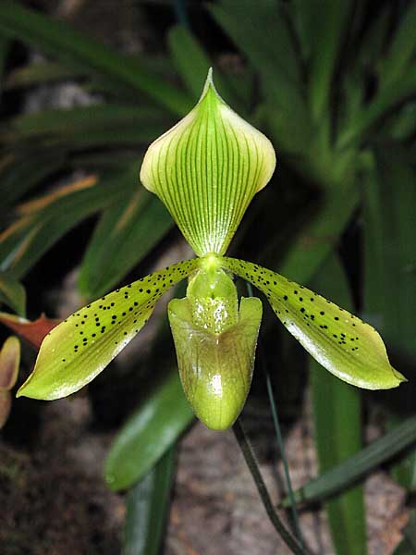
Synonyms
Cordula tonsa [Rchb.f] Rolfe 1912; Cypripedium tonsum Rchb. f. 1883; Paphiopedilum tonsum f. alboviride Braem 1998 ³
Description
A plant with oblong-elliptic, deep green mottled with gray green leaves with purple undersides that blooms on an erect, terminal, 12 to 15" [30 to 37.5 cm] long, purple marked, single flowered inflorescence with an elliptic-lanceolate floral bract.. ³
It is a mall sized, warm to cool growing terrestrial with narrowly elliptic or elliptic oblong, pale and dark green mottled, minutely bilobed apically, 12–23 cm long, 3.4–4 cm wide leaves.
The Java Paphiopedilum blooms in the summer and fall on a mottled pale green and crimson, erect, single flowered, to 30 cm long inflorescence with an elliptic, pale green spotted purple floral bract that has ciliate margins and midvein. Dorsal sepal pale green with darker green veins and a whitish pink margin; synsepal pale

green; petals pale green with a pink-purple apical quarter, finely spotted with dark maroon in basal half to three-quarters; lip bright green with darker veins, often brown-flushed.⁶

Range and Habitat
Occuring in Java and Borneo in hill and montane forests in fine-grained volcanic rock, boulder strewn slopes and in boulder crevasses in deep shade at elevations of 750 to 1900 meters.³
Northern and central Sumatra. Paphiopedilum tonsum grows in moderately bright situations at 3300-5900 ft. (1000-1800 m) on the western slopes of the Barisan Mountains from Padang northward. Plants usually grow in leafy humus on the forest floor or in humus filled cracks in limestone rocks and cliffs, but they may also be found in moss filled cracks and water seepages. -- Source: Charles Baker ⁴
Paphiopedilum tonsum is endemic to north and west Sumatra (from Merek to Sidikalang road) between 900 and 1800 meters above sea level. It grows in leafy humus on the forest floor or in humus-filled cracks in limestone rocks and cliffs and sometimes near water seepages. ⁶
• Elevation: 1000-1800 m
• Peak Flowering in the Wild: January-February
• Ecology: on the forest floor or in the cracks of limestone and other rock
• Mean Temperature Range: 18-20°C
• Light: moderately deep shade
• Medium: humus, leaf litter, sometimes calcareous⁷

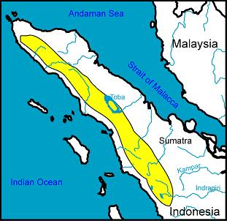⁷

F-1 Hybrids and Progeny
Of the 119 progeny produced since the grex was registered in 1895, very few amounted to anything and none are particularly fertile with only 3 generations of progeny. The most awarded is an F-1 called Olivia. It is a primary with P. niveum and has 19 progeny and 11 AOS awards. The only other hybrid of note is Solon, another primary, this time with P. rothschildianum. The rest of the grexes have a spattering of offspring and awards. Not a significant species.

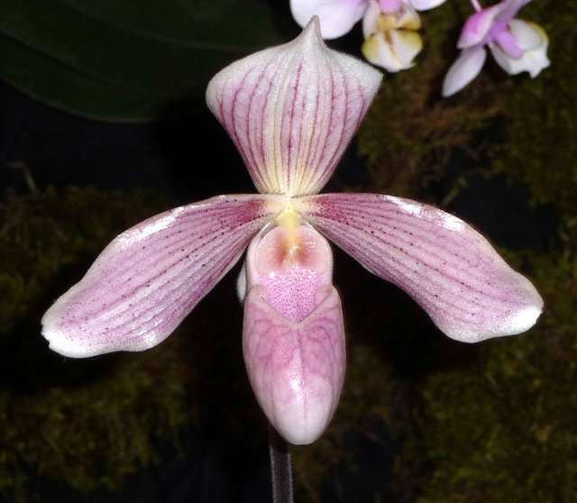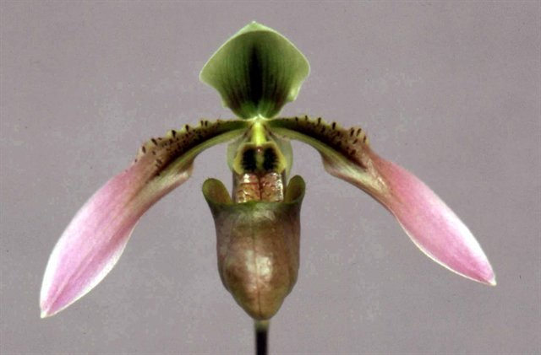
Paphiopedilum Olivia AM/AOS Paphiopedilum Solon AM/AOS

Awards

Paphiopedilum tonsum has received 52 awards, 34 from the AOS. These include 10 AM, 1 CCM, 1CHM, 20 HCC and 2 JC. The earliest was 1967 and the latest an AM in 2018.

Culture

Light:
Paphiopedilum tonsum like bright sunshine without access to direct sunlight, so during the midday solstice they must be placed behind a curtain or in the shade of other plants.

Temperature:

This orchid need the follow temperature regime: day temperature at 20-25 ° C with night reduction to 16-22 ° C. For successful cultivation at home, the night temperature of the content should always be 3 ° C lower than the daily one.

Humidity:
The humidity of 50-70% will be enough for normal growth and development of the plant. However, at temperatures above 27 ° C, it is desirable to increase the air humidity to at least 70%, since too dry air adversely affects the roots and leaves of the plant. A lot of fresh air and sufficient air circulation are recommended.

Substrate, growing media and repotting:
Paphiopedilum tonsum are grow only in the pot. A mixture of bark of coniferous trees with peat is best suited as a substrate. In addition, it is strongly recommended to add lime to the substrate. Practically not exhausted source of lime are seashells, which can be thoroughly washed from salt, crushed and poured into the substrate.
Repot is necessary annually. The best time for this is spring - the beginning of a new growth. A very important point here is the height of planting. If this orchid is planted incorrectly, for example, too high, the orchid's roots will hang in the air and stop growing. The substrate should cover the upper red-and-white part of the plant for 1-2 fingers, and in no case should it be tamped down, because if the substrate is too dense, the orchid can simply suffocate. When planting, you must take care of a thick layer of drainage to protect the orchid from stagnant water inside the pot.

Watering:
The Bald Paphiopedilum needs frequent and abundant watering throughout the year. Excess water during irrigation should flow freely from the pot, since stagnation of water both inside the pot and in its pan can very quickly lead to rotting of the roots and the lower part of the plant. The substrate between waterings should dry well, but not dry completely. After watering, water from the leaves must be removed with a tissue or tissue.
Spraying the outer part of the plant at home will not lead to anything good, since the structure of its leaves resembles a funnel, and water constantly accumulates in the core of the plant, which can very quickly lead to rotting of both peduncles and the core itself.

Fertilizer:
Throughout the year, this orchid is fertilized once every two weeks in the spring and summer, once every 4 weeks in the fall and winter. Fertilizer should be applied to the plant with 30-10-10 fertilizer, diluted, ¼ teaspoon per week in summer and once a month in winter. Each month to flush the water once to prevent the salt from standing in the pot.

Rest period:
Paphiopedilum tonsum needs a well-defined dormant period to stimulating flowering. It begins, as a rule, in the middle of November, and consists in the fact that orchids are much drier and colder than usual and not fertilized. Night temperature during this period should be no more than 15 ° C. Watering should be replaced with a light, clear spraying of the substrate. After the appearance of peduncles, the dormant period ends: watering is resumed in the usual volume, and the total temperature of the content rises. ⁶

References
Aldridge, Peggy. 2008. An Illustrated Dictionary of Orchid Genera. Selby Botanical Garden Press.
¹la Croix, Isobyl. 2008. The New Encyclopedia of Orchids. Timber Press
³Jay Pfahl's IOSPE at www.orchidspecies.com
⁴OrchidWiz.Database X5.3
⁵ Chase MW. 2006. Cypripedioideae. In: Pridgeon AM, Cribb PJ, Chase MW, Rasmussen F, eds. Genera Orchidacearum, Vol. 1. Oxford: Oxford University Press, 153-161.
⁶https://travaldo.blogspot.com/care-and-culture.html
⁷http://slipperorchids.info/paphdatasheets/
http://apps.kew.org/wcsp/qsearch.do
https://secure.aos.org/aqplus/SearchAwards.aspx

