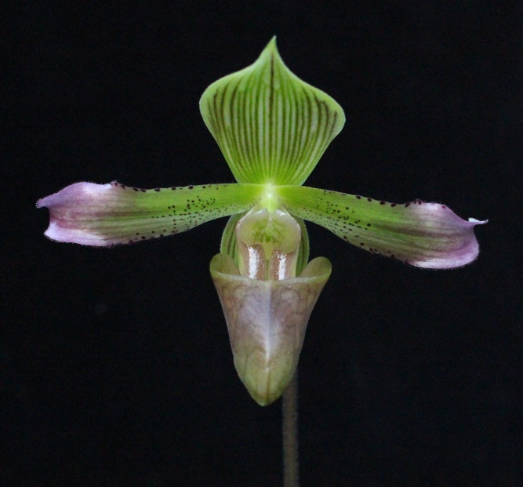
Paphiopedilum javanicum AM/AOS 86 Points
One flower on a 45 cm inflorescence, dorsal sepal apple green, veined brown; petals hirsute, apple green, overlaid lavender distally, finely spotted proximally and on margins; pouch light green, overlaid lavender, reticulated; staminode olive, green centrally; substance firm; texture glossy.

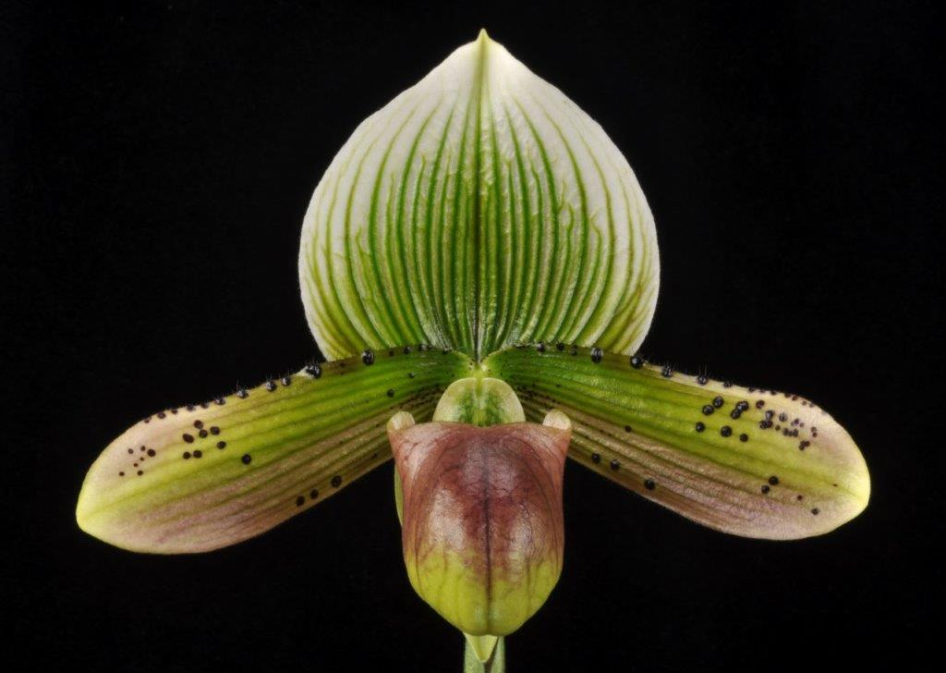
Paphiopedilum Luna Pleasure AM/AOS 87 Points
One well presented flower on a 27 cm inflorescence; dorsal sepal white, overlaid green centrally, veined apple green; petals white, superior half overlaid green and veined darker green, inferior half overlaid light mahogany, dark mahogany spotting along margins and clustered distally; pouch yellow green, overlaid mahogany; staminose green; substance firm; texture waxy.

Paphiopedilum Petula’s Jewell HCC/AOS 78 Points
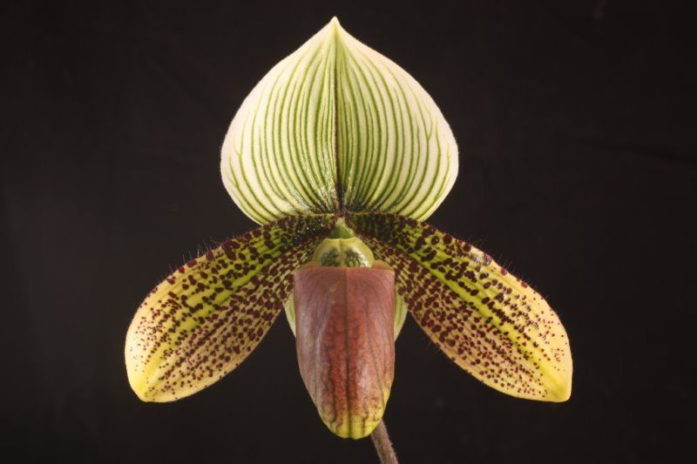
One flower on one strong 29 cm inflorescence; dorsal sepal cream, veined yellow green; petals downswept, golden yellow, overlaid green medially, veins spotted cordovan; pouch chartreuse, heavily overlaid cordovan; substance light; texture satiny.

Paphiopedilum China Dragon AM/AOS 82 Points
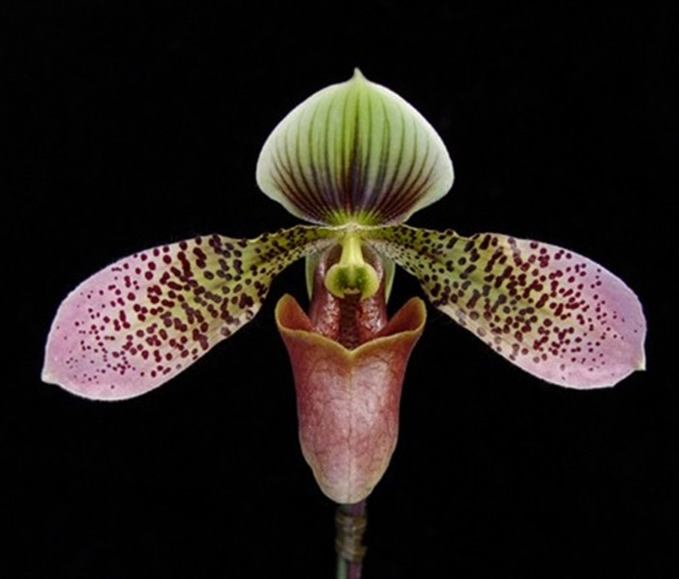
Two flowers on two 25 cm inflorescences; dorsal sepal white, overlaid light green except margins, veined mahogany, veining dark mahogany proximally, fading distally; petals white, overlaid green proximal half, rose distal half, spotted mahogany proximal two thirds; pouch white, heavily overlaid cordovan, lip margin chartreuse; staminose chartreuse, darker green centrally; substance firm; texture satiny.

Paphiopedilum Whimsey HCC/AOS 77 Points
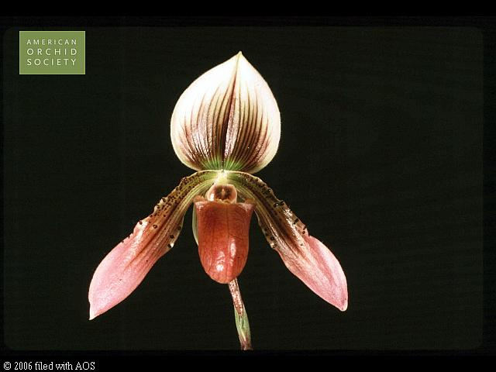
One flower and on one inflorescence; dorsal sepal white, veined mahogany centrally, wide margin unmarked, small basal area green; petals down swept, white, heavily overlaid and spotted brown proximal half, distal half pink; pouch white, heavily overlaid mahogany; staminode white, mahogany centrally; substance light; texture satiny.

