Aerides Lour. 1790
SUBFAMILY Epidendroideae, TRIBE Vandeae, SUBTRIBE Aeridinae.
ETYMOLOGY: From the Greek ‘Kypris’ , a name for Aphrodite (Venus) who was born on the island of Cyprus, and ‘pedilon’, a sandal or slipper, in reference to the shape of the lip. The suffix was incorrectly Latinized vernacular names in Europe such as ‘Frauenschuh’, ‘Marienschuh’, and ‘Lady's Slipper’, the lady being variously considered to be Aphrodite, Venus or the Virgin Mary.³
SYNONYMS: Aeridium Salisb. 1812; `Orxera Raf. 1836[1838]; Polytoma Lour. ex B A Gomes 1868¹
TYPE SPECIES: Aerides odorata Lour. 1790
DESCRIPTION: Coarse, epiphytic herbs. Stems ascending, enclosed by leaf-sheaths, with many nodes. Leaves linear-oblong to terete, coria-ceous, distichous, apex bilobed, jointed and sheathing at base. Inflorescence racemose or paniculate, lateral, pendent, usually densely many-flowered. Flowers showy. Sepals and petals similar, broad, spreading; lateral sepals decurrent on column foot. Petals smaller than sepals. Labellum continuous with column foot, usually immobile, trilobed, spurred, side lobes decurrent on column, erect, midlobe often erose; spur narrowly conical or horn-shaped, bent forward, usually with swellings or calli inside. Column elongate, often broadened at apex, foot distinct; anther cap two-celled, beaked; pollinia waxy, two, subglobular, une-qually cleft, attached by a long, slender stipe to a single, semi-circular viscidium; rostellum well developed, bifid after removal of pollinia, porrect. ³
ECOLOGY: Aerides species are epiphytes or sometimes lithophytes, from 0 to 2000 m. Aerides krabiensis Seidenf. is found growing in full sun on dry limestone coastal rocks in Thailand. Aerides mul-tiflora Roxb. is recorded as epiphytic on species of Dillenia L. (Dilleniaceae) and Fraxinus L. (Oleaceae) on river banks in Bhutan, on Maneera indica Wall. (Anacardiaceae) trees in India, and in deciduous forest in Thailand. Aerides odorata often grows high in the branches of trees where it receives ample light; it is recorded from secondary subtropical forests in Bhutan, litho-phytic in deciduous forests in Laos, epiphytic on Terminalia catappa L. (Combretaceae) in littoral vegetation in Kalimantan, and from lowland forests, hill forests, sometimes on ultramafic substrate, and lower montane forests in Sabah. Aerides ringens (Lindl.) C.E.C.Fisch. is known from moist semi-evergreen forest between the wet and dry zone and extending into tropical savannas in Sri Lanka.³
DISTRIBUTION: There are about 20 species of Aerides distributed from Sri Lanka, India, Nepal, Bhutan, Burma, China, Thailand, Indochina and Malaysia to the Philippines and Indonesia ³

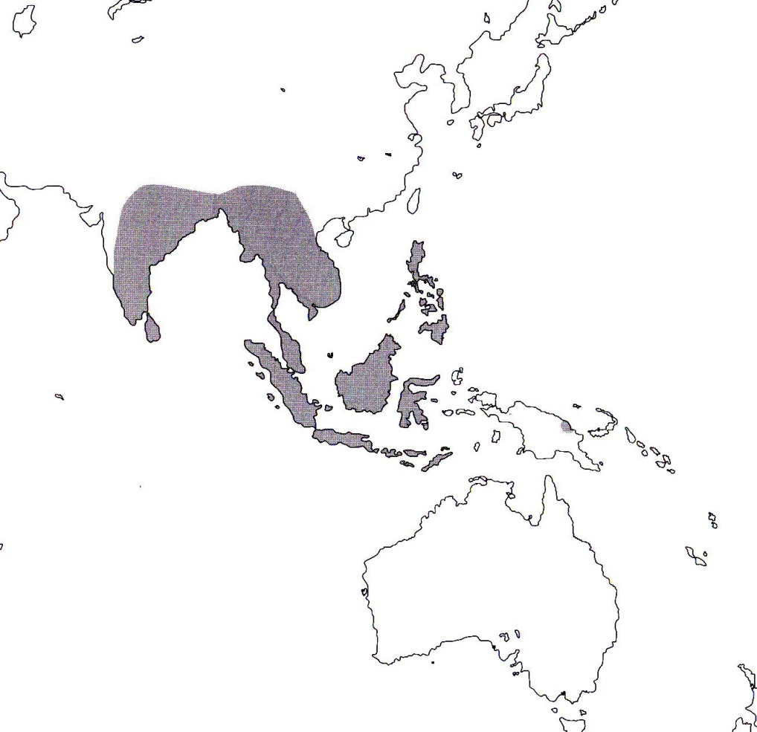
References
¹ Jay Pfahl's IOSPE at www.orchidspecies.com
²Aldridge, Peggy. 2008. An Illustrated Dictionary of Orchid Genera. Selby Botanical Garden Press.
³Cribb, CJ. 2014. Epidendroidae. In: Pridgeon AM, Cribb PJ, Chase MW, Rasmussen F, eds. Genera Orchidacearum, Vol. 6. Oxford: Oxford University Press, 344-349.

⁴la Croix, Isobyl. 2008. The New Encyclopedia of Orchids. Timber Press

