Angraecum Bory 1804
SUBFAMILY Epidendroideae, TRIBE Vandeae, SUBTRIBE Angraecinae.
ETYMOLOGY: From the Indonesian word anggrek meaning orchid ³
SYNONYMS: Aeranthus Rchb.f 1826; Aerobion Spreng. 1826; `Angorkis Thou. 1809; Angorchis Spreng 1822; Barombia Schlechter 1914; Angraecoides Szlach., Mytnik & Grochocka 2013; Arachnangraecum (Schltr.) Szlach., Mytnik & Grochocka 2013; Bonniera Cordem 1899; Boryangraecum (Schltr.) Szlach., Mytnik & Grochocka 2013; Conchograecum Szlach., Grochocka, Oledrz. & Mytnik 2018; Dolabrifolia (Pfitzer) Szlach. & Romowicz 2007; Epidorchis Thou. 1822; Gomphocentrum Szlach., Mytnik & Grochocka 2013; Hadrangis (Schltr.) Szlach., Mytnik & Grochocka 2013; Hermansia Szlach., Mytnik & Grochocka 2013; Humblotiangraecum (Schltr.) Szlach., Mytnik & Grochocka 2013; Lemurangis [Garay] Szlach., Mytnik & Grochocka 2013; Lepervenchea Cordem. 1899; Lesliegraecum Szlach., Mytnik & Grochocka 2013; Macroplectrum Pfitz. 1889; Monixus Finet 1907; Pectinaria Cordem. 1819; Pectinariella Szlach., Mytnik & Grochocka 2013; Perrierangraecum (Schltr.) Szlach., Mytnik & Grochocka 2013; Pseudojumellea (Schltr.) Szlach., Mytnik & Grochocka 2013 ¹
TYPE SPECIES: Angraecum eburneum Bory 1804
DESCRIPTION: Epiphytic or less commonly lithophytic herbs, sometimes psygmoid. Stem erect to pendent, leafy. Leaves distichously arranged or in a fan, dorsiventrally flattened, V-shaped in cross-section, unequally bibbed at tip. Inflorescences one to many in a fascicle, axillary, solitary- or many-flowered, usually unbranched. Sepals and petals free, subsimilar or petals smaller than sepals, usually tapering. Labellum entire, with or without a basal linear callus, with a globose, clavate or filiform spur. Column lacking a foot; pollinia two, each attached to its own linear or elliptic viscidium; rostellum deeply cleft, sometimes with a median tooth.³
DISTRIBUTION: Angraecum comprises 221 species, occurring mainly in Africa, Madagascar, and the adjacent islands of the Indian Ocean. Angraecum lanicum Lindl. occurs in the Seychelles and Sri Lanka. ³
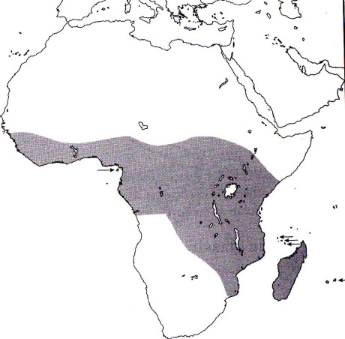
References
¹ Jay Pfahl's IOSPE at www.orchidspecies.com
²Aldridge, Peggy. 2008. An Illustrated Dictionary of Orchid Genera. Selby Botanical Garden Press.
³Cribb, CJ. 2014. Epidendroidae. In: Pridgeon AM, Cribb PJ, Chase MW, Rasmussen F, eds. Genera Orchidacearum, Vol. 6. Oxford: Oxford University Press, 344-349.

⁴la Croix, Isobyl. 2008. The New Encyclopedia of Orchids. Timber Press
⁵Meisel, Kaufmann, Pupulin 2014. Orchids of Tropical America .Cornel University Press

