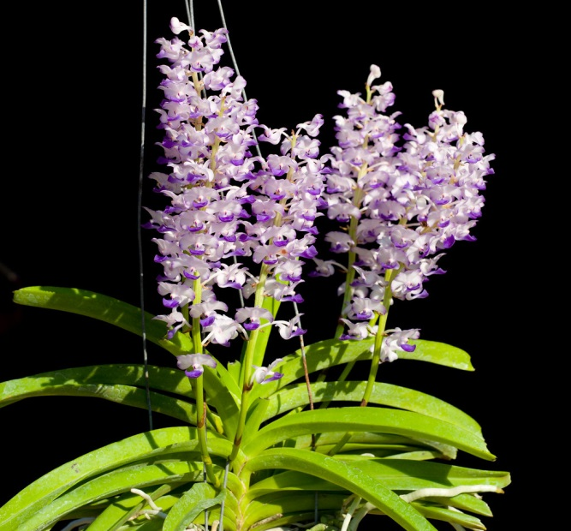
Rhynchostylis coelestis CCM/AOS 82 Points
Three hundred and twenty flowers and 14 buds on seven upright 420 cm long inflorescences grown in a 380 x 380 cm wooden basket in bark; sepals and petals white, suffused light fuchsia apically, lip white, distal half overlaid dark fuchsia; column white; substance firm; texture matte.

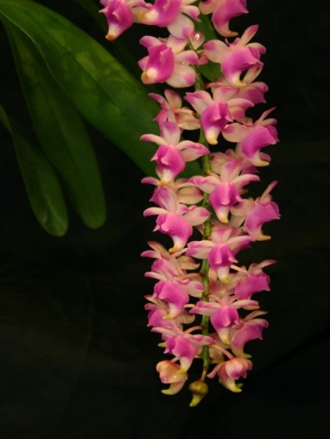
Aerides Punchinello AM/AOS 87 Points
Twenty-four flowers and two buds well presented on one pendant 80 cm inflorescence, sepals and petals cream, suffused rose magenta apically; lip hinged, oval, pointed, cream, overlaid rose basal two thirds; column tan;substance very firm; texture satiny

Angraecum Alabaster HCC/AOS 78 Points
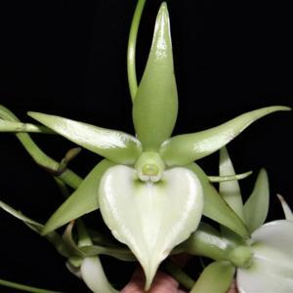
Fifteen open, stellate flowers on two inflorescences; sepals and petals white, suffused light green, slightly darker basally; lip chordate, white; column white, overlaid light green dorsally; substance firm; texture glossy.

Arangus articulata AM/AOS 82 Points
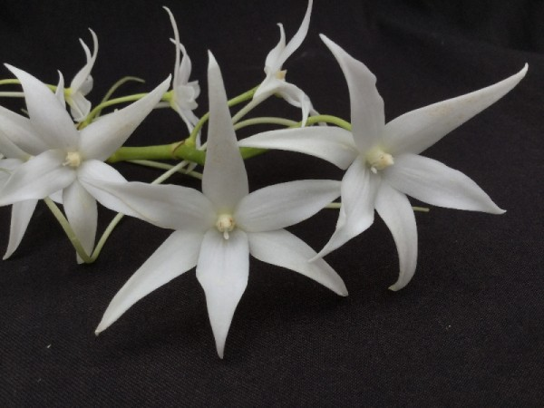
Thirty-one unblemished white flowers, well spaced and arranged on two inflorescences and 1 immature inflorescence; column cream; substance heavy; texture diamond dust.

Aerangus Elro HCC/AOS 77 Points
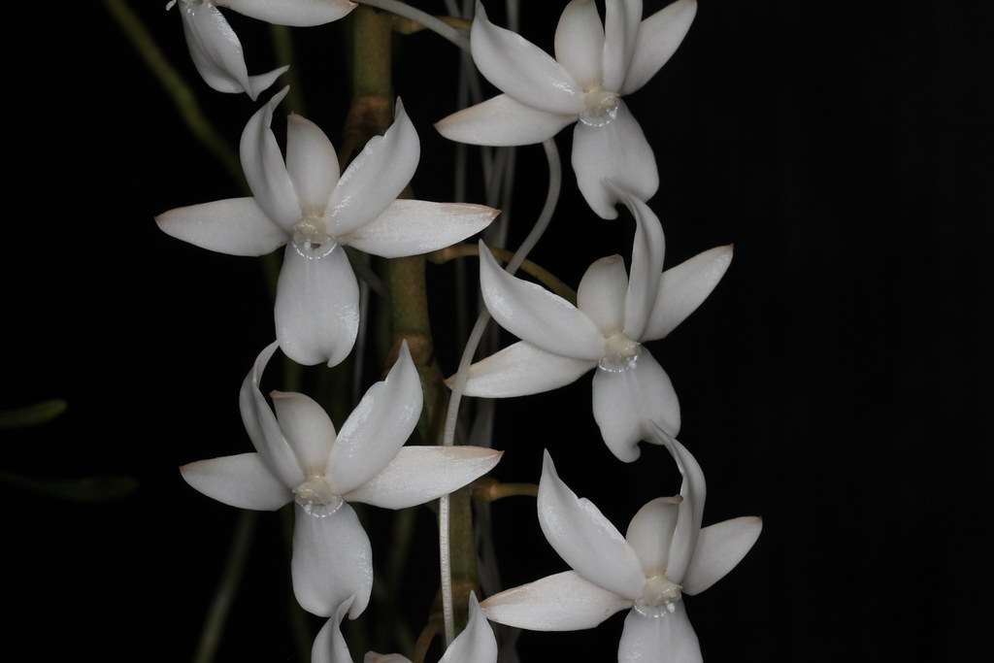
Forty-one flowers white well arranged on two arched, pendant 45 cm inflorescences; sepals reflexed; petals reflexed, superior margin suffused yellow-brown; lip white, nectary arched to 14 cm; substance firm; texture satiny.

