Rhynchostylis Blume 1825
SUBFAMILY Epidendroideae, TRIBE Vandeae, SUBTRIBE Aeridinae.
ETYMOLOGY: From the Greek rhynchos, snout, and solos, column, in reference to the beak-like column of the type species. ³
SYNONYMS: Anota Schlechter 1914
TYPE SPECIES: Cypripedium calceolus L.
DESCRIPTION: Epiphytic herbs. Stem robust. Leaves many, distichous, often lorate, channelled, unequally bibbed or toothed, usually with pale green stripes, articulate to a sheathing base. Inflorescence lateral, racemose, erect or pendent, many-flowered. Flowers resupinate, with a 'soapy' fragrance. Sepals and petals free, similar, spreading, lateral sepals often wider and oblique. Petals smaller than sepals. Labellum rigidly adnate to column foot, entire or slightly trilobed, midlobe dorsiventrally flattened, spurred at base; spur laterally compressed and backward-pointing, without internal callosities. Column with a column foot; anther cap beaked; pollinia two, waxy, globular, cleft, solid, stipe linear, apex slightly dilated, viscidium ovate; rostellum beaked. ³
DISTRIBUTION: Rhynchostylis includes three species collectively distributed from Sri Lanka and India through mainland Southeast Asia, China, and the Philippines south through Malaysia and Indonesia.³
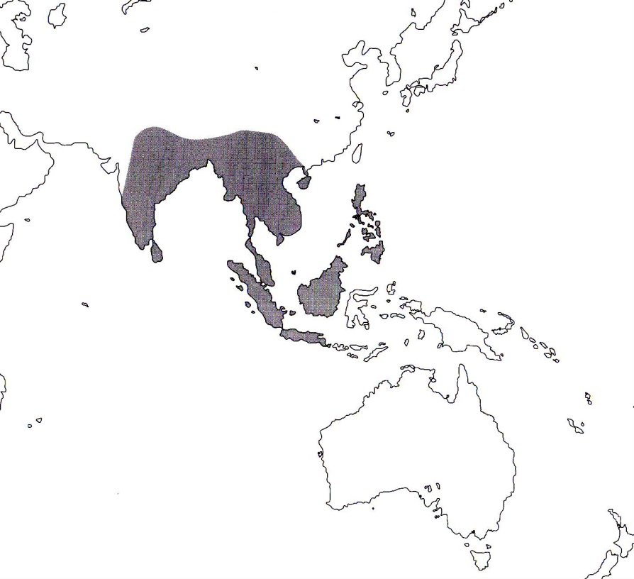
References
¹ Jay Pfahl's IOSPE at www.orchidspecies.com
²Aldridge, Peggy. 2008. An Illustrated Dictionary of Orchid Genera. Selby Botanical Garden Press.
³Cribb, CJ. 2014. Epidendroidae. In: Pridgeon AM, Cribb PJ, Chase MW, Rasmussen F, eds. Genera Orchidacearum, Vol. 6. Oxford: Oxford University Press, 344-349.

⁴la Croix, Isobyl. 2008. The New Encyclopedia of Orchids. Timber Press
⁵Meisel, Kaufmann, Pupulin 2014. Orchids of Tropical America .Cornel University Press

