Aerangis luteoalba (Kraenzl.) Schltr. 1918
The Beige Aerangis with Red Spots
SUBFAMILY Epidendroideae, TRIBE Vandeae, SUBTRIBE Aerangidinae.
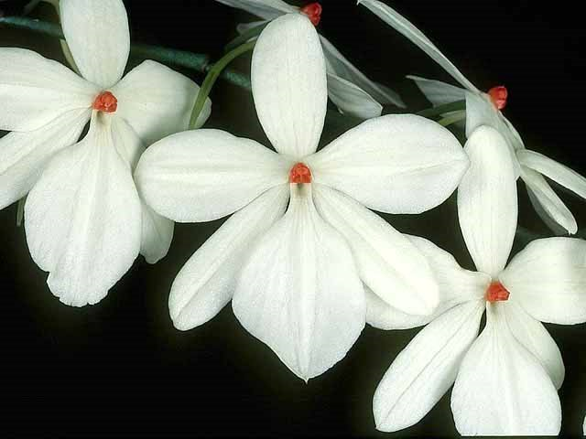
Synonyms
Aerangis albidorubra [DeWild]Schlecter 1918; Aerangis rhodistica [Krzl]Schlechter 1918; Angorchis rhodosticta (Kraenzl.) Kuntze 1903; Angraecum albidorubrum De Wild. 1916; Angraecum luteo-album Kraenzl. 1895; Angraecum mirabilis Hort. Angraecum rhodisticum Kraenzel 1899; Rhaphidorhynchus luteoalbus (Kraenzl.) Finet 1907 ³
Description
This miniature to just small sized, epiphytic species is found in the Central African Republic, Cameroon, Congo, Zaire, Ethiopia, Kenya, Tanzania and Uganda in riverine forests on small twigs and branches of bushes and trees, rarely on trunks at elevations of 1250 to 2200 meters and appreciates a humid environment. Aerangis leutoalba has flattened roots, a very short stem carrying several spreading, more or less distichous, linear, curved, fleshy, unequally bilobed apically leaf that are all set in the same plane leaves³
Range
The species grows across equatorial Africa from Cameroons and the Congo Republic in the west through the central and western forests of Uganda to Somalia, Ethiopia and Kenya in the east. In Kenya, the plants are usually found at 3000-5000 ft. (910-1520 m) on the southern and southeastern slopes of Mt. Kenya and on the southern slopes of Mt. Elgon. Aerangis rhodosticta grows in warm, moist conditions, almost always in forests along rivers. Plants normally grow in areas well protected from drought, often near waterfalls. They usually grow on twigs and branches of shrubs, but are occasionally found on tree trunks. -- Source: Charles Baker

Awards
AM | HCC | JC | CCM | CBM | CHM | FCC |  | Total
13 | 6 | 2 | 9 | 3 | 0 | 2 |  | 35

Hybrids

Thirteen F-1 primaries have been registered since 1982. Two have been awarded. There are no progeny.

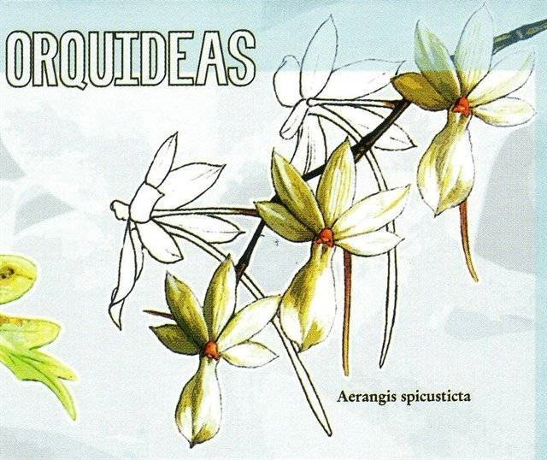

Aerangis Somastica AM/AOS Aerangis Spicustica AM/AOS

Culture

Light: Aerangis luteoalba needs a light level of 12000-20000 lux. This species grow well on window sills or under artificial lighting. You can use fluorescent lamps and placing the plants 15-23 cm below the light source.

Temperature: It is a thermophilic plant The average summer temperature in the summer is 24-27 ° C, and at night 14 ° C, with daily temperature fluctuations of 10-13 ° C. In winter, the average day temperature is 21-23 ° C, at night 13-14 ° C, with a daily amplitude of 8-9 ° C.

Humidity: The Beige Aerangis with Red Spots needs the average humidity of 70-75% for most of the year with a drop to almost 65% for a short period in early spring.
Substrate, growing media and repotting: Aerangis luteoalba var. rhodosticta grow best when fixed on cork pieces with a certain amount of sphagnum moss placed under the plant. The plants did not grow well on tree root pods. The plants mounted in this way require high humidity of the air. In addition, attached plants must be misted at least once a day for most of the year, and the hottest days of summer may require several additional fogs. If it is necessary to use pots, you can use a very loose substrate to allow air to enter the roots. You can use medium or large size pieces of fir bark. However, it seems that young seedlings grow better and less often lose their roots if a loose mixture of pumice or coconut fibers is used, and not a base based on fir bark. Use as small as possible clay pots.
Repotting should be carried out when new roots start growing, which allows the plant to settle in the new container as quickly as possible.

Watering: The Beige Aerangis with Red Spots should be kept moist in autumn and spring. In winter and in summer, they should allow a slight drying between waterings, but the substrate should never completely dry up and the plants should not be dried out for a long period of time. In the case of plants mounted on rootstocks, it is recommended to fog 5 times a week outside the winter period and rainy days. During hot weather, the plants should also be well moistened daily or completely immersed in water 3 times a week.

Fertilizer: During the period of strong growth, the plant should be fertilized every week 1/4-1/2 of the recommended dose of fertilizer for orchids. You can use fertilizer with low nitrogen content and high phosphorus content in autumn. If pots are used for cultivation, every few weeks the soil should be rinsed to avoid the formation of mineral deposits, especially when high doses of fertilizers are used. Rinsing throughout the whole year is important especially where the water is highly mineralized.

Rest period: In 4 months of winter and two months of summer, early morning fogging and thorough watering about every two weeks is recommended for Aerangis luteoalba var. rhodosticta. Special attention should be paid to any signs of weakening of the plants during periods of reduced watering, especially in summer. If such signs appear, the amount of water should be increased.⁵

References
Aldridge, Peggy. 2008. An Illustrated Dictionary of Orchid Genera. Selby Botanical Garden Press.
¹la Croix, Isobyl. 2008. The New Encyclopedia of Orchids. Timber Press
³ Jay Pfahl's IOSPE at www.orchidspecies.com
⁴OrchidWiz.Database X5.3
⁵https://travaldo.blogspot.com/care-and-culture.html
http://apps.kew.org/wcsp/qsearch.do
https://secure.aos.org/aqplus/SearchAwards.aspx

