Aerides houlletiana Rchb.f 1872
SUBFAMILY Epidendroideae, TRIBE Vandeae, SUBTRIBE Aeridinae SECTION Falcata
Common Name: Houllet's Aerides
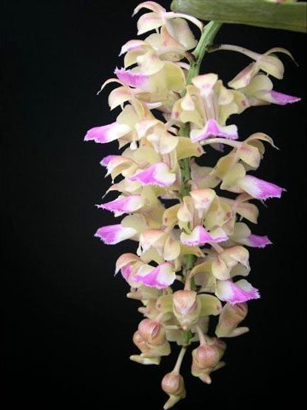
Synonyms
Aerides falcata var houlletiana [Rchb.f] Veitch; Aerides houlletiana var. majus André 1891; Aerides picotianum Rchb. f. 1888; Aerides platychilum Rolfe 1893 ³
Description/Range
A medium to large sized, hot to warm growing species from Thailand, Vietnam and Cambodia occuring in evergreen, semi-deciduous and deciduous dry lowland forests at elevations of sea level to 700 meters in partial

shade, with ligulate, apically bilobed leaves that blooms in the spring and summer on a 16" [40 cm] long, dense, pendulous inflorescence carrying many [12 to 20], large, fleshy flowers that are quite fragrant. ³
F-1 Hybrids and Progeny
Aerides houlletiana has 37 F-1 hybrids registered since 1971. The have received 40 awards and have 24 progeny in 2 generations.

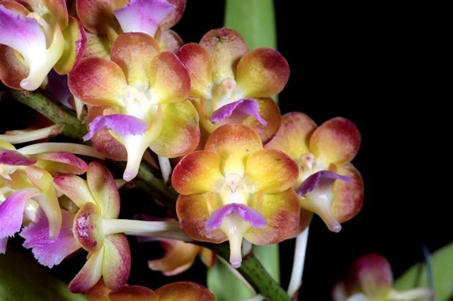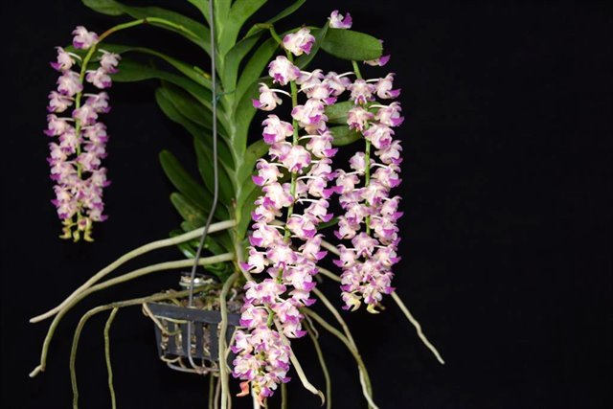
Perreiraara Bangkok Sunset/AOS Aerides Korat Koki AM/AOS
Awards
AM | HCC | Total
6 | 5 | 11

Culture

Light: Medium to high with South windows being ideal in winter months (Northern hemisphere) and East windows during summer months. 2,500 to 3,500 foot candles. This plant will also do well out of doors given diffused sunlight as through a birch or pine tree. This plant will also do well under high pressure sodium fixtures.

Humidity and temperature: Aerides houlletiana species require medium-high temperatures with lowest values preferably over the 20 °C, high humidity, 50% or higher is ideal (the use of humidity trays or room humidifiers is beneficial), and constant ventilation.

Watering: It is best to use rainwater, distilled or reverse osmosis water. Municipal water with a pH of 7.5 or lower can also be used. Water as the mix just dries out. When in spike or bloom water as the mix approaches dryness but do not allow the mix to become completely dry between watering. Overwatering can cause several problems such as root rot and infectious bacteria/fungus in the potting medium.

Growing medium: Plants are best grown hanged in baskets and on mounted. Plants should be grown in media that is well drained such as tree fern fibers (for small plants), several pieces of coarse fir bark, or sphagnum moss.

Fertilizer: Use 20-10-20 for municipal or well water. Use at the rate of ½ teaspoon per gallon. If using with rain, distilled, or reverse osmosis water, add back in 5 - 10% municipal or well water to supply the necessary calcium and magnesium. Fertilize every other watering in the summer and every third watering in the winter.
References
Aldridge, Peggy. 2008. An Illustrated Dictionary of Orchid Genera. Selby Botanical Garden Press.
¹la Croix, Isobyl. 2008. The New Encyclopedia of Orchids. Timber Press
²Meisel, Kaufmann, Pupulin 2014. Orchids of Tropical America .Cornel University Press
³ Jay Pfahl's IOSPE at www.orchidspecies.com
⁴OrchidWiz.Database X5.3
http://apps.kew.org/wcsp/qsearch.do
https://secure.aos.org/aqplus/SearchAwards.aspx

