Angraecum scottianum C.F.Reed, Phytologia 48: 426 (1981).
Common Name: Scott’s Angraecum
SUBFAMILY Epidendroideae, TRIBE Vandeae, SUBTRIBE Angraecinae SECTION Arachnangraecum

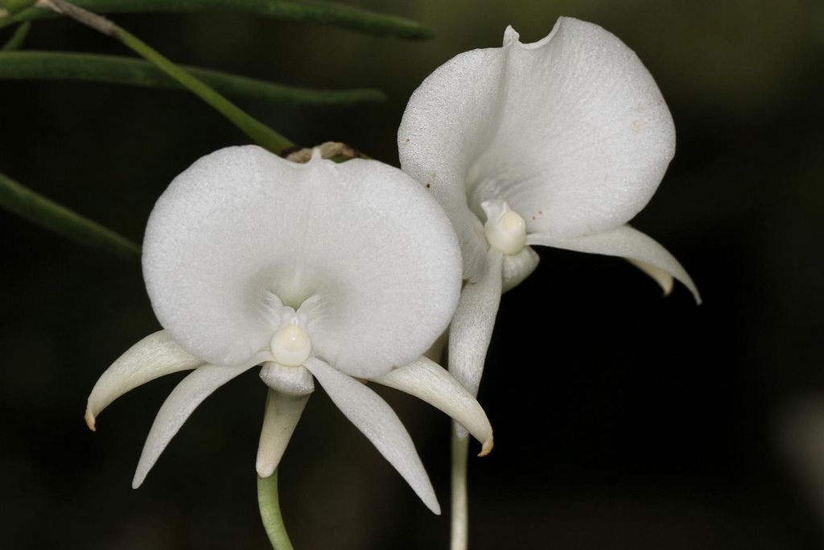
Synonyms
Angorchis scottiana [Rchb.f] O.Ktze. 1891; Angraecum reichenbachinum Kraenzl. 1890; Arachnangraecum scottianum (Rchb.f.) Szlach., Mytnik & Grochocka 2013 ³
Description
This small sized, hot to warm growing epiphyte with subcylydrical to terete leaves comes from the Comoros Islands and is found at an altitude of 350 to 600 meters in open exposed areas with erect or pendant, elongated, cylindrical stems carrying 6 to 8, subcylindrical or terete, subulate, bicarinate, canaliculate leaves that blooms in the spring, summer and early fall on a 4" [10 cm] long, axillary, slender, mostly ascending raceme with scarious bracts and carrying fragrant, inverted, waxy, successively opening flowers with only one open at a time.
Habitat: Comoro Islands. On Grande Comoro Island, this species is found on the western slopes of Mt. Karthala at 1300-1950 ft. (400-600 m). It grows epiphytically on the trunks and lower branches of large trees, often with other epiphytes. Plants are most frequently found on the west side of the trees where they are exposed to almost full afternoon sun. -- Source: Charles Baker⁴
F-1 Hybrids and Progeny
Angraecum scottianum has 12 F-1 offspring. All but 2 are primaries with Vandaceous species. The most awarded is a cross with Angraecum longicalcar called Angraecum Longiscott. It has 6 AOS awards including 2 AM, 1 HCC and 3 CCM. Another primary, Joyce Stewart, has an HCC. There is only 1 secong generation offspring called Angraecum Argonaut. No photo could be found
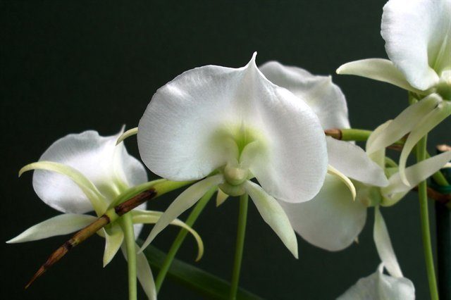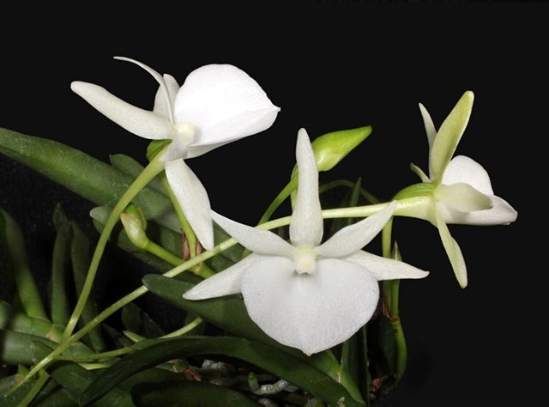
Angraecum Longiscott AM/AOS Angraecum Joyce Stewart HCC/AOS
Awards
The species has received three AOS awards, 1 CCM, 1Chm and 1 CBM.

Culture

Light: Angraecum scottianum loves bright sunlight and is able to tolerate direct morning and evening sun, however, in the hot summer noon (especially on windows of southern orientation), the orchid should be protected from direct sunlight: put behind a curtain (for example, on a table near the window) or in the shade of other plants, otherwise the plant can get a sunburn.

Temperature: This type of orchid refers to a moderately warm temperature regime, and throughout the year the plants are recommended to be kept under the following temperature conditions: Day temperature at 20-28 ° C; Night temperature at 16-18 ° C. To successfully growing at home, it is necessary that the night temperature of the content is always at least 4 ° C lower than the daytime temperature.

Humidity: Scott's Angraecum needs the humidity of 60-65% (ideally 70-80%). Too dry air negatively affects the overall development of the plant - its growth is inhibited, roots begin to dry out, and the leaves become flabby and turn yellow.

Substrate, growing media and repotting: Angraecum scottianum can be grow in pots and hanging lattice baskets and placed on blocks. As a substrate, a mixture of bark of coniferous trees with charcoal and a small fraction of sphagnum moss is best. When growing orchids on blocks to prevent rapid drying of the root system of the plant, it is recommended to make a small interlayer of moss between it and the block. Above the roots can also be put live or dry sphagnum, and the plant itself is placed with a slight inclination down, but not upside down. This species reacts negatively to the repotting and can not bloom after 1-2 years, therefore it is recommended to replant the plant only when it is really necessary. For example, in cases of severe salinization or compaction of a substrate, too high or low pH, etc. The best time for transplantation is the spring period.

Watering: Watering this kind of orchids directly depends on the total temperature of the content, the higher it is, the more often and abundant it will be necessary to water. Plants growing on blocks should be watered daily in the morning, so that by evening the roots of the orchids could dry out relatively well. When watering orchids in pots, it is necessary to remember that excess water during watering should flow freely out of the pot, as the stagnation of water both inside the pot and in its pallet can very quickly lead to rotting of the roots and the lower part of the plant. The substrate between waterings should dry well, but in no case is more than two days completely dry.

Fertilizer: In the period from March to October, this type of orchids is fertilized once every 2-3 weeks in 1/2 or 1/4 of the fertilizer concentration indicated on the package. In addition to the usual root top dressing, it is also recommended to produce a foliar dressing, when a very much diluted fertilizer is sprayed on the outer part of the plant. It is best to feed the orchid, alternating both these methods. The best fertilizer is fertilizer containing nitrogen, phosphorus and potassium in equal parts, for example, NPK = 3-3-3 or 8-8-8. If you do not have such fertilizer, then at the beginning of the growing season (the appearance of new leaves), feed the orchid fertilizer with a large content of nitrogen, and a little later - fertilizer with a higher content of phosphorus.

Rest period: Angraecum scottianum does not need a period of rest to stimulate flowering. However, if you have problems with the flowering of this type of orchids, try to slightly reduce the amount of watering from the middle of June and keep the orchid at a temperature not higher than 20 ° C.
References
Aldridge, Peggy. 2008. An Illustrated Dictionary of Orchid Genera. Selby Botanical Garden Press.
¹la Croix, Isobyl. 2008. The New Encyclopedia of Orchids. Timber Press
²Meisel, Kaufmann, Pupulin 2014. Orchids of Tropical America .Cornel University Press
³ Jay Pfahl's IOSPE at www.orchidspecies.com
⁴OrchidWiz.Database X5.3
http://apps.kew.org/wcsp/qsearch.do
https://secure.aos.org/aqplus/SearchAwards.aspx

