Aerangis Rchb.f 1865
SUBFAMILY Epidendroideae, TRIBE Vandeae, SUBTRIBE Aerangidinae₁
ETYMOLOGY: From the Greek ‘Aer’ , air, and ‘angos’, a vessel, in reference to the epiphytic nature of the plant.³
SYNONYMS: Aerobion Spreng. 1826 in part; `Angorkis Thou. 1809; Angorchis Spreng 1822; Barombia Schlechter 1914; Radinocion Ridley 1887; Rhaphidorhynchus Finet 1907₁
TYPE SPECIES: Aerangis flabellifolia.
DESCRIPTION: Epiphytic herbs with tough stems bearing numerous, elongate, aerial roots in lower part. Stem usually unbranched, covered with the remains of overlapping leaf-bases, bearing few to several leaves apically. Leaves in two rows, usually thick and fleshy, sometimes leathery during dry season, sheathing at base, much longer than broad and usually wider in upper half, unequally bibbed at apex. Inflorescence lateral, racemose (rarely branched), few- to many-flowered; bracts often amplexicaul. Flowers resupinate, white or variously tinted with green or brown, pale green, brown or orange. Sepals and petals free, spreading or reflexed. Labellum entire, often similar to sepals and petals, spurred at base, ecallose or with two low ridges at mouth of spur; spur cylindrical, elongate, decurved or rarely rising above ovary. Column often narrowed toward base and enlarged at level of stigma; androclinium straight or sloping, anther-cap some-times beaked, pollinia two, sessile on a single stipe attached to a variously shaped viscidium; stigma an oval or rhombic sticky depression; rostellum entire, elongate, deflexed or porrect. Ovary straight or curved. Capsule cylindric or ellipsoid, often elongated. (PC) ³
Forty-nine exceptionally graceful, monopodial epiphytes or rare lithophytes comprise this unusual genus. Most species are found in low to mid elevation, hill to montane evergreen forests, savannas or along river banks of Ethiopia, Ivory Coast to Tanzania and Zambia, Madagascar and the Comoros Islands with one species in Sri Lanka. These mostly small, erect to hanging, fan-shaped plants have flat, leathery to rarely fleshy, channeled, unequally bilobed leaves arranged in two rows. The long or short, often zig-zagged, solitary to few-flowered inflorescence usually has white to cream, star-shaped, waxy flowers suffused pink or green. They are remarkably nocturnally fragrant and have widespreading or bent downward sepals and petals. The entire lip, often similar to the petals, has a slender, green or pink suffused, nectar-filled spur of various lengths. The flowers have a. short and stout or long and slender, footless column.₂

CULTURE:
- Light: These tropical orchids need lots and lots of bright, direct sunlight in order to thrive.
- Water: Aerangis orchids need a very moist environment, especially when grown epiphytically. Keep them well watered.
- Temperature: Warm tropical temperatures above about fifty degrees. These plants are not frost tolerant.
- Soil: A well-draining epiphyte mix is best, like chopped sphagnum moss with Styrofoam. Good drainage is essential: standing water will kill these plants.
- Fertilizer: Feed regularly with a balanced, diluted fertilizer during the growing season in spring and summer. Their fertilizer can be scaled back during the dormant season in fall and winter.
DISTRIBUTION: A genus of about 53 species widespread in central Africa, Madagascar and the Comoros Islands. ³
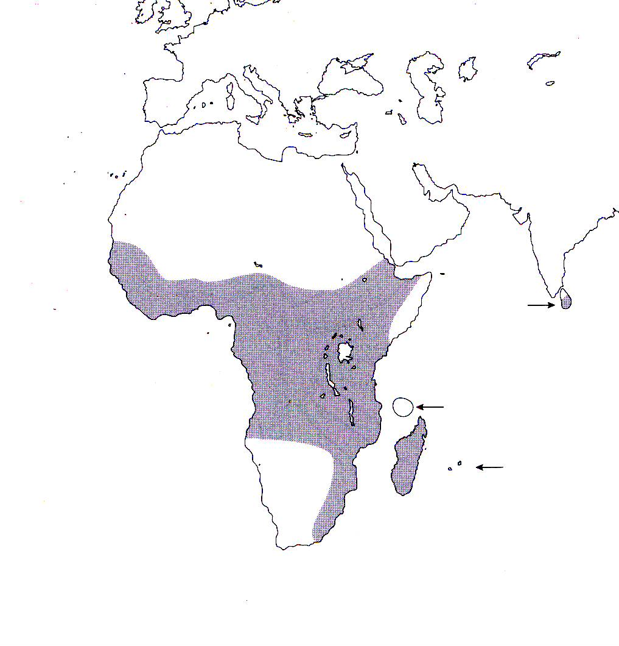
References
¹ Jay Pfahl's IOSPE at www.orchidspecies.com
²Aldridge, Peggy. 2008. An Illustrated Dictionary of Orchid Genera. Selby Botanical Garden Press.
³Cribb, CJ. 2014. Epidendroidae. In: Pridgeon AM, Cribb PJ, Chase MW, Rasmussen F, eds. Genera Orchidacearum, Vol. 6. Oxford: Oxford University Press, 344-349.

⁴https://www.thespruce.com

