Aerangis Species

SPECIES PROGENY AWARDS AWARD TYPE RANGE TEMP/LHT BLOOM TIME
F-1/Total AOS Peak
articulata | 9/11 | 14 | 8 AM, 3 CBM, 2 CCM, 1 HCC | Madagascar and Comoros | Warm/Lo | August
biloba | 7/7 | 14 | 2 AM, 1 CBM, 7 CCM, 3 HCC | West Africa | Warm/Lo | October
citrata | 6/6 | 13 | 1 AM, 1 CBM,. 2 CCE, 4 CCM, 2 HCC | Madagascar | Cool/Lo | March
fastuosa | 8/9 | 8 | 2 AM, 1 CBM, 3 CCM, 1 CHM, 1 HCC | Madagascar | Warm/Lo | March
kotschyana | 13/16 | 7 | 1 CBM, 3 CCM, 3 HCC | Africa | Warm/Lo | October
luteoalba | 13/13 | 35 | 13 AM, 3 CBM, 9 CCM, 2 FCC, 6 HCC, 2 JC | Africa | Cool/Lo | April
mystacidii | 7/7 | 5 | 2 CCM, 2 CHM, 1 JC | SE Africa | Cool/Lo | September
somalensis | 6/6 | 1 | 1 CHM | E Africa | Cool/Lo | January
Type species: Aerangis brachycarpa Judging Scale – Vanda Building Block Species

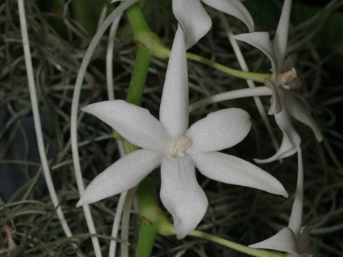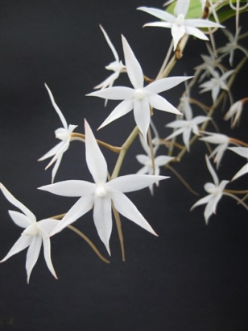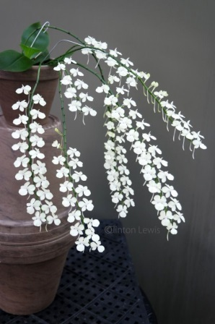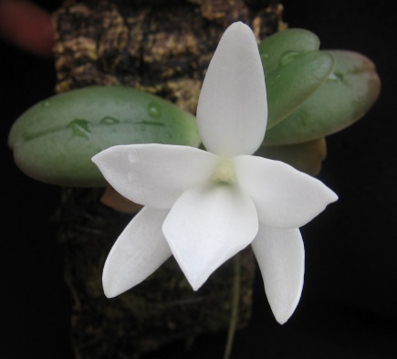
Aerangis articulata A. biloba A. citrata A. fatuosa

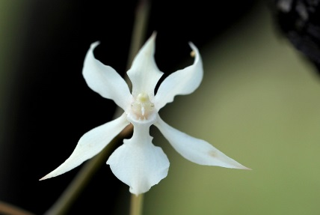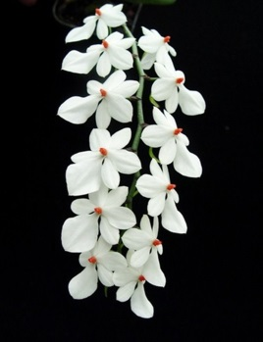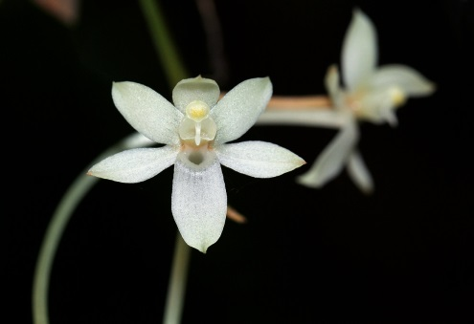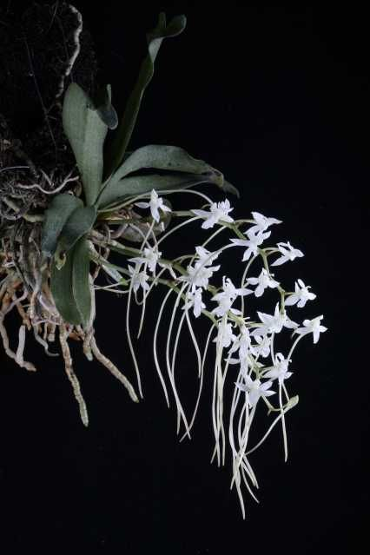
A. kotschyana A. luteoalba A. mystacidii A. somalensis

