Aerides Species

SPECIES PROGENY AWARDS AWARD TYPE RANGE TEMP/LHT BLOOM TIME
F-1/Total AOS Peak
crassifolia | 23/29 | 4 | 1 CBM, 1 CCM, 1 CHM, 1 HCC | Burma, Thailans, Laos | Cool/Lo | May
falcata | 20/25 | 2 | 1 AM, 1 JC | Thailand, Cambodia, Vietnam | Cool/Lo | June37/60
houlletiana | 37/60 | 11 | 6 AM, 5 HCC | Thailand, Cambodia, Vietnam | Hot/Hi | May
lawrenceae | 162/197 | 54 | 35 AM, 1 AQ, 6 CCM, 3 FCC, 7 HCC, 2 JC | Philippines | Hot/Hi | October
leeana | 23/32 | 6 | 1 AM, 4 CCM, 1 HCC | Philippines | Warm/Lo | February
multiflora | 32/37 | 16 | 4 AM, 3 CBM, 2 CCM, 2 CHM, 5 HCC | SE Asia | Warm/Lo | May
odorata | 62/113 | 23 | 9 AM, 1 CBM, 1 CCE, 3 CCM, 1 CHM, 3 HCC, 5 JC | India, SE Asia | Hot/Hi | June
quinquevulnera | 25/25 | 18 | 13 AM, 1 CBR, 1 CCE, 1 CCM, 1 HCC, 1 JC | Philippines, New Guinea | Hot/Hi | September
rosea | 19/26 | 16 | 9 AM, 1 CCM, 2 CHM, 3 HCC, 1 JC | India, SE Asia | Cool/Hi | May
Type species: Aerides odorata Judging Scale – Vanda Building Block Species

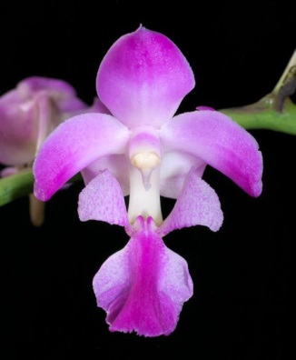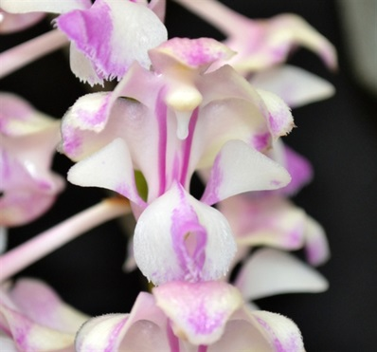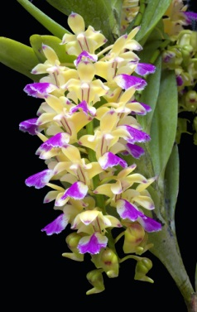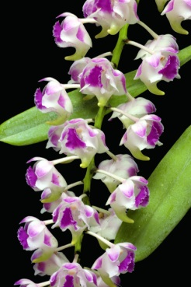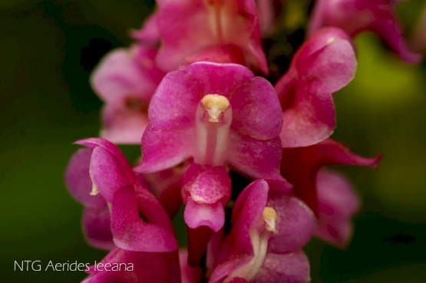
Aerides crassifolia A. falcata A. houlletiana A. lawrenceae A. leeana

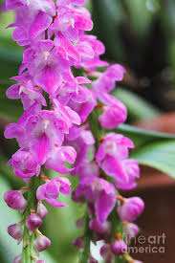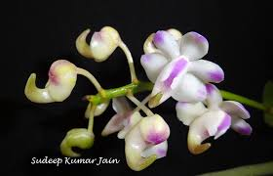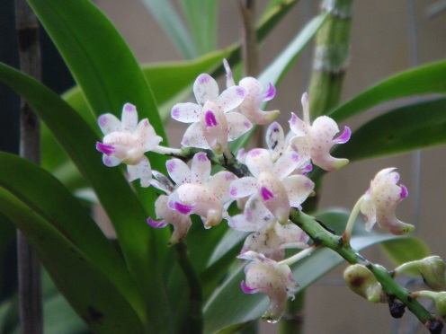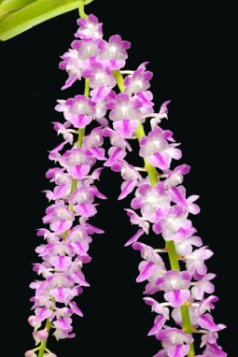
- multiflora A. odorata A. quinquevulnera A. rosea

