Angraecum Species

SPECIES PROGENY AWARDS AWARD TYPE RANGE TEMP/LHT BLOOM TIME
F-1/Total AOS Peak
eburneum | 26/33 | 32 | 4 AM, 4 CBM, 2 CCE, 19 CCM, 1 CHM, 2 HCC | Mascarenes and Seychelles | Warm/Lo | January
magdalenae | 22/31 | 12 | 4 AM, 2 CBM, 1 CCE, 3 CCM, 2 HCC | Madagascar | Cool/Hi | June
scottianum | 12/13 | 3 | 1 CCM, 1 CHM, 1 CBM | Comoro Islands | Hot/Lo | July
sesquipedale | 24/38 | 38 | 15 AM, 1 CC, 14 CCM, 5 FCC, 3 HCC | Madagascar | Hot/Hi | January
Type species: Angraecum eburneum Judging Scale – Vanda Building Block Species

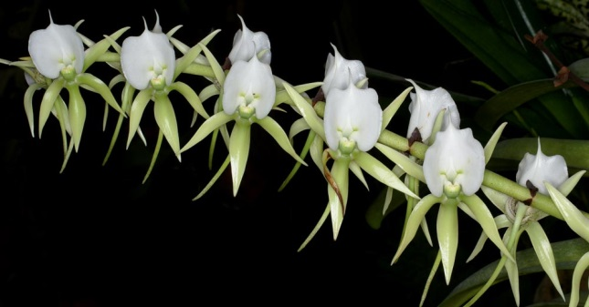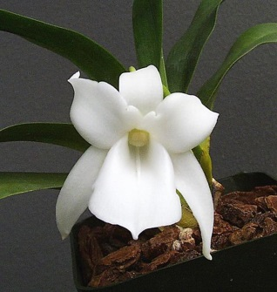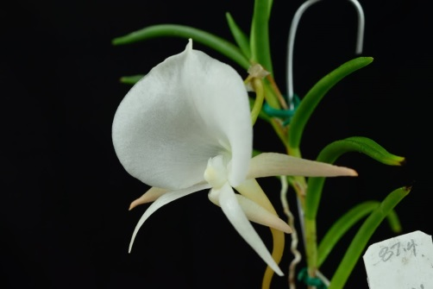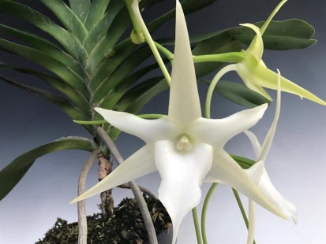
Angraecum eburneum A. magdalenae A. scottianum A. sesquipedale

